
APPROVED BY
Head of Division
Procurement Support Division,
Procurement Department
KAZ Minerals Management LLC
T.B. Bakhytzhanov
___ __________ 20___

USER GUIDE

For DDP Suppliers as External Users
of the Cargo Tracking Information System

Drafted by:
Head of the Methodology Section of the Procurement Support Division, SCM Department
KAZ Minerals Management LLC
К.А. Abildinova

Drafted on: July 10, 2024
Updated on:

Almaty, 2024

Table of Changes
36
Date | Created by | Revision | Description of changes
10.07.2024 | K. Abildinova | 1.0 | New document

Contents

1. PURPOSE AND SCOPE 4
2. ROLES AND RESPONSIBILITIES 4
3. BACKGROUND EVENTS 4
4. LOGIN TO Cargo Tracking System IS 4
5. COMPLETING A GREENLIGHT REQUEST. 4

PURPOSE AND SCOPE

This User Guide is designed to describe the use of the Cargo Tracking Information System and detailed steps for suppliers to complete a shipment and request for GREENLIGHT under concluded contracts with DDP delivery terms (Incoterms 2020).

ROLES AND RESPONSIBILITIES

The function for processing shipments and requests for GREENLIGHT is provided to a supplier’s contacts who have an account and a contact for the Shipping Contact purpose in the Oracle IS. If you need to provide a supplier contact with access to the Cargo Tracking System IS, you must independently submit a request to Oracle IS to create an account and a contact or send an email to Supplier.Support@Kazminerals.com.

BACKGROUND EVENTS

A goods supply contract or a goods shipment order under a framework agreement under the DDP delivery terms was concluded between the supplier of goods and KAZ Minerals Aktogay/Bozshakol LLC.

LOGIN TO Cargo Tracking System IS

You can log in to the Cargo tracking System by clicking the link https://cts.kazminerals.com/login
Or follow the link from notifications that will be sent to your email address.

COMPLETING A GREENLIGHT REQUEST.
  - After a goods supply contract is approved, the supplier will receive a notification by email.
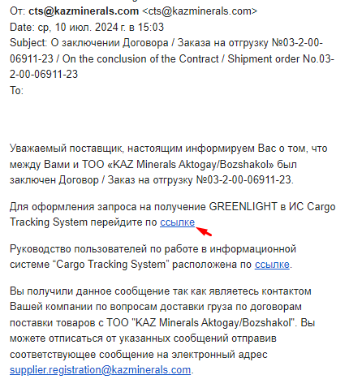
Follow this link https://cts.kazminerals.com/login in the email.

  - The login and password match with the data in the Oracle IS.
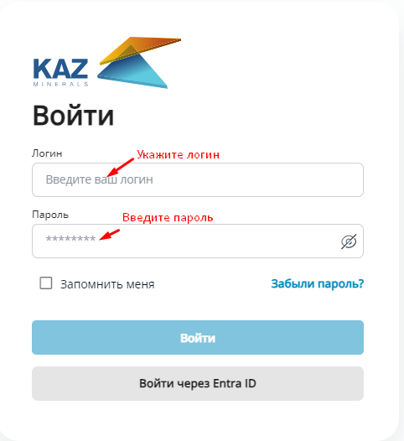
  - To create a request for Green Light, you must first create a shipment and select items for which you are going to request Green Light.
  - The PO Log displays all concluded contracts or goods shipment orders. Open a contract or shipment order for which you are going to submit a Green Light request.
  - In the window that opens, select the goods for which you are going to submit a Green Light request. Check the box (1) opposite to the selected goods and click (K) Create shipment (2)
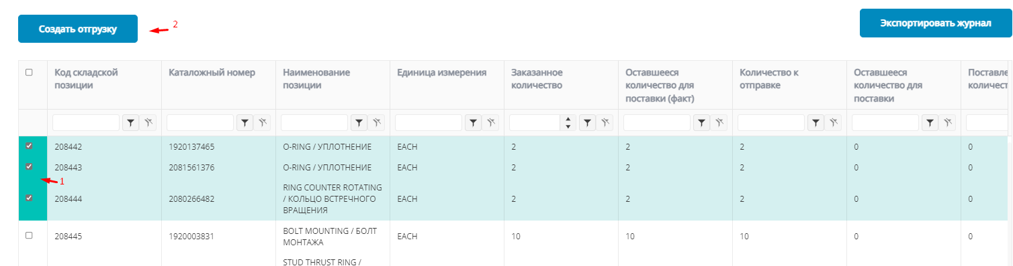
Or you can select all the lines and click on (K) Create shipment (2)
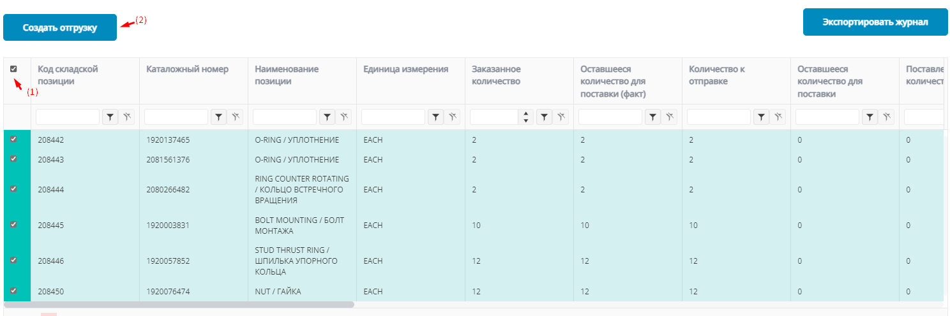
  - In the form that opens, the top part of the data will be filled in automatically. You can attach the necessary documents by clicking on (K) Upload.
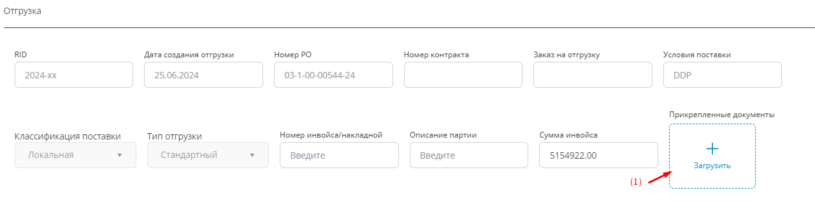
  - Fill in the packaging information. Go to the "Packaging and Dimensions" section.
You can add several packages, if necessary
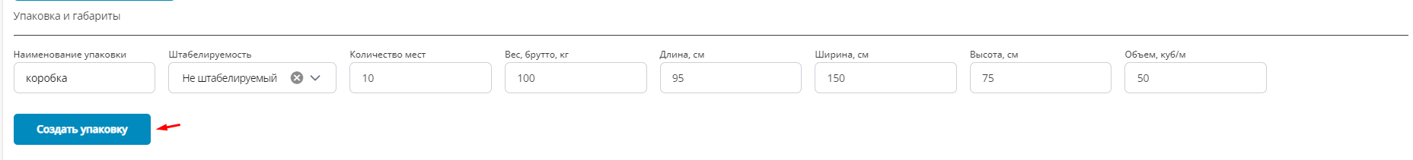
  - After creating the shipment and creating the packaging, click (K) Save.
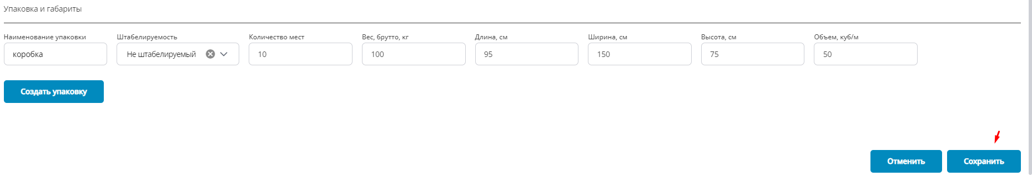
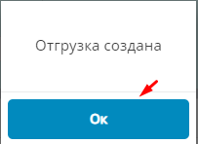
  - The created shipment will be displayed in the Shipments section
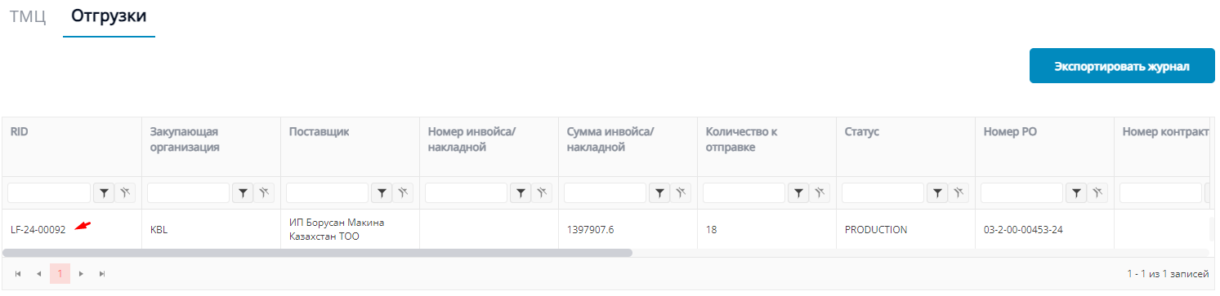
  - Within one contract or order, you can create several Shipments depending on the selected inventories or the quantity of one type if inventory.
IMPORTANT! One shipment must contain only stock items with one delivery date under a contract or ashipment order.

  - Go to the Green Light section
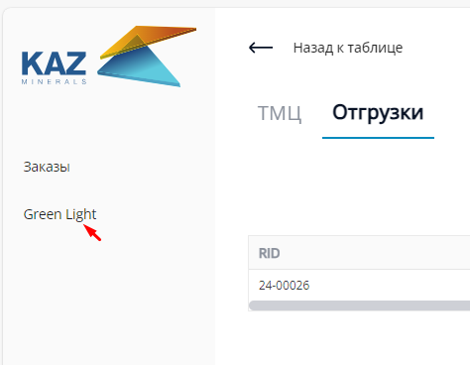
  - Click (K) Create Green Light Request
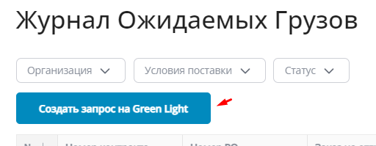

  - In the opened form, fill in the following data:
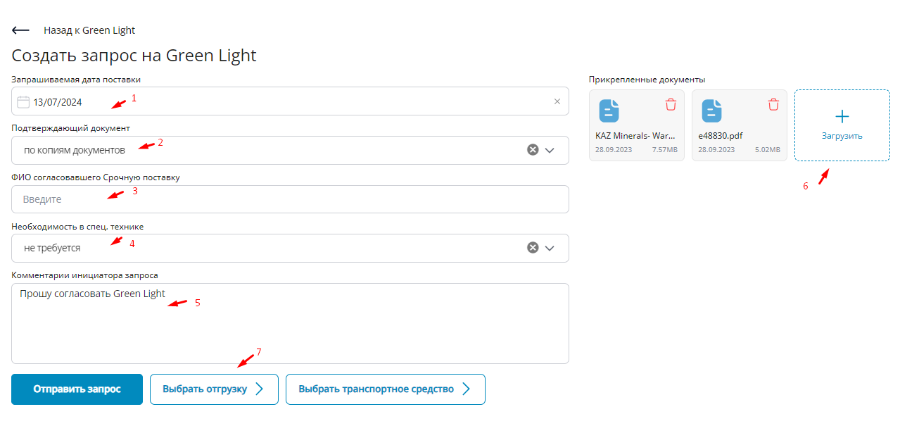
- Select the Requested Delivery Date from the calendar
- Select the “By document copy” value from the Supporting Document drop-down list;
- If the delivery is urgent, indicate the full name of the employee who agreed on the urgent delivery;
- Select the required value from the drop-down list if unloading requires the use of special equipment;
- Fill in additional comments, if necessary.
- Attach all required documentation

  - Next, click (K) Select shipment (7)
  - In the form that opens, select the shipment by checking the box next to the shipment and click (K) Select.
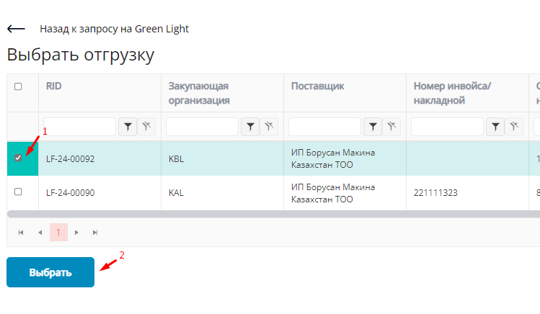
  - Next, press (K) Select vehicle
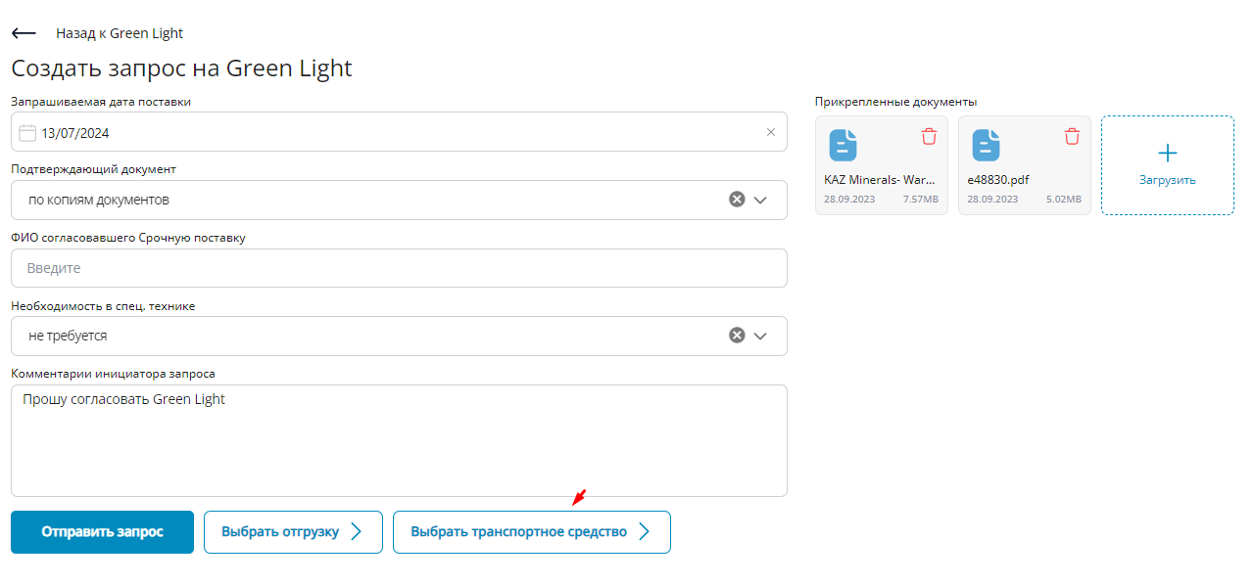
  - In the form that opens, select a vehicle (1) from the list and click (K) Select
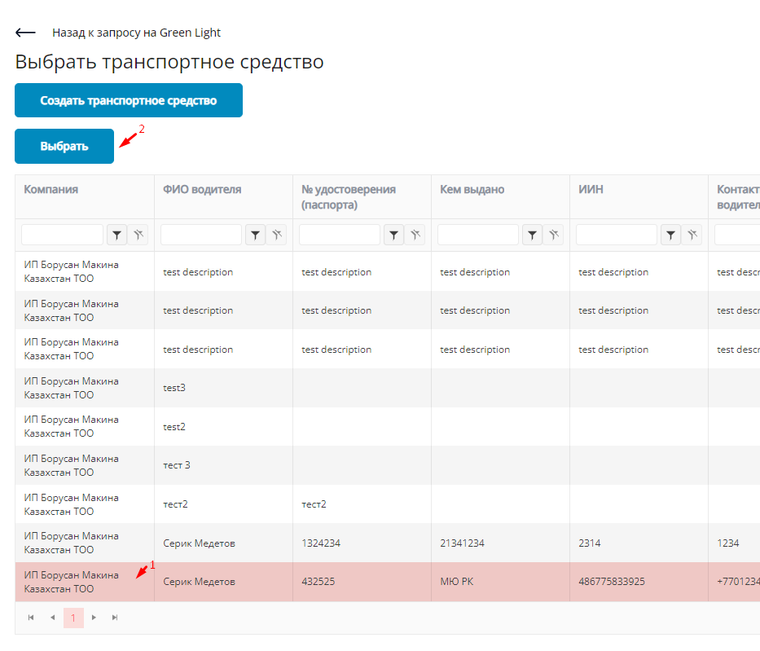
  - If the required value is not in the list, create a vehicle
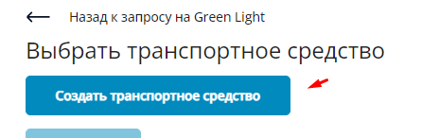
  - Fill in the required data and click (К) Save
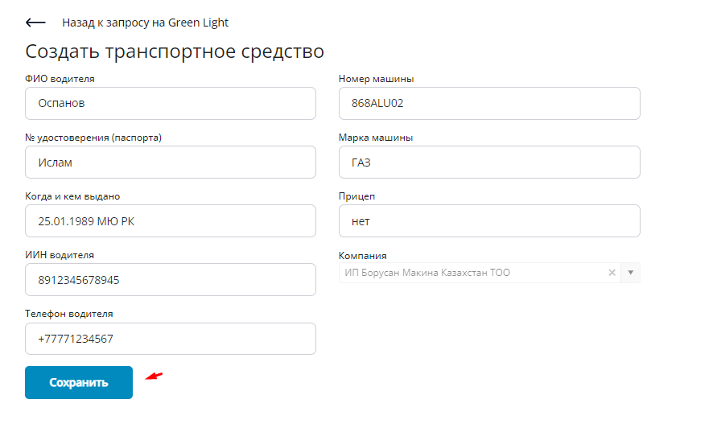
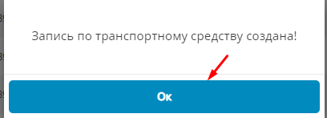
  - After filling out all the information on Green Light, click on (K) Send request
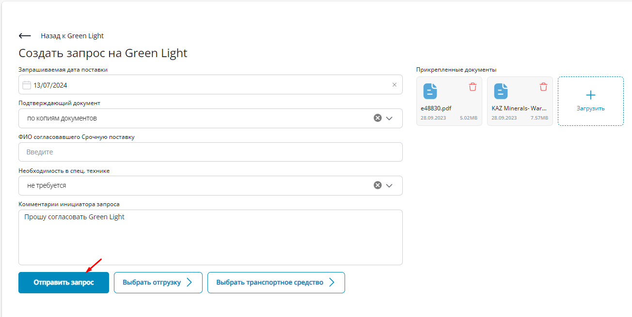

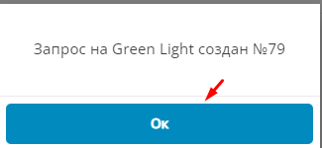
  - After you submit your Green Light request, the status will change to REQUESTED.
  - All previously created requests for Green Light will be displayed in the Expected Cargo Log
  - In order to track the status, you can open a request for Green Light
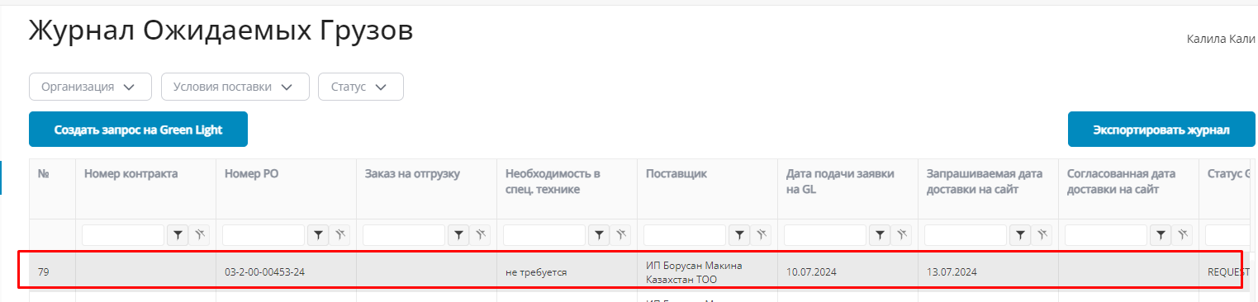
  - Also, regarding any decision (Approved / Rejected / Agreed for another date) on Green Light, you will receive a message by email.
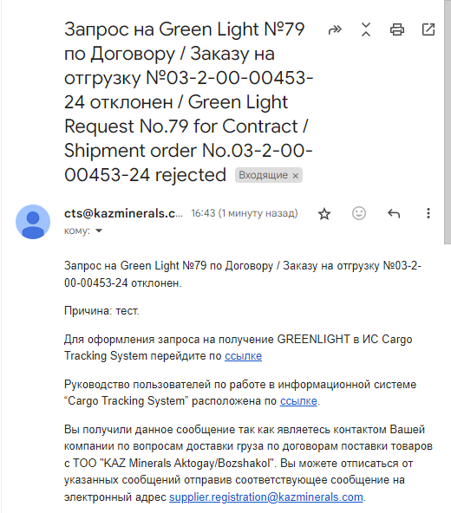
  - If you need to make changes to a completed request for Green Light, go to the Green Light section and open the request.
Important! You can edit a request for Green Light in the Decline status

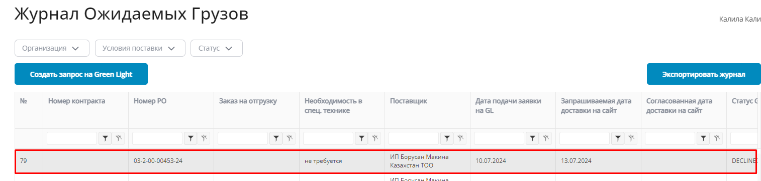
  - If you need to delete an added shipment in a created Green Light, click (K) Delete opposite to the selected shipment.
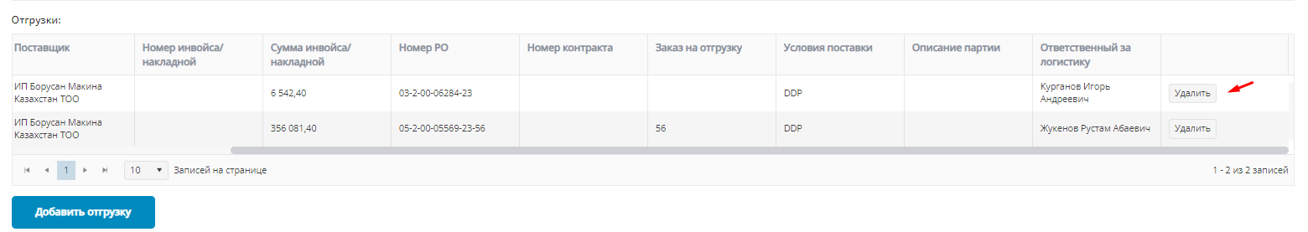
  - If you need to add a new shipment, click in the Shipments Section (K) Add shipment.
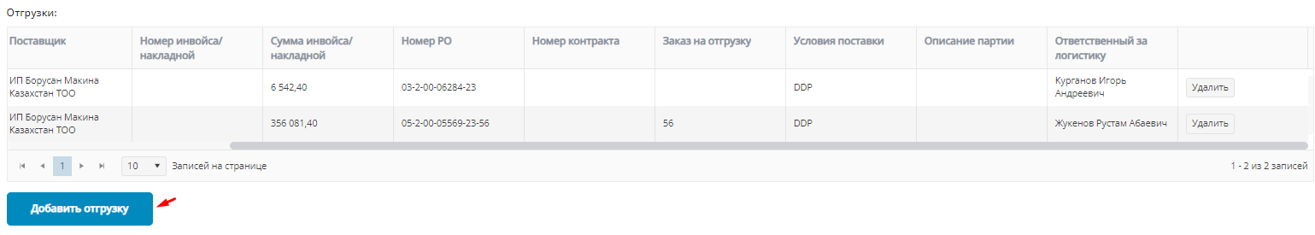
  - Next, click (K) Edit
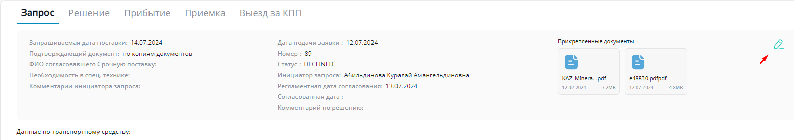
  - And in the window that opens, click (K) Save
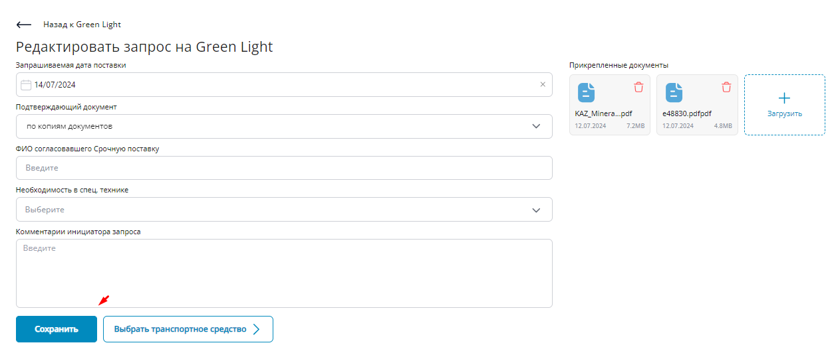

  - To edit other data, press (K) Edit
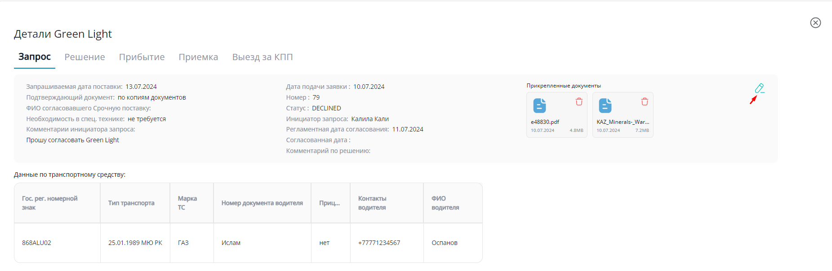
  - Make the necessary changes as described in the previous steps and click (K) Save.
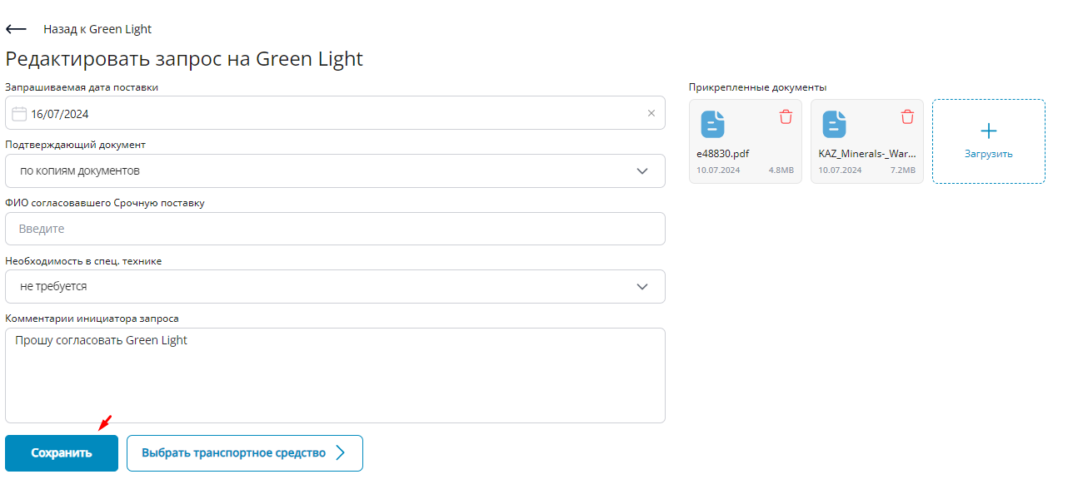
  - After resubmitting the approval request, the request status will change to REQUEST REAPPROVAL.
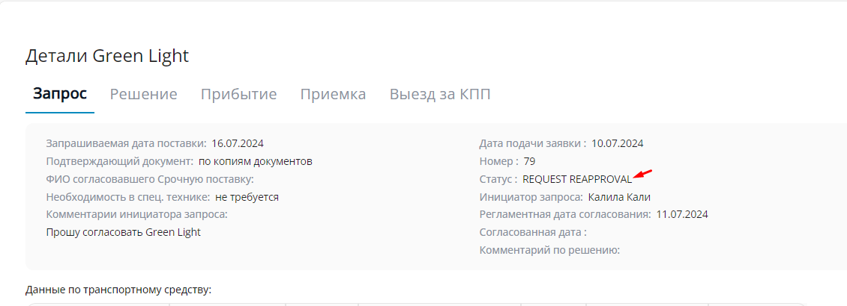

GREENLIGHT means a procedure that includes planning the date of delivery of goods to the Buyer's warehouses, preliminary check of shipping documents for compliance with the terms and conditions of the relevant purchase order, visual examination to check whether proper transport packaging is available and whether the goods can be unloaded in the environment of the warehouse upon their arrival at the respective checkpoint of the Buyer
DDP delivery terms under Incoterms 2020 stands for “Delivered Duty Paid” named place of destination. The seller is obliged to: complete export customs clearance, deliver the goods to the agreed destination and complete import customs clearance with payment of duties. The Buyer is obliged to: unload and receive the goods. Risks shall pass at destination.

