APPROVED BY
Development Director,
Procurement Department KAL/KBL
KAZ Minerals Management LLC
J. Christopher Brodie
___ __________ 20___

USER GUIDE

EDITING SUPPLIER PROFILE

Drafted by:
Head of the Methodology Section of the Procurement Support Division, SCM Department
KAZ Minerals Management LLC
К.А. Abildinova

Created on: 10 December 2021
Updated on: 17 June 2022

Almaty, 2021
Table of Changes
36
Date | Created by | Revision | Description of changes
10.12.2021 | K. Abildinova | 1.0 | New document
11.02.2022 | N. Kalenova K. | 1.1 | Information and Print Screen Updates
20.03.2022 | N. Kalenova K. | 1.2 | Final editing
14.04.2022 | N. Kalenova K. | 1.3 | More information
17.06.2022 | N. Kalenova K. | 1.4 | Addition to Clause 2.7.1

Contents

I. PURPOSE AND SCOPE 4
II. ROLES AND RESPONSIBILITIES 4
III. BACKGROUND EVENTS 4
IV. DETAILED STEPS 4
1. Entering the system and initial settings 4
2. Profile Management 5

PURPOSE AND SCOPE

This User Guide will help you (as an approved supplier) to fill in the Questionnaire for registering your company in your Personal Account of the Oracle system, Version 12.2.7.

ROLES AND RESPONSIBILITIES

The authority for accessing and editing data in your Personal Account of Oracle, Version 12.2.7, is provided to all approved suppliers.

BACKGROUND EVENTS

A notification was sent to your e-mail address that you were registered and assigned a login in the Oracle system, Version 12.2.7. As a registered supplier, you have access to manage your company's data. We kindly ask you to keep all the information of your company up to date, as it will help us further interact with you. All the data that you fill in, for example, contacts for concluding contracts, will be automatically reflected in the contracts (data on the contract signatories, settlement accounts, etc.)

DETAILED STEPS

Follow the link to enter your Personal Account:
https://suppliers.kazminerals.com/OA_HTML/AppsLocalLogin.jsp

Entering the system and initial settings
  - Enter your login and password.
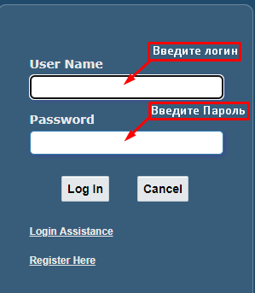

  - When you log in for the first time, the system will prompt you to change the default password. Create, enter and confirm a new password.
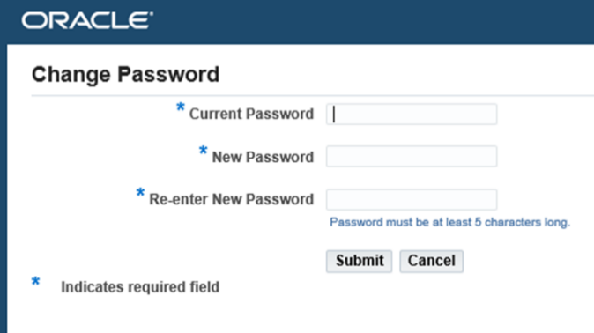
  - Upon successful logging in the system, the Home Page will appear. On the left side of the navigator click on the triangle next to “KMM iSupplier Portal” => click on “Supplier Details”
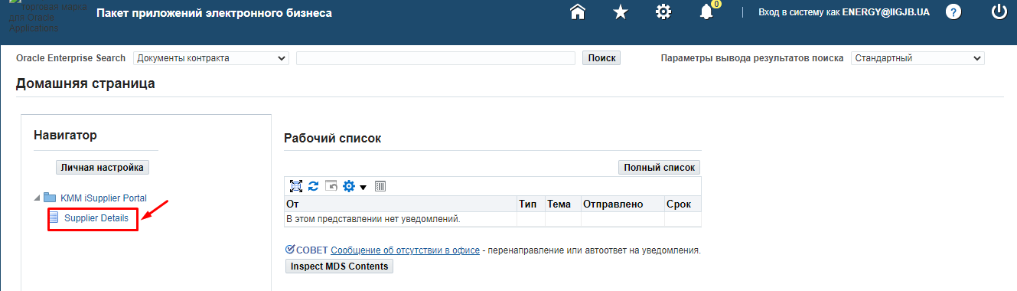

Profile Management
The Navigator contains a list of sections in which changes can be made, documents attached, etc.
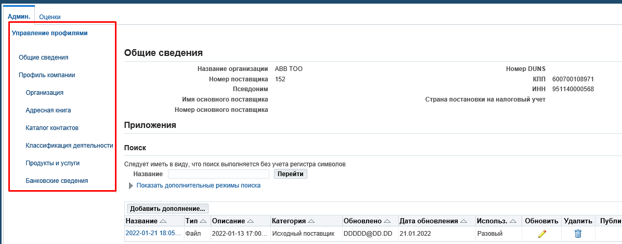
  - General Information Section.
IMPORTANT!!! Please check whether all required documents are attached. If some documents are missing, please attach the scanned documents in accordance with the following classification.

Category Description |  | No. | List of Documents
*Documents confirming the authority of the contract signatory | Resident of the Republic of Kazakhstan |  | The minutes of meeting (decision) of the executive body on the election (appointment) of the chief executive officer or the power of attorney for an authorized representative, if the signatory is not the chief executive officer of the said legal entity.
 | Non-Resident of the Republic of Kazakhstan |  | The minutes of meeting (decision) of the executive body on the election (appointment) of the chief executive officer or the power of attorney for an authorized representative, if the signatory is not the chief executive officer of the said counterparty;
 | Branch of the non-residents of the RoK: |  | A document confirming the authorities of the counterparty’s signatory (decision or PoA)
 | IE, the Resident of the Republic of Kazakhstan |  | Identity Document
 |  |  | Power of Attorney for an authorized representative, if the signatory of a respective GWS purchase contract is different from the said individual entrepreneur
*Foundation documents | Resident of the Republic of Kazakhstan |  | The articles of association of the legal entity. If a representative of the counterparty is its structural business unit (a branch or a representative office), then, in addition to the articles of association, such a party must provid the branch or representative office regulations and documents on the appointment of the head of the structural business unit
 |  |  | The certificate or the confirmation of the state registration (re-registration) of the legal entity
 | Non-Resident of the Republic of Kazakhstan |  | Constitutional documents (the Articles of Association or an equivalent document)
 |  |  | Document confirming the registration of a legal entity with an authorized state body or chamber of commerce.
 | IE, the Resident of the Republic of Kazakhstan |  | Certificate or notification of the individual entrepreneur’s state registration with tax authorities, if such registration is required in accordance with the statutory regulations of the Republic of Kazakhstan;
 | Branch of the non-residents of the RoK: |  | The articles of association of the legal entity
 |  |  | The Provisions of the Branch or Representative Office
 |  |  | Document on the appointment of the head of a branch or representative office
 |  |  | Certificate of Branch or Representative Office registration
*Tax Details | Resident |  | The certificate of VAT registration (if applicable)
 |  |  | In case the counterparty is a VAT payer, a tax authority’s statement of the absence of outstanding tax and other payment debts to the state budget; in case the counterparty is not a VAT payer, a relevant confirmation statement from a tax authority;
 | IE, the Resident of the Republic of Kazakhstan |  | The certificate of VAT registration (if applicable)
 |  |  | In case the counterparty is a VAT payer, a tax authority’s statement of the absence of outstanding tax and other payment debts to the state budget; in case the counterparty is not a VAT payer, a relevant confirmation statement from a tax authority;
 | Branch of the non-residents of the RoK: |  | The certificate of VAT registration (if applicable)
 |  |  | In case the counterparty is a VAT payer, a tax authority’s statement of the absence of outstanding tax and other payment debts to the state budget; in case the counterparty is not a VAT payer, a relevant confirmation statement from a tax authority;
*Banking data | Resident of the Republic of Kazakhstan |  | Certificate of the existence of a current account and the absence of loan indebtedness from the servicing bank with bank details
 | IE, the Resident of the Republic of Kazakhstan |  | Certificate of the existence of a current account and the absence of loan indebtedness from the servicing bank with bank details
 | Branch of the non-residents of the RoK: |  | Certificate of the existence of a current account and the absence of loan indebtedness from the servicing bank with bank details
Licenses/certificates | Resident of the Republic of Kazakhstan |  | The state license of the Republic of Kazakhstan for carrying out licensed activities and permits for performing works (rendering services) (if applicable), including the copies of all the appendices to the state license
 |  |  | Goods manufacturer certificate
 | Non-Resident of the Republic of Kazakhstan |  | The state license of the Republic of Kazakhstan for carrying out licensed activities and permits for performing works (rendering services) (if applicable), including the copies of all the Appendices to the state license
 |  |  | Goods manufacturer certificate
 | Branch of the non-residents of the RoK: |  | The state license of the Republic of Kazakhstan for carrying out licensed activities and permits for performing works (rendering services), where such works (services) are subject to licensing, including the copies of all the Appendices to the state license (if applicable)
 |  |  | Goods manufacturer certificate
*Anti-Bribery and Corruption Compliance Questionnaire | For all suppliers |  | Anti-Bribery and Corruption Compliance Questionnaire, filled in and signed by the counterparty
*Misc | For all suppliers |  | (5) A letter confirming that your Company is/is not subject or target to the sanctions introduced by the USA Government, UN Security Council, European Union, Her Majesty's Treasury or other respective sanctions authorities.

If it is impossible to submit the documents referred to in Subparagraphs 2, 8, and 9, it is required to provide a letter on the official letterhead, confirming information about the company, business reputation and the responsibilities of the person authorized to sign documents. Draft letter (see at the end of the instructions).

To attach the necessary documents, click on (K) Add Supplement
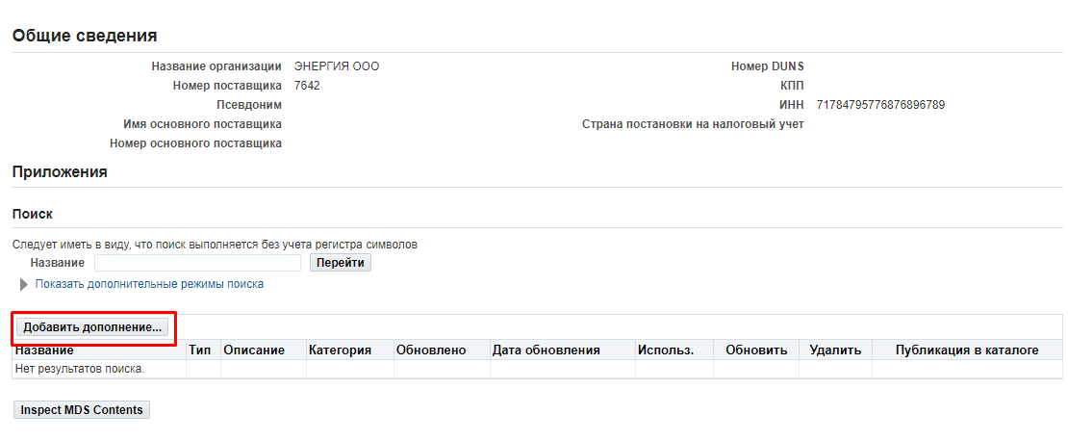
    - (1) In (П) Add-on type, select the file type;
(2) In (П) Title, enter the title of the document;
(3) In (П) Description enter a description of the document;
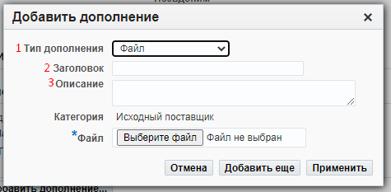
    - Click on (K) Select File (1), select the relevant document and on (K) Open (2).
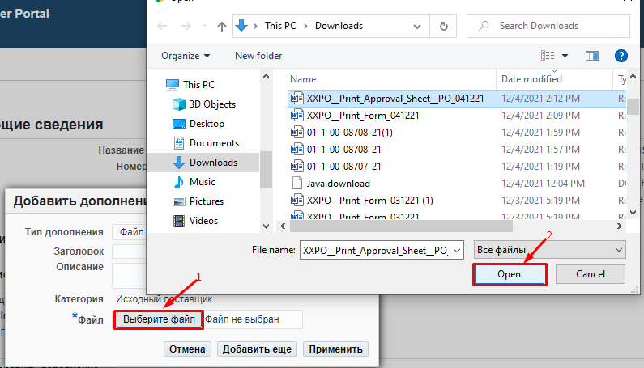
    - If you need to attach additional documents, click on (K) Add more (1), the previous file will be automatically loaded (2).

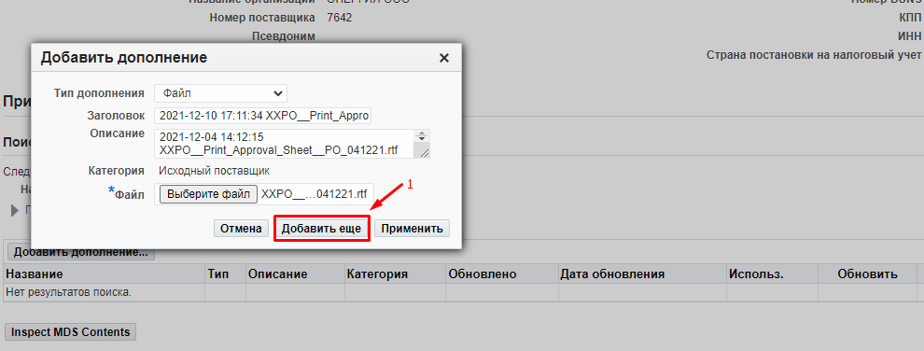
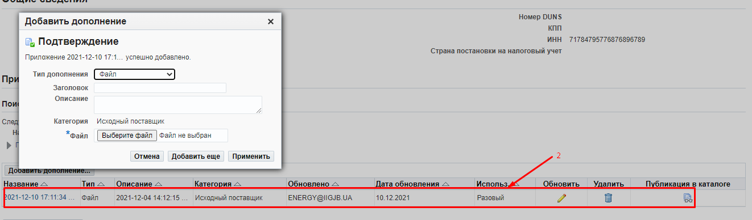
    - After uploading all the required documents, (3) press (К) Apply
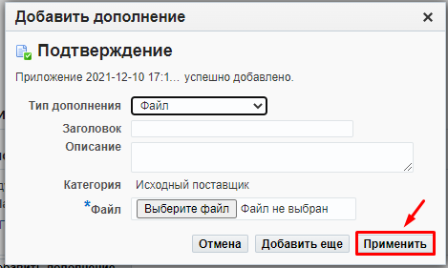
  - Organization Section: General Information Section
    - General Information Section: Contacts
Please make sure that the contact details is up to date, as they will be reflected in the contract.
If there are changes, fill in/edit the following fields:

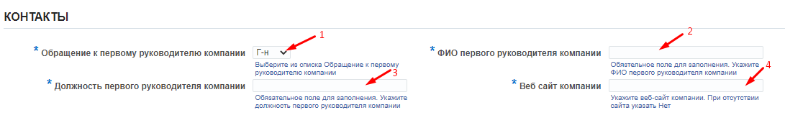
(1) in the “Title of the top manager of the company” field, select a required value from the list.
(2) in the "Full name of the top manager of the company" field, indicate the full name of the head of the company for sending official letters.
(3) in the "Position of the top manager" field, indicate the position in accordance with the internal documents of the company.
(4) in the "Company Website" field, enter the name of the company website. If there is no website, enter the word "no".

    - General Information Section: Legal Data
In cases of legal data, delete the previous record in the (П) “Legal Structure" field and (1) then click on the magnifying glass =>(2) in the window that opens, click the (К) "Start" button => (3)select a legal form of the entity that matches your company and click on (К) "Express selection”

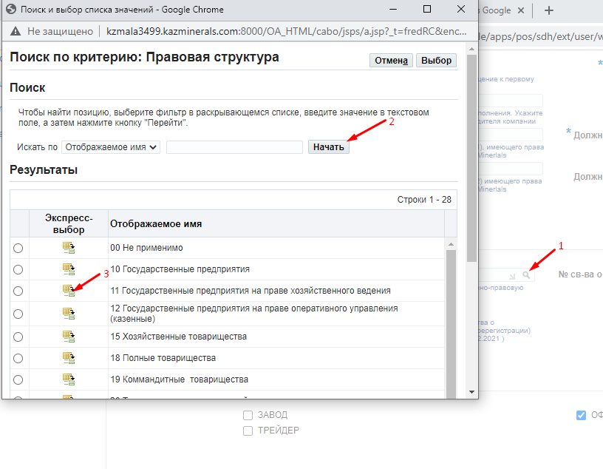
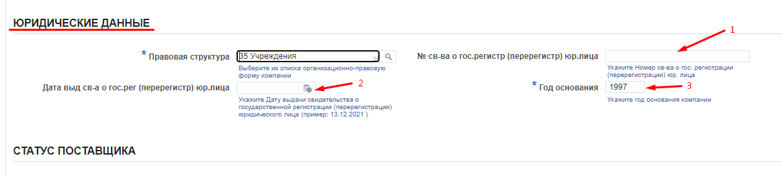
(1) and (2), in the “Number and date of the certificate of state registration (re-registration) of legal entity”, fill in the number and date of the certificate of state registration (re-registration) of a legal entity. For the residents of the Republic of Kazakhstan, these fields are mandatory to be filled in.
(3) in the “Year of foundation” field, fill in the year of initial state registration.
    - General Information Section: Supplier Status
Check your company’s status. If there are changes, check the checkbox of your company’s current status
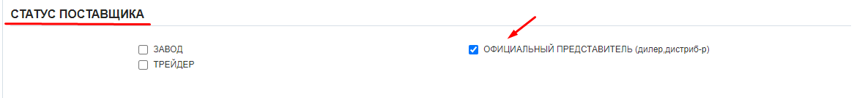

    - General Information Section: Goods Dealer/Manufacturer Certificates
If your company is a manufacturer of a product (Factory) or an Official Representative (dealer, distributor), it is mandatory to list the certificates. Scanned copies of certificates should be attached in accordance with the instructions in Paragraph 2.1.1.
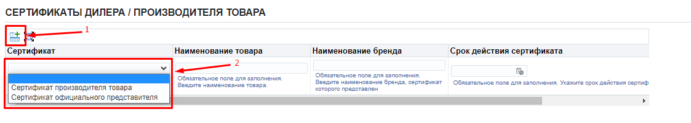
- Click on (К) “Add New Row” button => (2) select the required value from the list.
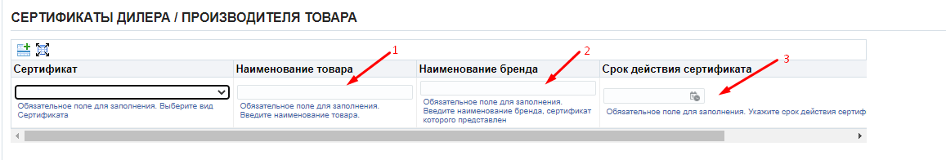
- in the "Product name" field, enter the name of the certified product => (2) in the "Brand name" field, enter the name of the brand, for which the certificate was submitted => (3) in the "Certificate validity period" field, enter the certificate validity period. Repeat the steps as needed to add several lines.
    - General Information Section: Positive tests of goods at KAZ Minerals
If your products were tested by KAZ Minerals companies and the testing completed successfully, please check the checkboxes of those companies. Otherwise, leave this section blank.
    - General Information Section: Licenses/Certificates FOR PERFORMANCE OF WORK/RENDERING SERVICES
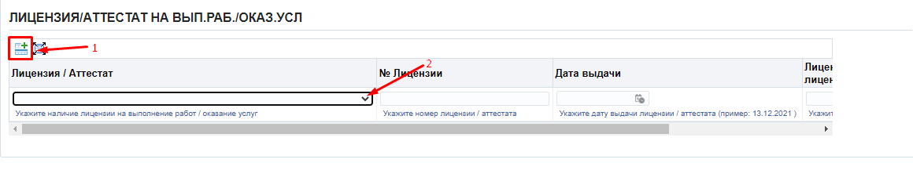
- Click on (К) “Add New Row” button => (2) select the required value from the list. If the work/service is licensed, but you do not have the relevant document, select the "No” value. If the work / service is not licensed, select “Not Required”.
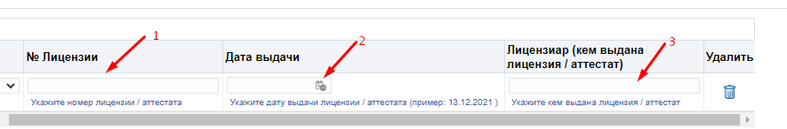
- in the "License No." field, enter the license/certificate number => (2) in the "Issue date" field, indicate the date of issue of the license/certificate (DD.MM.YYYY.) => (3) in the "Licensor (who issued the license/certificate)" field, indicate who issued the license/certificate. Repeat the steps as needed to add several lines.
After the filling in, be sure to save all the necessary data by clicking on (K) Save.
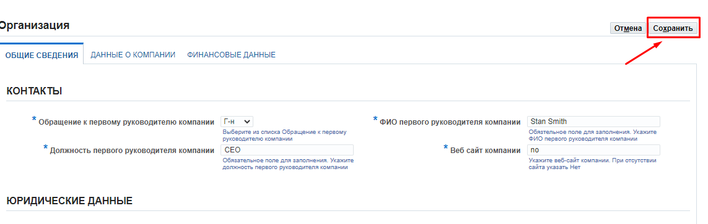
    - Company Profile Tab.
Check the relevance of data on your company. If there are changes, fill in/edit the following fields:
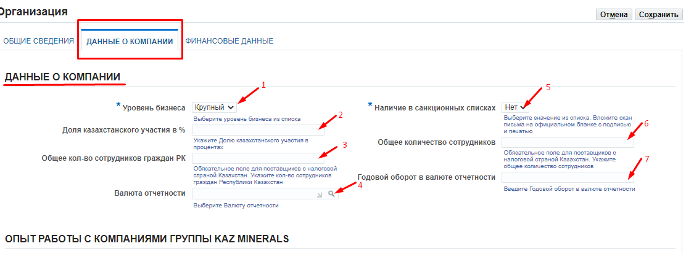
(1) in the mandatory field "Business level“, select the appropriate value for your company from the list.
(2) in the mandatory field “Local Share in%”, the Residents of the Republic of Kazakhstan, should indicate the share in the company in percentage owned by the citizens of the Republic of Kazakhstan. For the non-residents of the RoK:
(3) in the mandatory field "Total number of employees of citizens of the Republic of Kazakhstan" for residents of the Republic of Kazakhstan. For the non-residents of the RoK:
(4) in the "Reporting currency" field, click on the magnifying glass => in the window that opens, click the "Start" button => select the reporting currency or click on the "Express selection" button
(5) in this mandatory field “Presence in the sanctions lists”, you should specify whether your Company is subject or target to the sanctions introduced by the USA Government, UN Security Council, European Union, Her Majesty's Treasury or other respective sanctions authorities. It is mandatory to attach a confirmation letter on an official letterhead signed and stamped by your Company.
(6) in the field "Total number of employees”, the residents of the Republic of Kazakhstan must indicate the total number of employees in your Company. For the non-residents of the RoK:
(7) in the "Annual turnover in reporting currency" field, enter the Annual turnover in the reporting currency in the numerical format.
    - Company Profile Tab: Cooperation experience with KAZ Minerals Group companies
If your Company has cooperation experience with other KAZ Minerals companies, please list those companies or select “No experience with KAZ Minerals”.

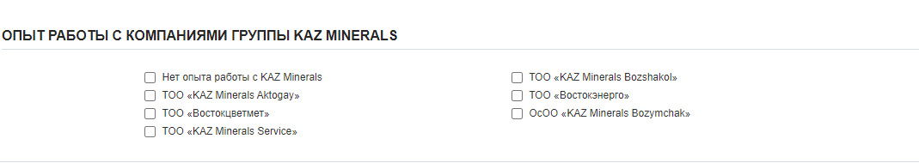
After the filling in, be sure to save all the necessary data by clicking on (K) Save.
    - Financial Data Tab
Check the relevance of financial data on your company. If there are changes, fill in/edit the following fields:

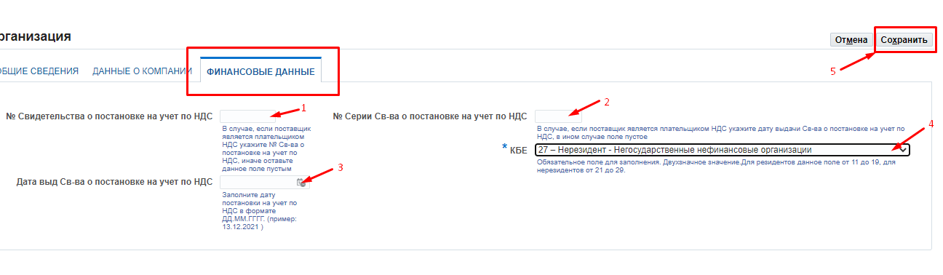
- the "VAT registration Certificate No.", (2) "VAT registration Certificate Series No." and (3) "Date of issue of VAT Registration Certificate" fields should be filled only by the residents of the Republic of Kazakhstan, if your Company is a VAT payer. Otherwise, leave this field blank. (4) in the "KBE" field, select from the list the relevant value for your Company.
(5) Click on (К) Save.
In case of editing the data in the following sections, all changes/updates will be re-approved by the administrator.

  - Address Book Section

    - To edit the address, click on the pencil in the Update column.
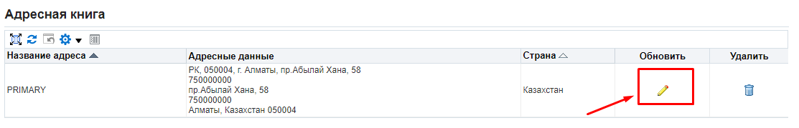
    - On the page that opens, fill in/edit the required data.

For the residents of the RoK:
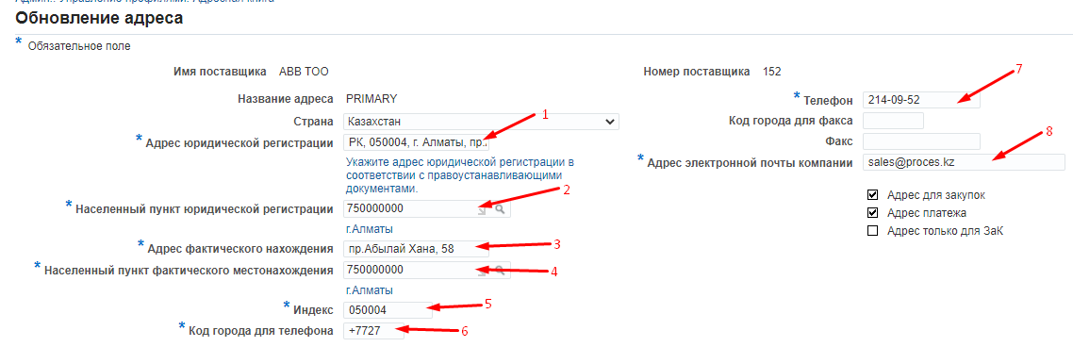

(1) in the "Official Registration Address" field, indicate the address of official registration in accordance with the documents of title. For example, 185 Kurmangazy Street, Almalinsky District, Almaty City
(2) in the "Settlement of Official Registration" field, select the settlement of registration from the Directory Classifier of Units of Administrative and Territorial Distribution (KATO).
(3) In the field "Address of Actual Location", indicate the full address of the actual location of the company. For example, 24a M.Zhusup Street. Ekibastuz City, Pavlodar Region.
(4) in the "Settlement of Actual Location" field, select the settlement of actual location from the Directory Classifier of Units of Administrative and Territorial Distribution (KATO).
(5) in the "Index" field, indicate the index of official registration
(6) in the field “City Phone Area Code" enter the city area code
(7) in the "Phone" field, enter the phone number of the company
(8) In the "Email Address" field, enter the company email address. This address will be used to send messages and notifications.
After filling in, click on (K) Save.

For the non-residents of the RoK:
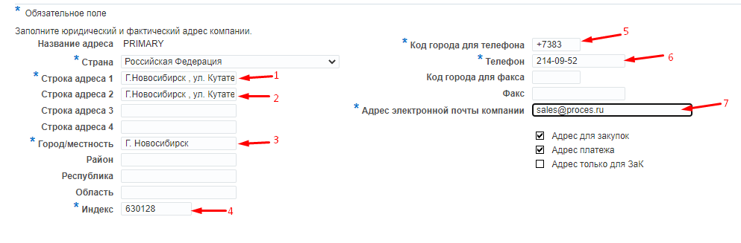

(1) in the "Address Line 1" field, indicate the address of official registration in accordance with the documents of title. For example, 4g-238 Kutateladze Street, Novosibirsk
(2) In the field "Address Line 2", indicate the full address of the actual location of the company.
(3) In the "City/Town/Locality “ field, enter the city of the official location of your company.
(4) in the "Index" field, indicate the index of the official registration
(5) in the field “City Phone Area Code" enter the city area code
(6) in the "Phone" field, enter the phone number of the company
(7) In the "Email Address" field, enter the company email address. This address will be used to send messages and notifications.
Click on (К) Save

  - Contact Directory Section: active contacts
    - Please make sure that contact details with e-mail addresses are indicated for your organization. If contact information is missing, you will not be able to receive requests for quotations, requests for information, etc.
If you need to change the contact details of a contract signatory, click on (К) Create.
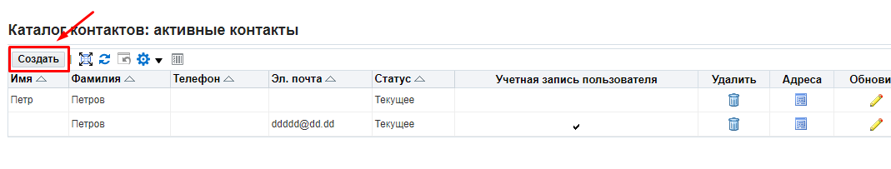
    - Fill in required fields.
- in the ”Title of the Contact Person” field, select a required value from the list.
- in the “First Name" field, enter the first name.
- in the "Patronymic" field, enter the patronymic.
(4) in the “Last Name” field, enter the last name.
(5) in the "Position" field, enter the position in accordance with the internal documents of the company.
(6) In the “Contact’s Email Address" field, enter the email address.
(7) In the “City Phone Area Code” field, enter the city area code.
(8) In the "Phone" field, enter the phone number.

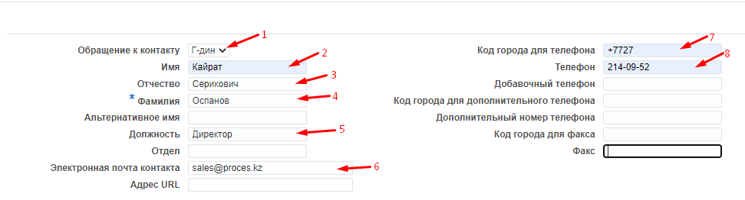

    - In (П) Purpose of Contact, click on the "Add a new line" button (1) => Select from the reference list the Contract Signatory value.
.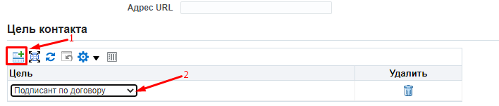 Click on (К) Save
If several employees in your company have the right to sign supply contracts, then you need to create contacts for each of such employees.

    - To edit contact data, click on the pencil in the Update column.
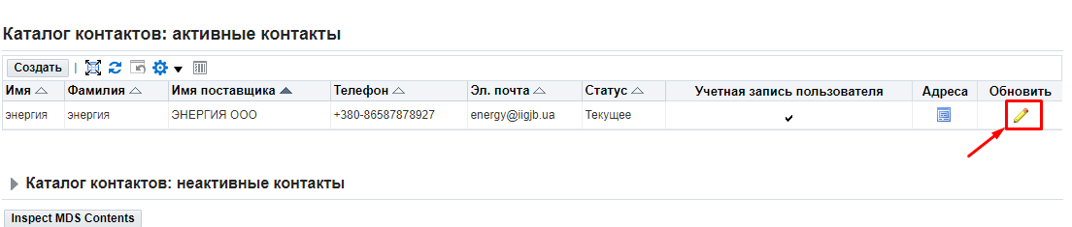

    - Fill in the required details and click on (К) Apply
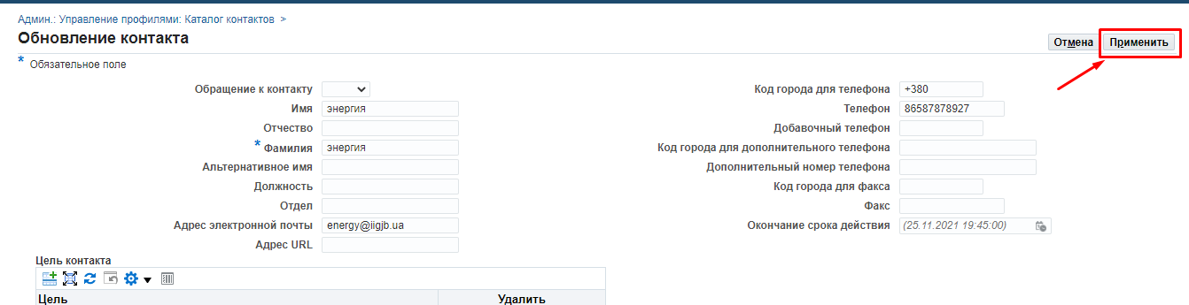

  - Business Classification Section
(If the classification neds to be changed, in the Classification list, select one or more values (1) corresponding to your company. Click on (К) Save (2).
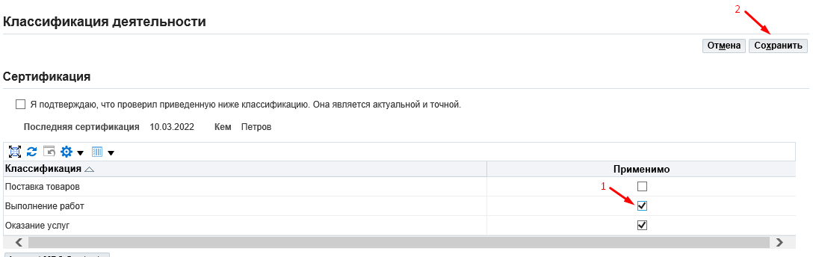

  - Products and Services Section
    - If you need to delete previously selected categories of products and services, select the categories by checking the boxes and click on (K) Delete
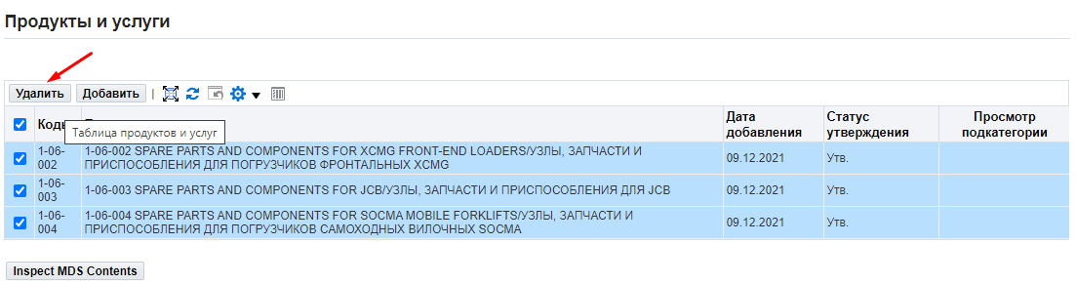
    - If you need to add them, click on (K) Add
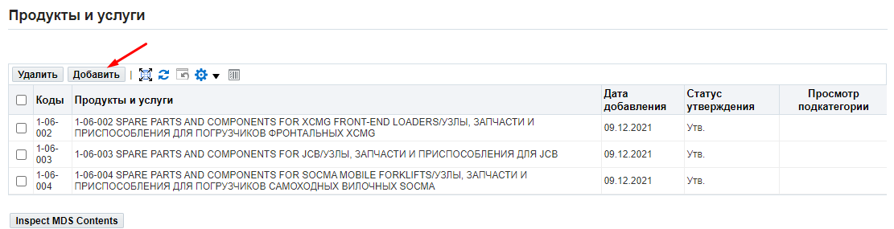
    - If you need to preview the entire list of categories of goods, works and services, click on (К) "Export list”.
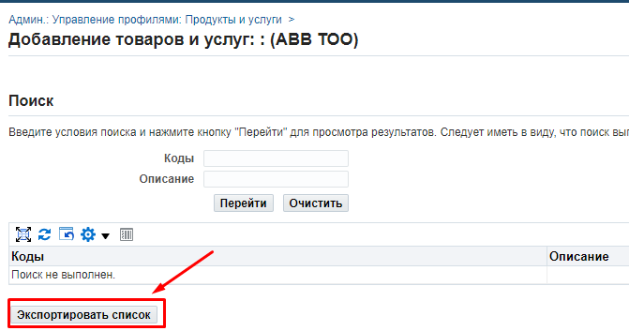

2.6.4. In (П) Codes, enter the category code from the exported list of goods/works/services (1) that you are planning to supply. Click on (К) Go to (2).
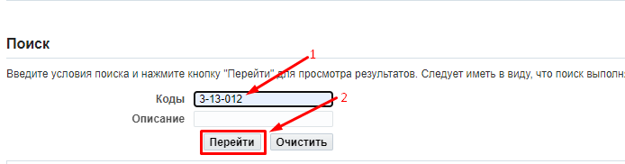

1.6.5. Check the box next to the selected category (1), click on (K) Apply (2) and then click on (K) Save and Exit (3).

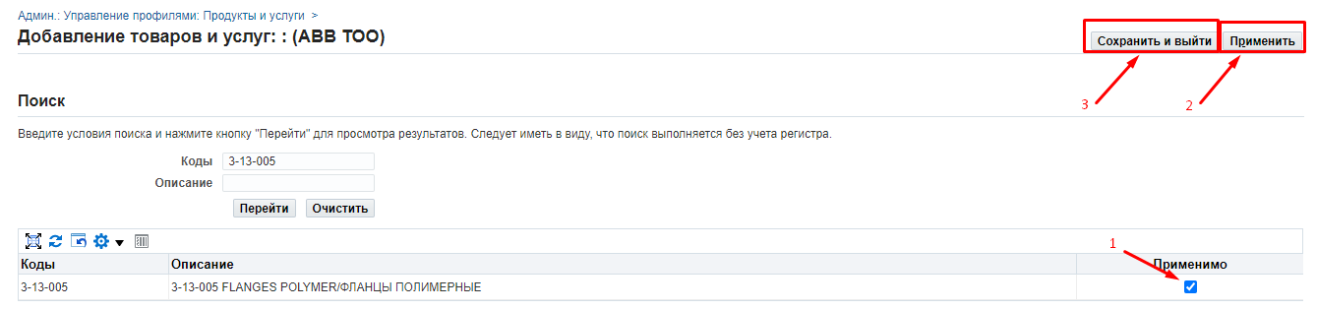

  - Banking Details Section

    - To add a new bank account, click on (К) Create.
In case of adding a new bank account, a form justifying the need to change banking details needs to be filled out.
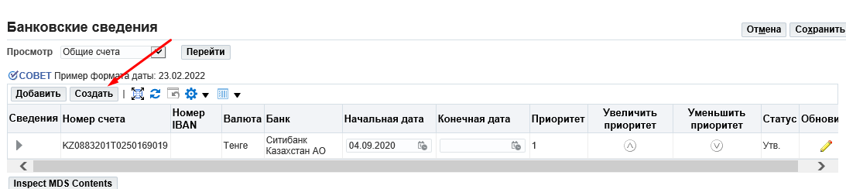

    - In the opened form, fill in the following data:
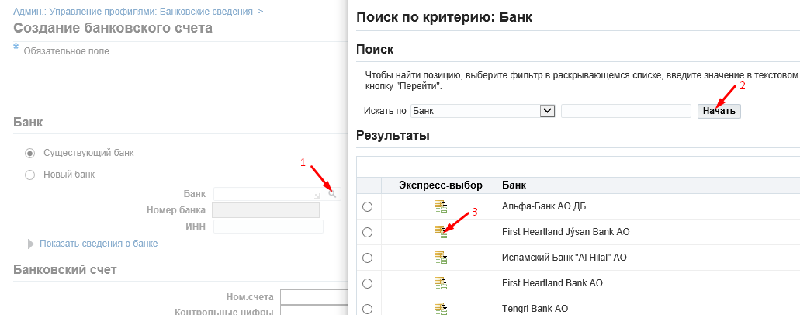
(1) in the "Bank" field, click on the magnifying glass => in the window that opens (2) click on (К) "Start" => select the required bank from the list and (3) click on (К) "Express Selection"

To fill in the bank branch:
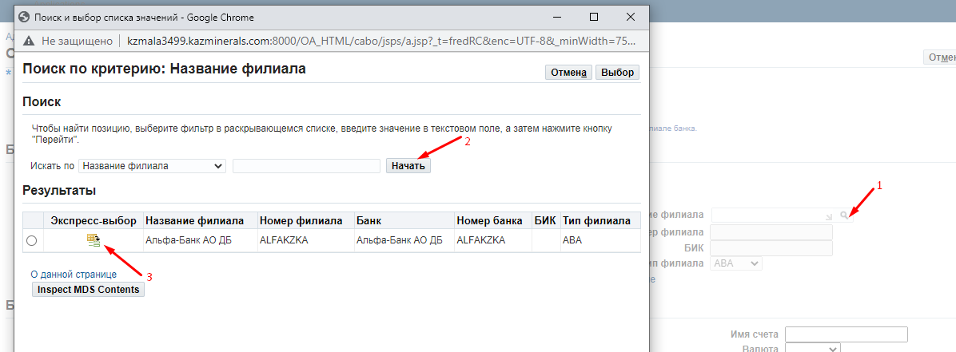
(1) in the “Bank Branch Office” field, click on the magnifying glass => in the window that opens (2) click on (К) "Start" => select the required bank branch office from the list and (3) click on (К)"Express Selection"
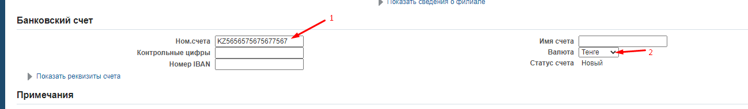
Enter the bank account number (1) in the "Account number " field.
(2) In the “Currency ” field, select bank account currency from the list.
After filling in all the required fields, press (К) Save
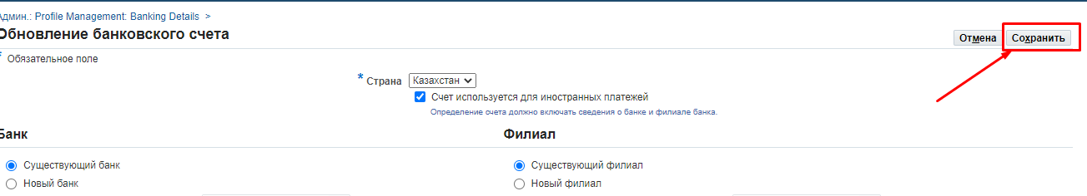

    - To edit the approved bank account, click on the pencil in the Update column.
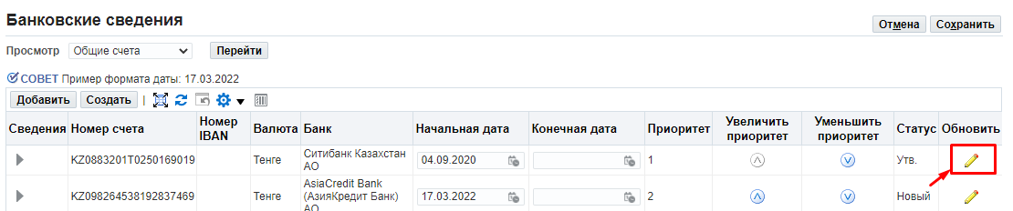

    - The following fields are available for editing in respect of an approved bank account:
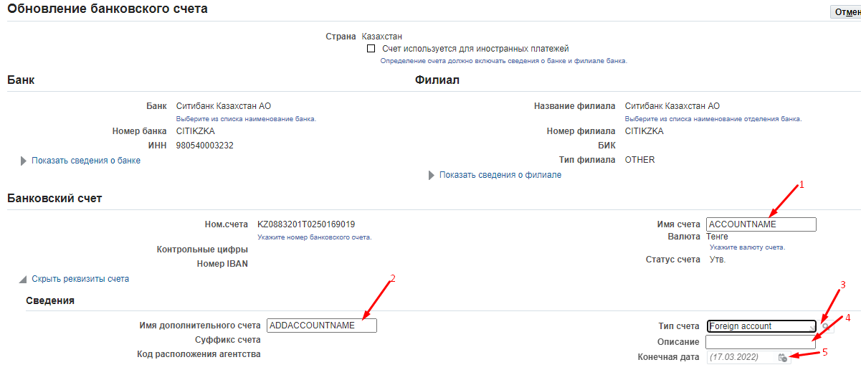
- Account name
- Additional account name
- Account Type
- Description
- Final Date

After filling in, click on (K) Save.

    - If you want to deactivate an existing bank account, in the End Date column, enter the end date next to the bank account you want to deactivate and click on (K) Save.
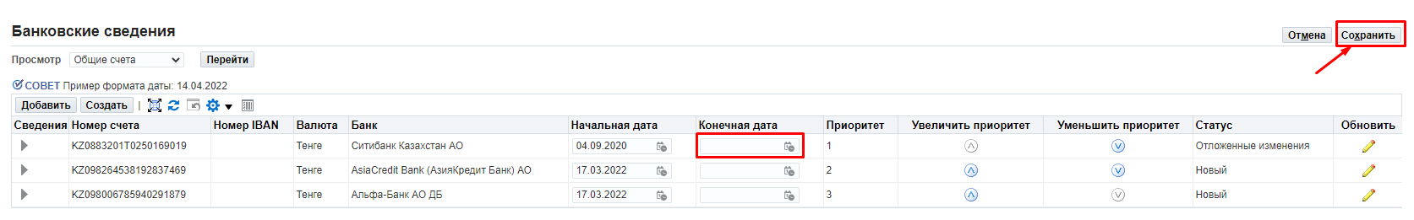

The draft of the letter to be provided by the non-resident supplier in case it is impossible to provide documents specified in Subparagraphs 2, 8, and 9

ON A COMPANY LETTERHEAD
Date _______________
To: KAZ Minerals Aktogay LLC / KAZ Minerals Bozshakol LLC (keep the required)

Confirmation of the information on the company, its business reputation and the authority of the signatory
We hereby certify that _________________ (company name) (Company) is a duly incorporated and registered organization with good business reputation (solvent, not in liquidation or bankruptcy and not having any other liabilities), and that the following information and documents are complete, valid and accurate as of the date of this letter:
1. Country of registration / residence:
2. Registration number:
3. Date of registration / incorporation:
4. Documents attached (electronic copies of originals):
4.1. The certificate of registration and / or statment of good business reputation
4.2. [Documents confirming that a person (persons) appointed as the signatory has the right to sign a contract for the supply of the offered goods / works / services on behalf of the Company, based on:
a. The Articles of Association; and / or
b. The Decision of the Board of Directors or the executive body; and / or
с. Power of attorney (or all of the above documents, jointly confirming the powers of the signatory)]
[Note to the Company: if those documents are not available or cannot be fully disclosed due to confidentiality, the Company shall replace the documents requested for in Paragraph b) above with the following]
[The Company confirms that the person (s) appointed as the signatory _________________ (state the full name and position of that authorised person) is an employee of the Company and has the right to sign contracts for supply of goods / works / services and all supporting documents on behalf of the Company.]
Information on the registration of the company and its constituent documents are available for verification and control on the following official web portal of the state registrar:
_____________________________________________________________
(Please provide a valid link to the relevant portal and include it in the text of the email).
We certify that the supporting documentation and / or information available on this website is complete, valid and accurate as of the date of this letter.

Best regards,
Signature _____________
Full name_______________
Position _________________ [Note for the Company: This letter shall be signed by persons (excluding the employee appointed as the signatory) in a position higher than the employee appointed as the signatory, who has the authority to provide such representations, for example, the Company Secretary, Directors, Executive Management, etc.]

Seal (if the Company has a seal)

For the Residents of the RoK Individual entrepreneurs and legal entities that carry out operations listed below cannot be recognized as small businesses, including micro-businesses: 1) operations related to the turnover of narcotic drugs, psychotropic substances and precursors; 2) manufacturing and (or) wholesale of excisable products; 3) grain storage operations at grain receiving units; 4) lottery holding activities; 5) operations in the field of gambling business; 6) activities related to the circulation of radioactive materials; 7) banking operations (or certain types of banking operations) and activities in the insurance market (except for insurance agent activities) 8) audit operations; 9) professional activities in the securities market; 10) credit bureau operations; 11) security operations; 12) operations related to the circulation of civilian and service weapons and ammunition for them. Medium-sized businesses are individual entrepreneurs and legal entities engaged in entrepreneurship that are not related to small and large businesses. Large business entities are individual entrepreneurs and legal entities engaged in entrepreneurship and meeting one or two of the following criteria: the average annual number of employees is more than two hundred and fifty persons and (or) the average annual revenue is more than the three million-fold monthly calculated indicator, established by the state budget law and effective as of 1 January of the corresponding financial year. For the non-residents of the RoK: Small businesses are companies with an average annual number of employees no more than 100 persons and an average annual revenue of no more than $2 million. Large businesses are companies that meet one or two of the following criteria: the average annual number of employees is more than 250 persons and/or the average annual revenue is more than $21 million. Medium businesses are companies that are not small and large businesses.
KBE is a 2-digit code. For the residents of the Republic of Kazakhstan, this field is to be from 11 to 19, and for the non-residents from 21 to 29. The first digit means residence (1 - resident, 2 - non-resident). The second digit is the supplier's economic sector code: 1 - Central Government 2 - Regional and local governments 3 - Central (national) banks 4 - Other depository institutions 5 - Other financial institutions 6 - State non-financial institutions 7 - Non-state non-financial institutions 8 - Non-profit organizations serving households 9 – Households.
For this field, the controls are set to check: 1) for the residents of the Republic of Kazakhstan, the value in this field is 20 characters; 2) for non-residents it is up to 30 characters; 3) this field can contain only numbers and Latin letters.

