APPROVED BY
Director,
Procurement Department KAL/KBL
KAZ Minerals Management LLC
Christopher J. Brodie
___ __________ 20___

USER GUIDE

Creating a Response to Request for Quotation RFQ and Request for Information RFI
Oracle IS, version 12.2.7.

Drafted by:
Head of the Methodology Section of the Procurement Support Division, SCM Department
KAZ Minerals Management LLC
К.А. Abildinova

Created on: 14 March 2022
Updated on: 15 July 2022

Almaty, 2022

Table of Changes
36
Date | Created by | Revision | Description of changes
00033 | Gorbunov D., Karanovich A, Pyatkov A., Belykh L.
14.03.2022 | K. Abildinova | 1.0 | New document
15.07.2022 | K. Abildinova | 2.0 | Making changes and amendments based on the results of the pilot operation and developments in the Oracle IS

Contents

1. PURPOSE AND SCOPE 4
2. ROLES AND RESPONSIBILITIES 4
3. BACKGROUND EVENTS 4
4. DETAILED STEPS 4
4.1. Creating a Response to Request for Quotation (RFQ) for Goods. 4
4.1.1. Reviewing data in Request for Quotation (RFQ) 4
4.1.2. Correspondence and discussion on Request for Quotations (RFQ) 10
4.1.3. Creating a Response to Request for Quotation (RFQ) via the web page 12
4.1.4. Creating a Response to Request for Quotation (RFQ) using a spreadsheet 17
4.2. Creating a Response to Request for Quotation (RFQ) for Works and Services. 29
4.2.1. Reviewing data in Request for Quotation (RFQ) 29
4.2.2. Correspondence and discussion on Request for Quotations (RFQ) 35
4.2.3. Creating a Response to Request for Quotation (RFQ) via the web page 37
4.3. Creating a Response to Request for Information (RFI) for Goods. 42
4.3.1. Reviewing data in Request for Information (RFI) 42
4.3.2. Correspondence and discussion on Request for Information (RFI) 48
4.3.3. Creating a Response to Request for Information (RFI) ia the web page 50
4.3.4. Creating a Response to Request for Information (RFI) using a spreadsheet 55
4.4. Withdrawing a Response to Request for Quotation RFQ / Request for Information RFI 64

PURPOSE AND SCOPE

This User Guide describes how to work in the Supplier Sourcing module of Oracle, Version 12.2.7, and presents the detailed steps for creating a Response to Request for Quotation (RFQ) or Request for Information (RFI).
Requests for Quotation (RFQ) are used to monitor the market and search for potential suppliers of goods and services.
Requests for Information (RFI) are used to conduct preliminary market monitoring, determine/clarify technical characteristics, cost and other data on goods and services for subsequent procurement activities.
For each of these documents, there is a deadline for providing a response.

ROLES AND RESPONSIBILITIES

In order to create responses to Requests for Quotation (RFQ) or Requests for Information (RFI), the potential supplier must have the Sourcing Supplier responsibility.
For full-scale work in Oracle IS and correct creation of responses, the use of the default English interface is recommended.

BACKGROUND EVENTS

The goods, work and service procurement specialist has generated and published a Request for Quotation (RFQ) or a Request for Information (RFI).

DETAILED STEPS

Creating a Response to Request for Quotation (RFQ) for Goods.

Reviewing data in Request for Quotation (RFQ)
      - After the Request for Quotation (RFQ) is published, potential suppliers will be notified via email and the Worklist.
      - Follow to the said message in the Oracle IS
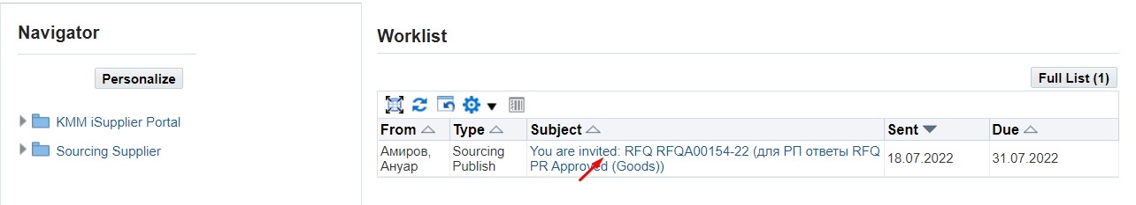
      - In the form that opens, you can confirm your participation in the Request for Quotations (RFQ) by clicking on (K) Yes (2); in this case, the system will automatically create a draft response, the notification will disappear and for further work on the creation of the response, you will need to go to the responsibility Supplier Sourcing > Sourcing > Sourcing Home Page.
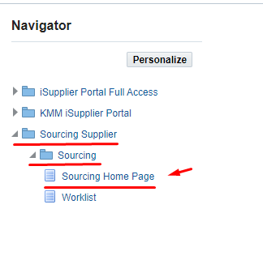
Or you can immediately refuse the invitation by indicating the reason in the Note to Buyer field (3) and clicking on (К) No (4)
      - Before making a decision to participate in the Request for Quotations (RFQ), it is recommended that you view and read the details by clicking on the entry Negotiation Details (1).
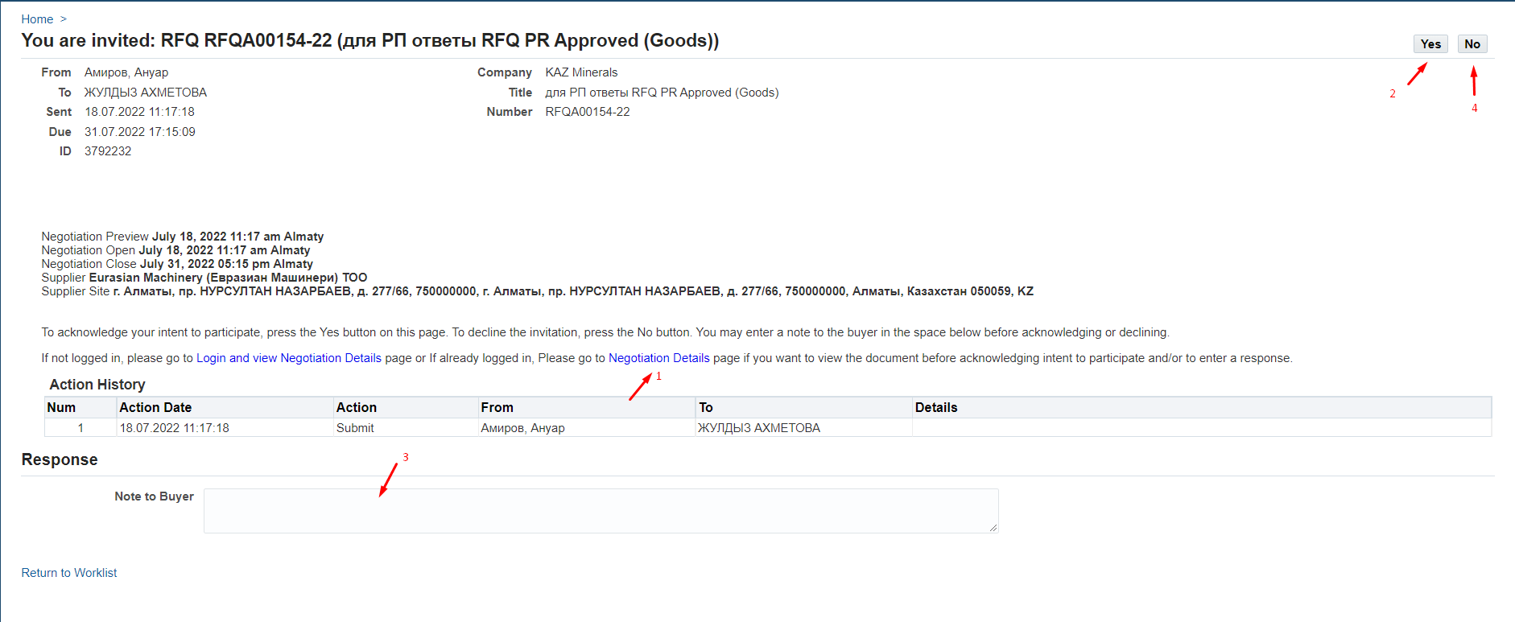
      - In the form that opens, please pay attention to the date in (P) Time Lef, which indicates the number of days and hours until the closing date for receiving answers in (P) Close Date.
Please be guided by the indicated time when preparing your response.
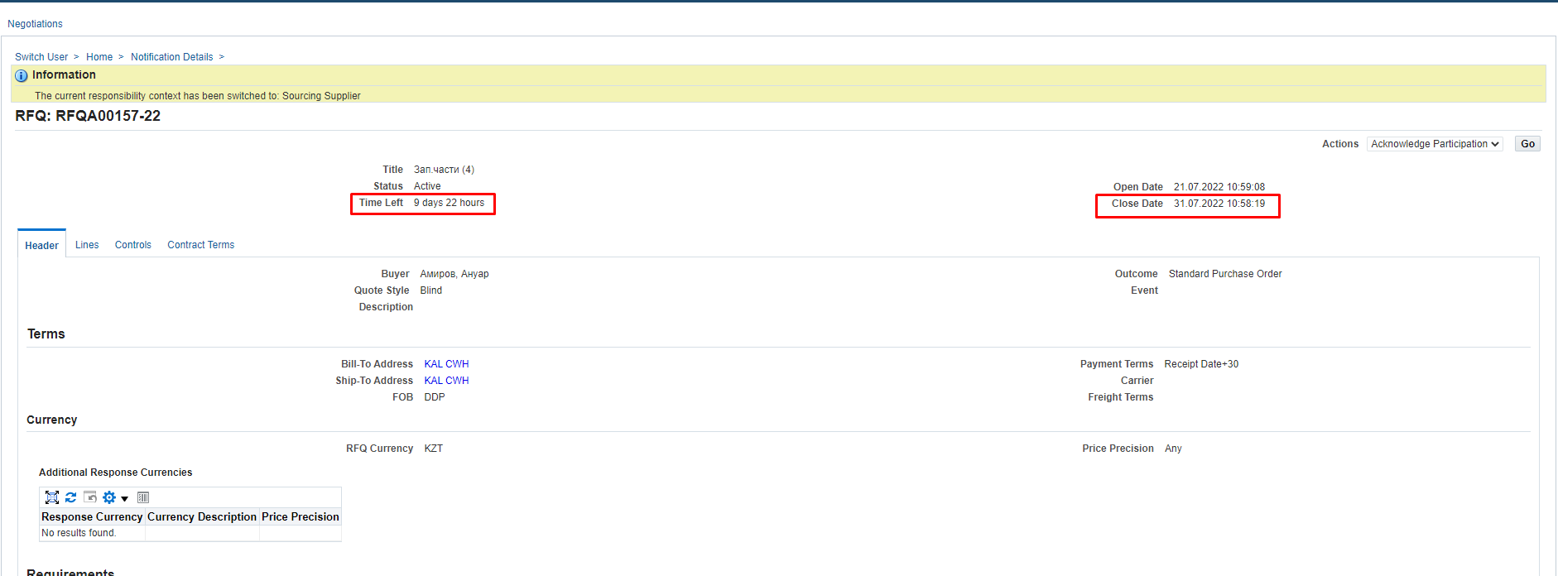
      - The Header tab displays all general information on the Request for Quotations (RFQ).
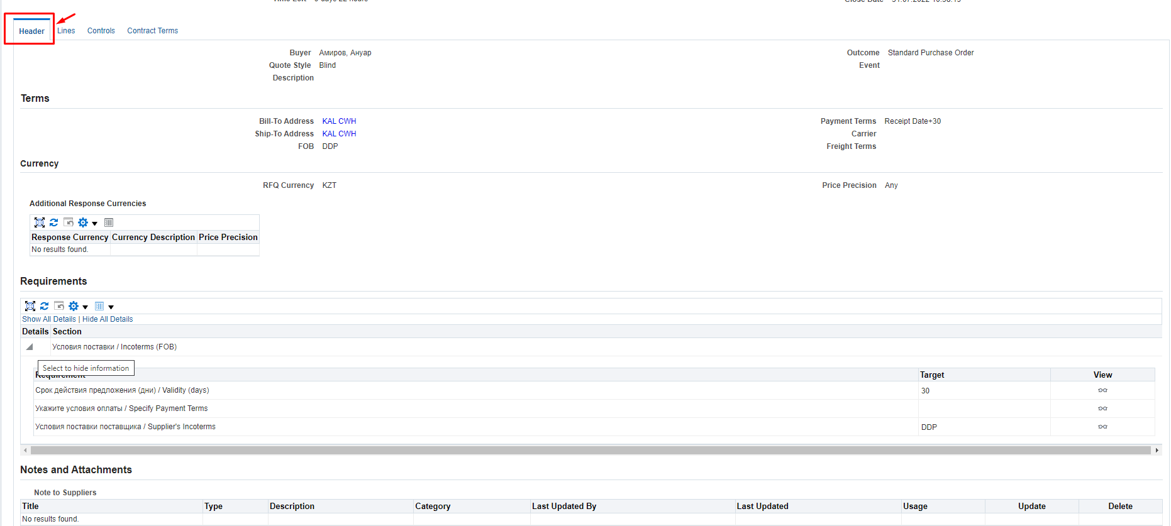
      - Be sure to review the Requirements section, which displays the Request for Quotation (RFQ) requirements. Click on (К) Show All (1). And also pay attention to which requirements are mandatory, and which are for information or optional (non-mandatory) for filling in. Press (K) Vew (2) for each requirement.
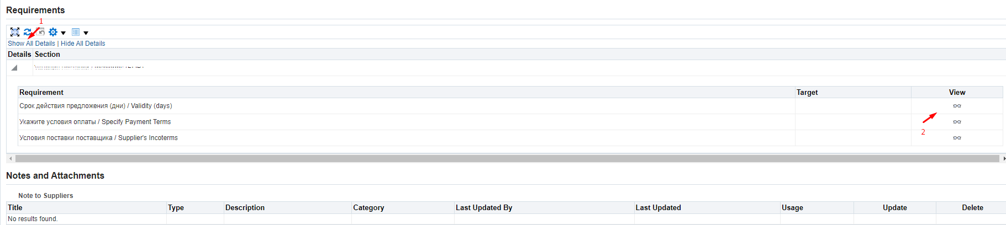
      - (P) Type (1) specifies a value depending on how you should respond to this requirement. Responses may be mandatory or optional. Or the attribute may be for information only.
In (P) Value Type (2), the response format is indicated: date, numeric value, text or link.
(P) Target indicates the target value (if any)
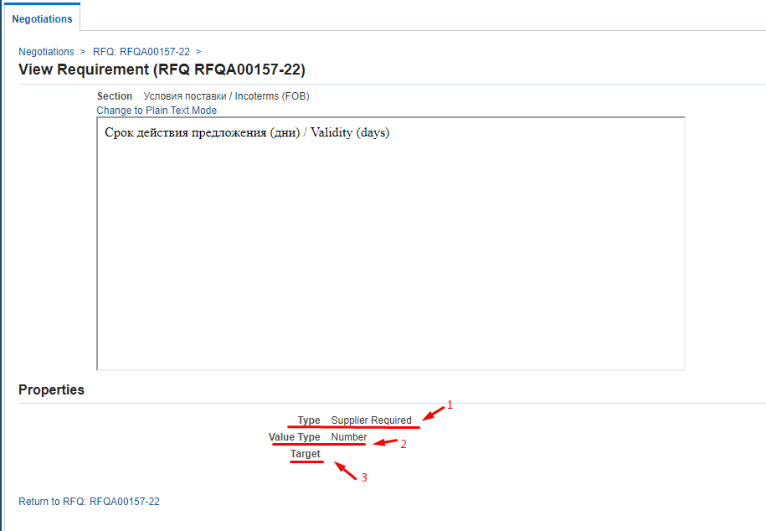
      - To view attachments to the Request for Quotation (RFQ) in the Notes and Attachments section, go to the document name in (P) Title
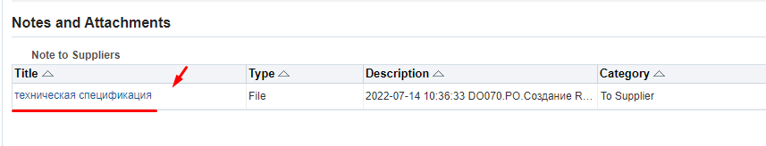
      - To review additional specifications in the Lines (1) tab, go to Description (2)
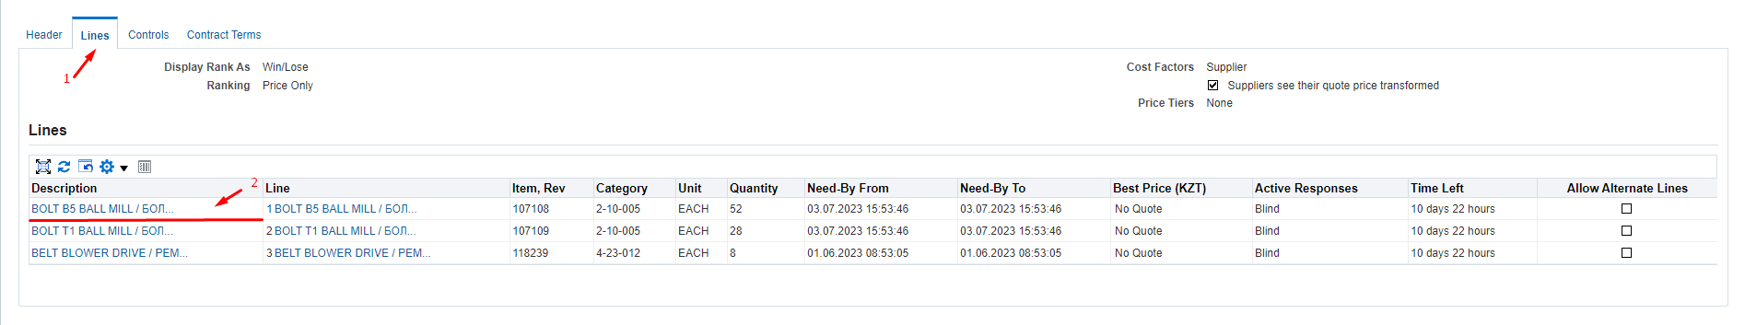
      - In the form that opens, in (P) Quantity (1), specify the quantity for the item. The Attribute column (2) indicates an additional list of attributes using which you need to view in (P) Attribute Type which attributes are mandatory, for information, or optional (not mandatory) and using (P) Value Type view the response format.
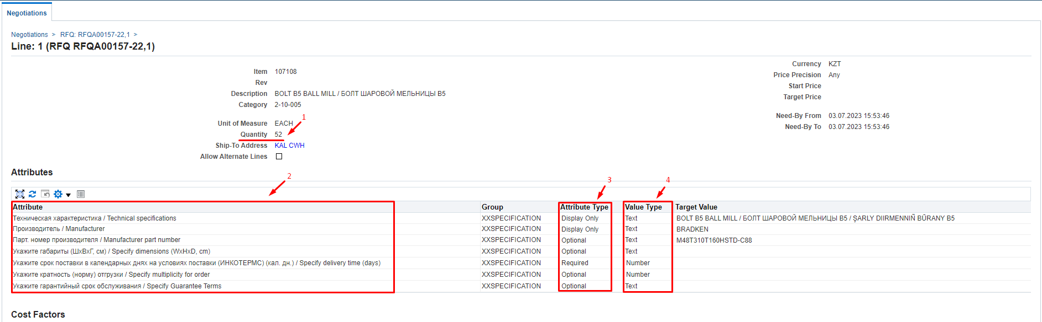
      - To return to view the next line, please click on the Request for Quotation (RFQ) number on the left side of the form.
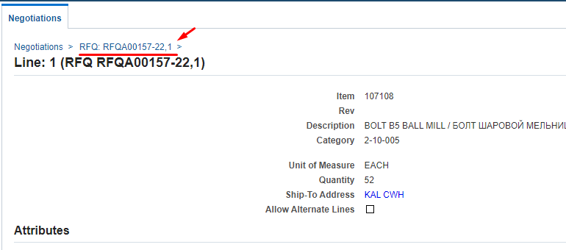
      - On the Controls tab (1), review the response rules that were set when the Request for Quotations (RFQ) was being generated
Negotiation is restricted to invited suppliers – if the box is checked, then the provision of responses to the Request for Quotations (RFQ) is limited only to invited suppliers, if the box is not checked, then responses can be received from any suppliers.
Suppliers are allowed to respond to selected lines – if the box is checked, then suppliers are allowed to respond to individual lines in the Request for Quotations (RFQ), if the box is not checked, then suppliers must provide a response only exclusively to all the lines in the Request for Quotations (RFQ).
Suppliers are required to respond with full quantity on each line – if the checkbox is checked, then suppliers must send responses with the full quantity indicated on the line.
Suppliers are allowed to provide multiple responses – if the box is checked, then suppliers are given the option to submit several responses during the opened period, of which only one can be active. When this box is checked, another rule may be displayed:
Suppliers are allowed to submit Multiple Active Responses – if the box is checked, then suppliers are given the option to quote the price once or multiple times (or revise their response) and each latest quote will be an active proposal.
Allow Quote Withdrawal – if the box is checked, all suppliers are allowed to withdraw their responses after they have submitted them. Quotes can only be withdrawn before the closing date. Withdrawn quotes may be revised as required by the request and may be updated by the supplier. The withdrawn proposal will not be visible to the Procurement Specialists during the evaluation and selection process.
Buyer may close the negotiation before the Close Date – if the checkbox is checked, then the Buyer may close the submission of responses before the set closing date, if necessary.
Buyer may manually extend the negotiation while it is open – if the box is checked, then the Buyer can extend the deadline for providing responses, if necessary. The deadline can only bet extended till the closing date.
Allow Alternate Lines on Supplier Responses – if the checkbox is checked, then the supplier is allowed to offer an alternative item and add a new line in the quote.
Allow Staggered Awarding - if the box is checked, then for this Request for Quotations (RFQ) it will be possible to select several winners for different items.
      - On the Contract terms tab, please read the terms and conditions of the Purchase Order by clicking on (К) Preview Contract Terms
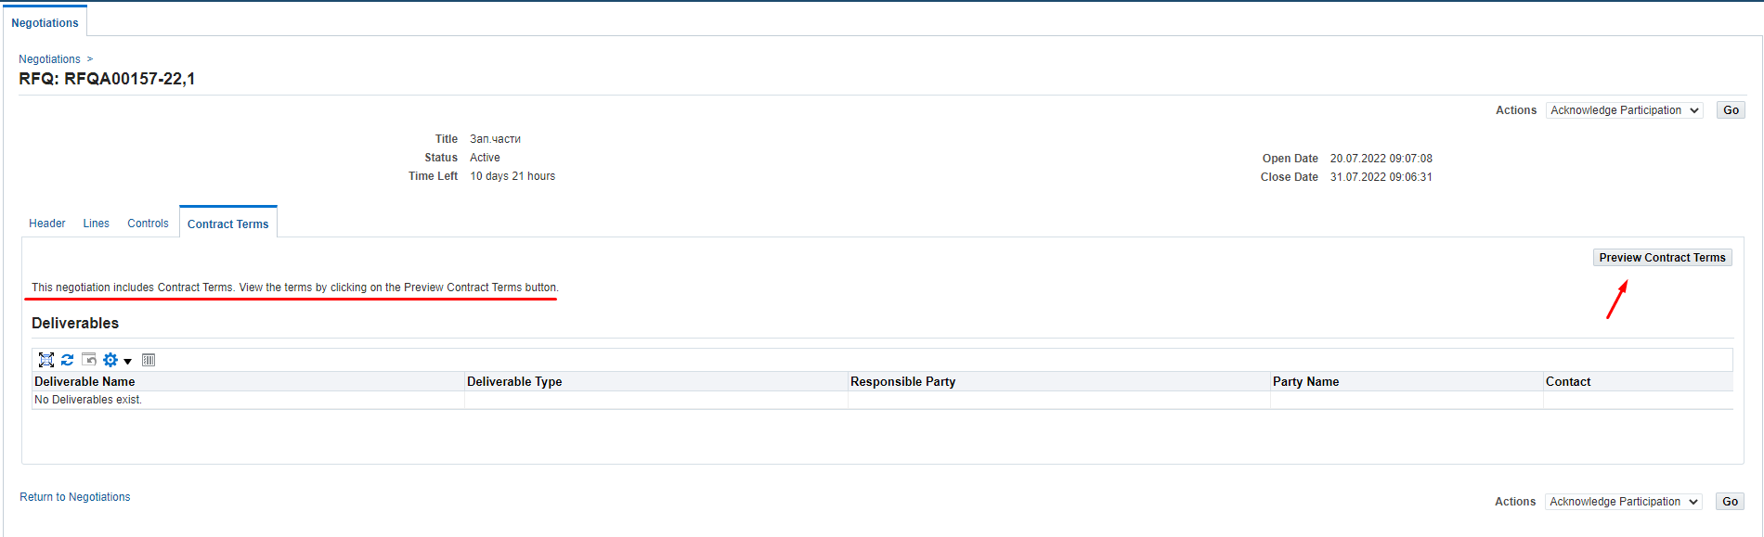
Open the downloaded PDF document and read the terms of the Purchase Order
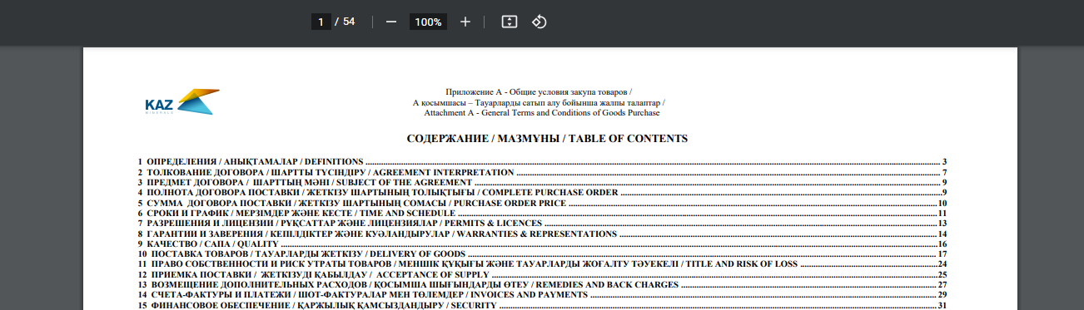
      - You can also review all data on the Request for Quotation (RFQ) by downloading the printed form. In (P) Action (1), select the Printable View (2) value from the dropdown list and press (K) Go (3)
Open the downloaded file
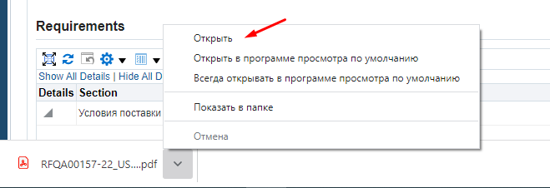
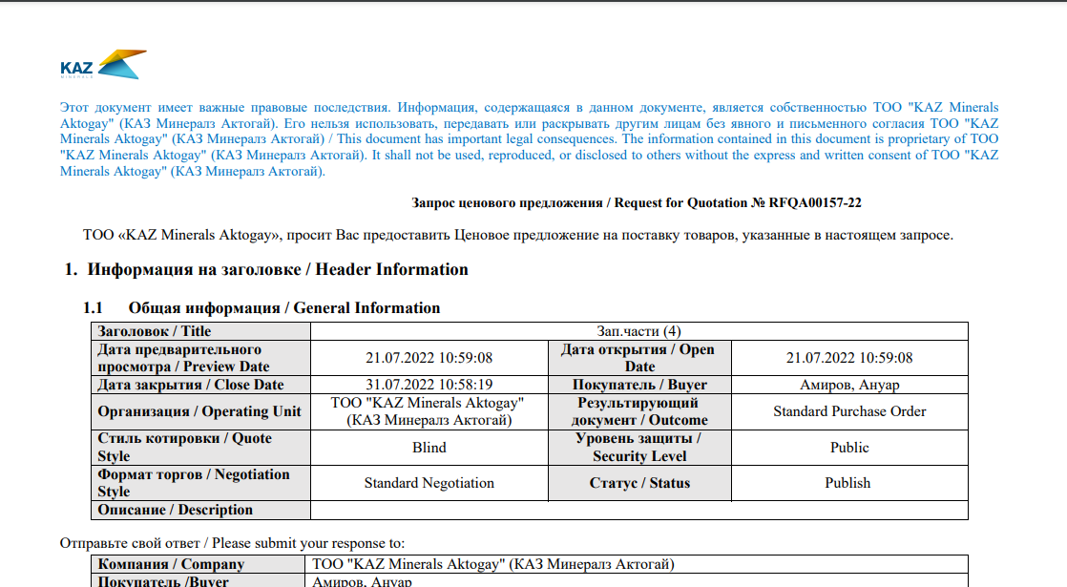

Correspondence and discussion on Request for Quotations (RFQ)
      - If you need to send a request to clarify some details in respect of the Request for Quotation (RFQ) after its review and examination, select the Online Discussion (2) value and click (K) Go (3) in (P) Action (1).
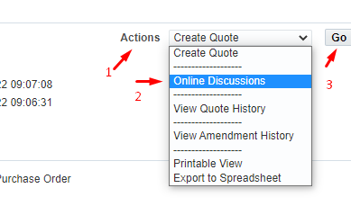
      - In the window that opens, click on (К) New Massage
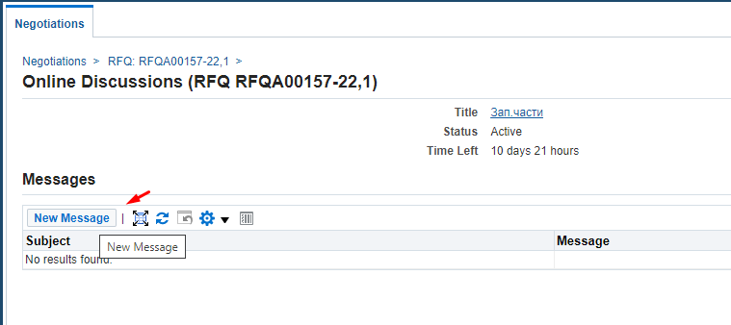
      - In (П) Subject (1), enter the subject of the message, in (П) Message (2), enter the text of the message. If necessary, attach documents - Attachment (3) - and click (К) Send (4)
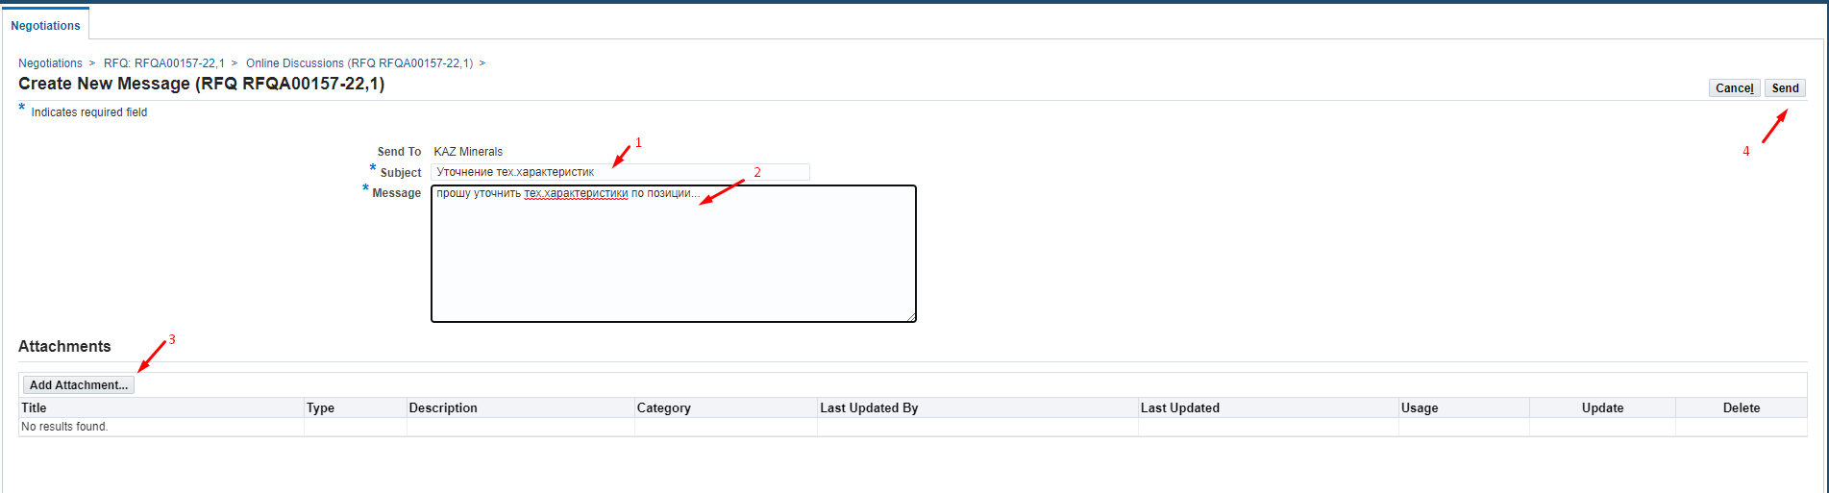
      - To return to the home page, click Home or on the left side of the Negotiations window
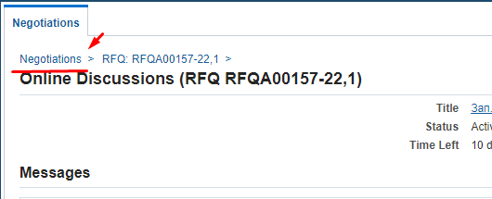
      - You will receive a notification that your request has been responded via e-mail and the worklist in Oracle IS.
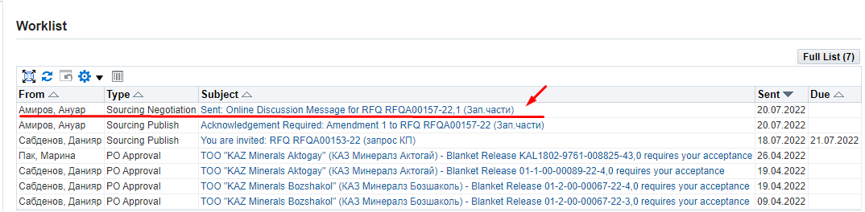
      - In the notification you will see the response to your request (1) and to view the details and attachments (if any) click on (К) here (2)
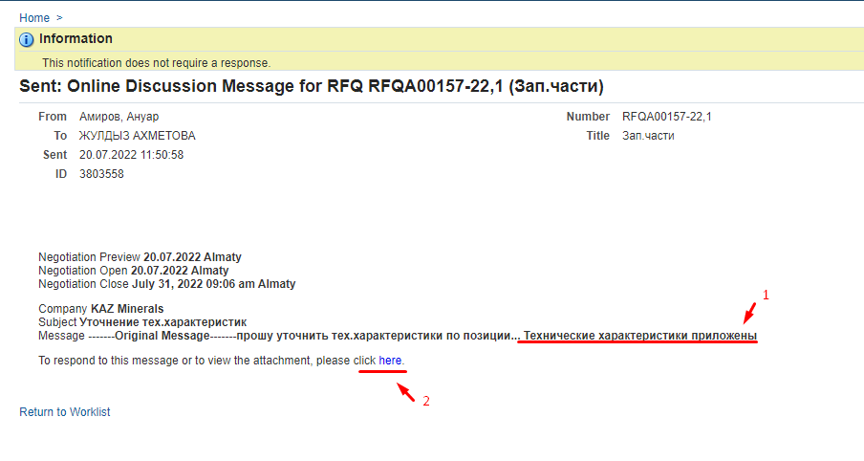
      - If you need to continue the correspondence, click on (К) Reply
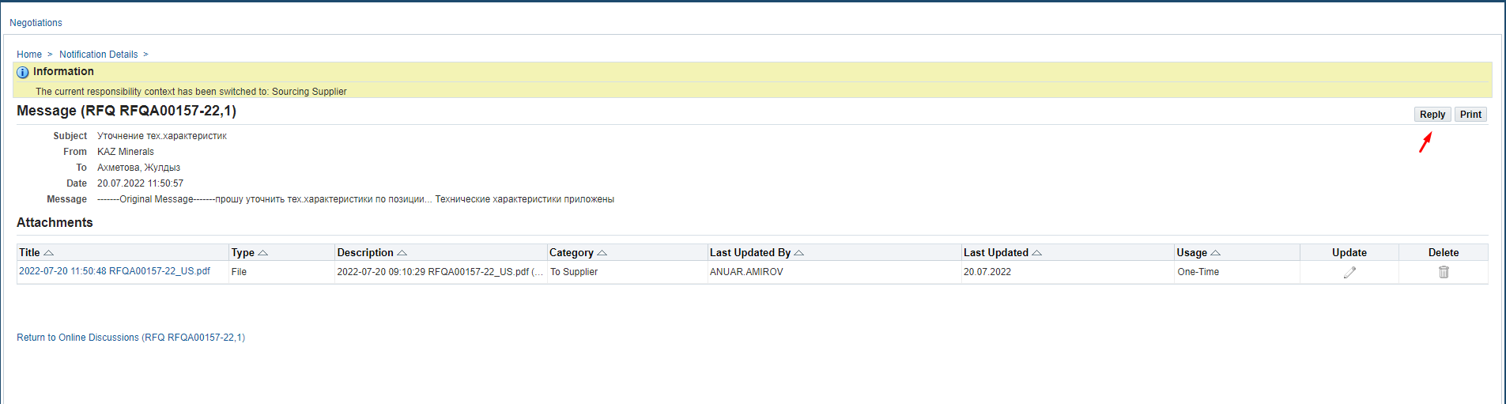

Creating a Response to Request for Quotation (RFQ) via the web page
      - If you need to response in respect of the Request for Quotation (RFQ), in (П) Action (1), select the Create Quote (2) command and click on (K) Go (3)
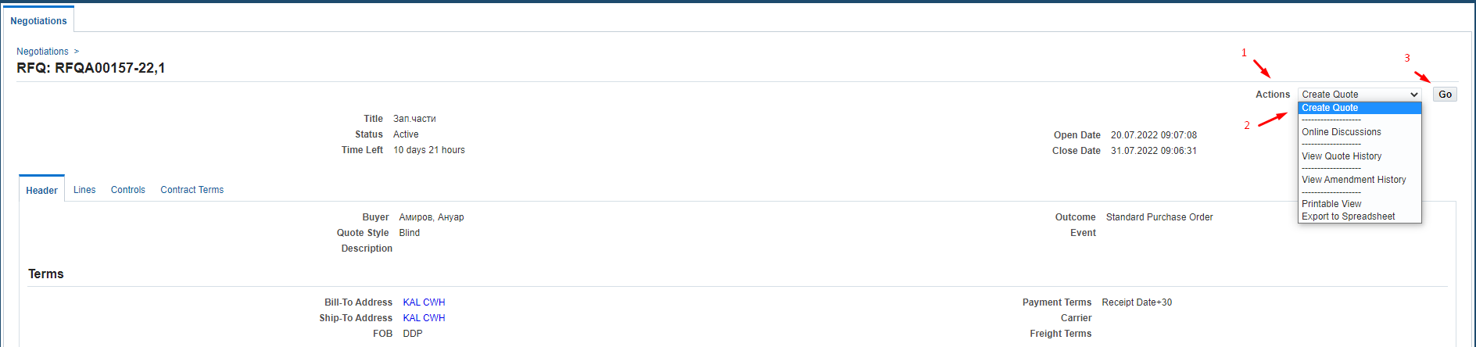
      - In (R) Quote Valid Until, enter the valid date for the quote. Click on Calendar (1) > select a date (2) > click on (К) Select (3)
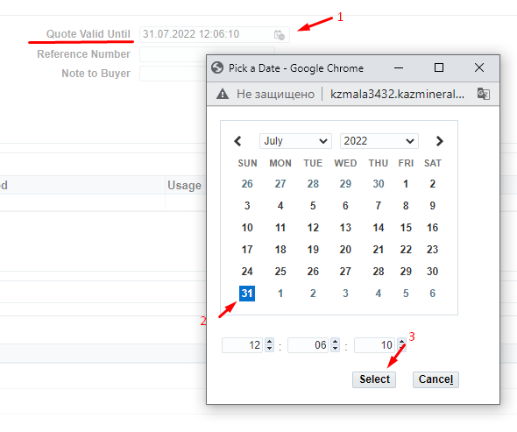
      - For non-residents of the Republic of Kazakhstan, in (P) Quote Currency, you should select the response currency from the drop-down list.
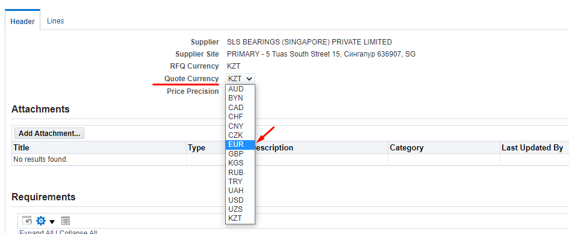
      - If necessary, you can specify any comment for the Buyer in (P) Note to Buyer (1) and/or attach documents using Add Attachment (2)
The availability of attached scans of technical specifications, certificates, technical documentation and other details increases your chances of becoming a contract awardee, when a winning quotation is selected.
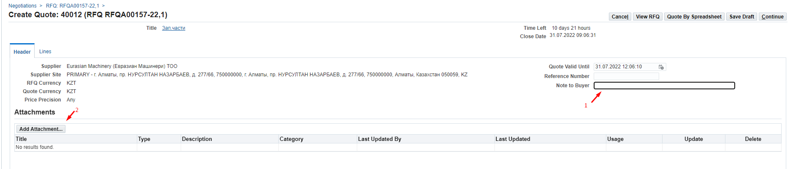
      - If you need to attach any documents, click (К) Attachment.
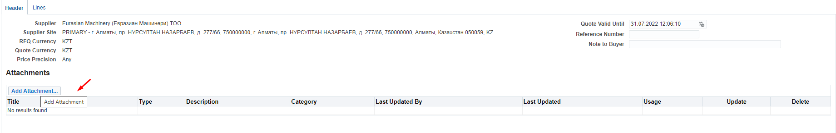
      - In (P) Title (1), enter a short description of the document; in (P) Description (2), enter a detailed description of the document and press (K) Select file (3)
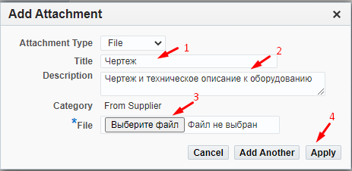
Select the necessary document and press (К) Open 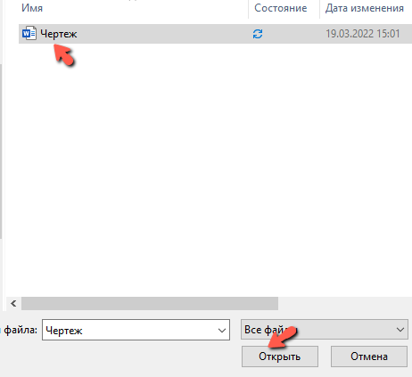
After uploading press (K) Apply (4)
      - In the Requirements section, you must enter the data on the values that require your response. To view the full list of requirements, you can click on the Expand All link
Please pay attention to the response format (numeric, text, drop-down list, etc.).
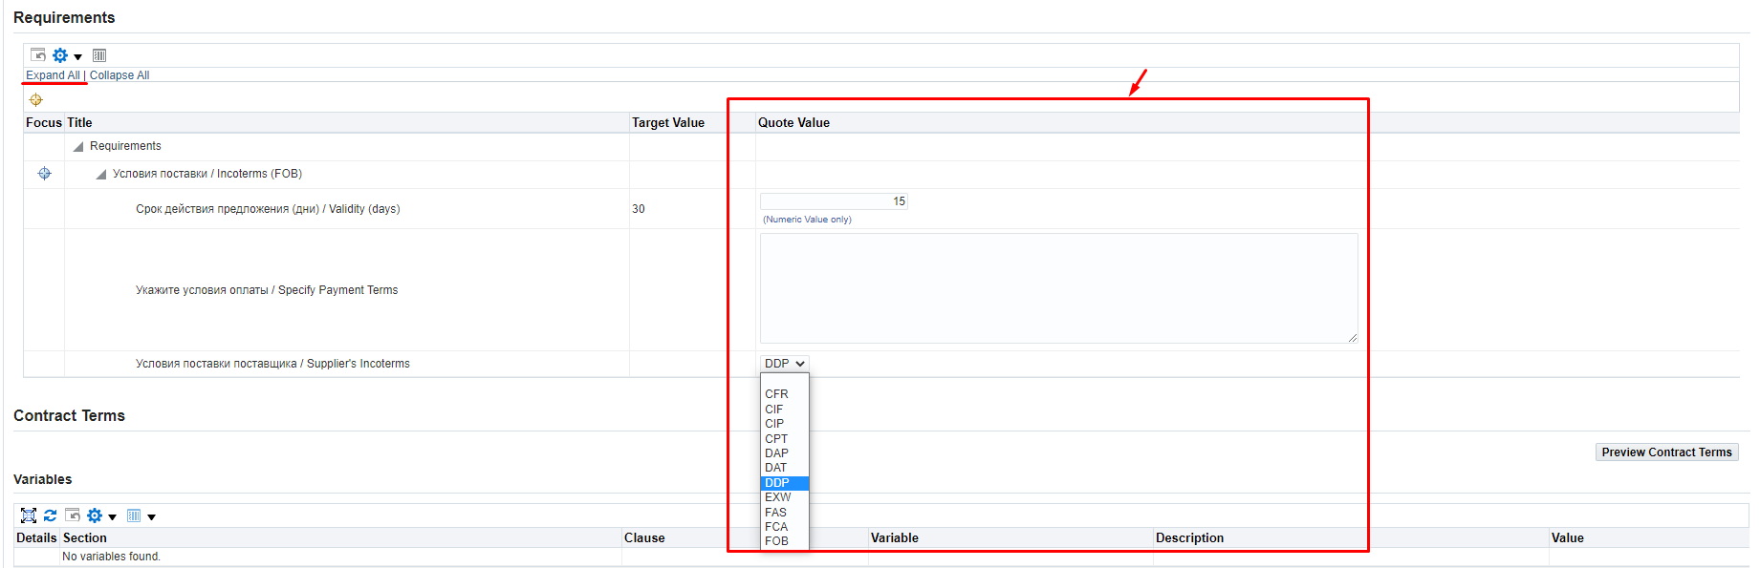
IMPORTANT! If in the response to the terms of delivery, you indicated EXW or FCA, when filling in the data on the Header in the requirements, then you must fill in the data for each line in the attribute “Specify dimensions (WxHxD, cm) / Specify dimensions (WxHxD, cm)”
If the specified data is not filled in, the following error will occur when you will be sending the response.
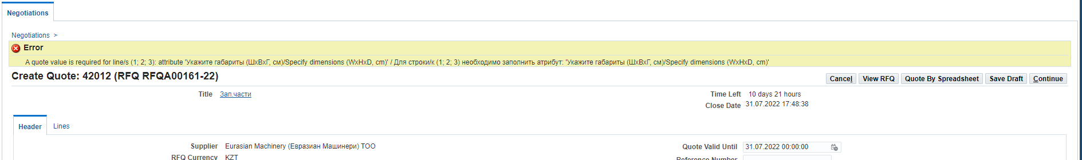
      - Go to the Lines tab to populate data related to the lines
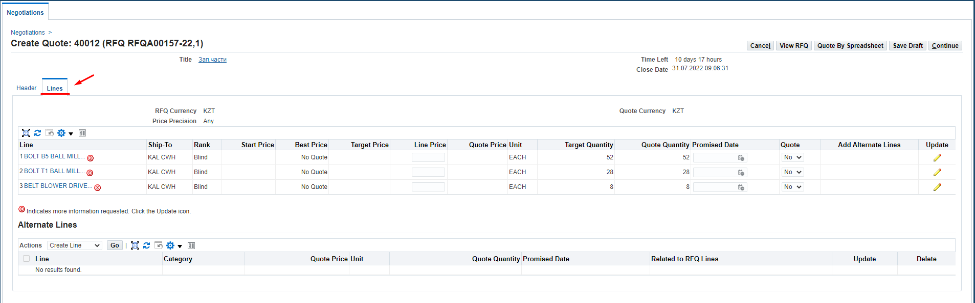
      - Please note that if the icon is indicated on the line, then there is additional information that needs to be filled in.
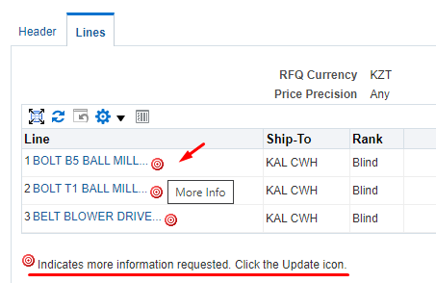
      - To fill in the data for additional information on the line, click on (К) Update
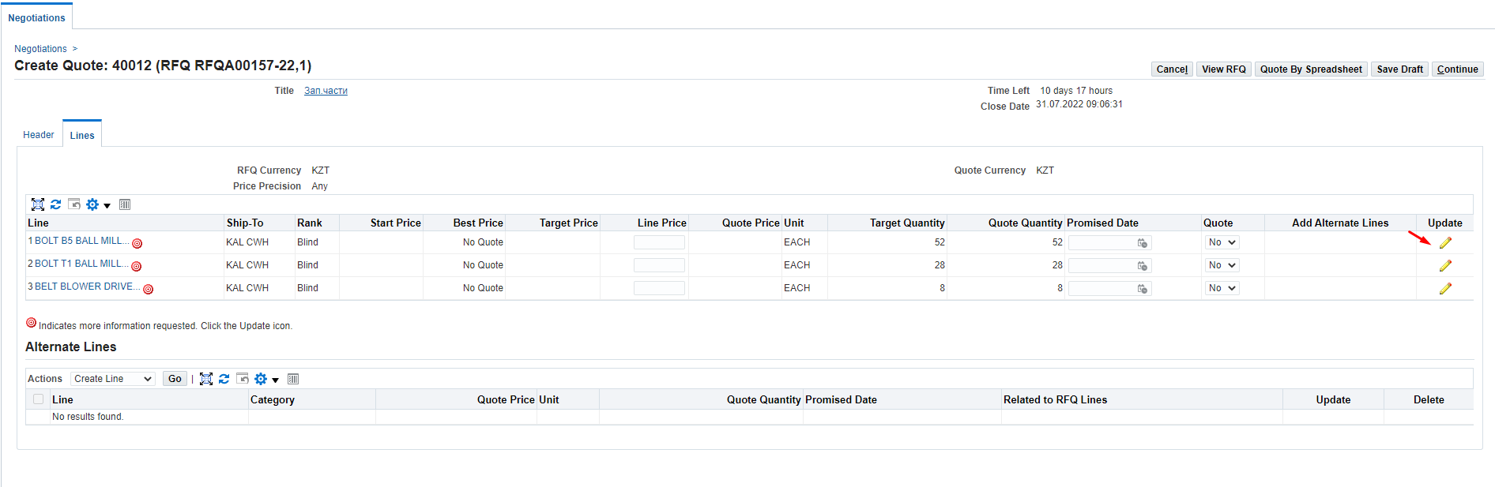
      - In the Quote Value (1) column, fill in the data taking into account the format of the response.
Attributes for which the Required (2) response format is specified must be mandatorily filled in.
IMPORTANT! If in the response to the terms of delivery, you indicated EXW or FCA, when filling in the data on the Header in the requirements, then you must fill in the data for each line in the attribute “Specify dimensions (WxHxD, cm) / Specify dimensions (WxHxD, cm)” (3
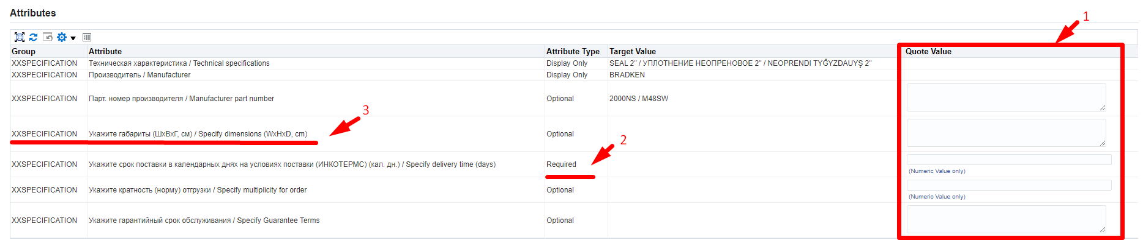
      - If in respect of “Manufacturer part number” (1) attribute in the Target Value (2) column of the Request for Quotation (RFQ), incorrect information is specified, you can update it by entering a new value in the Quote value (3) field.
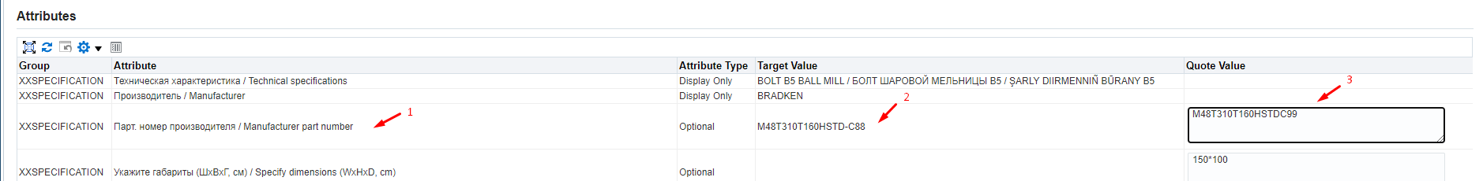
      - In respect of (P) Line Price in (P) Quote Value (1), specify the price in the currency of the response under the delivery terms of the response and excluding VAT.
IMPORTANT! Do not change or delete data in the Delivery Cost line !!!
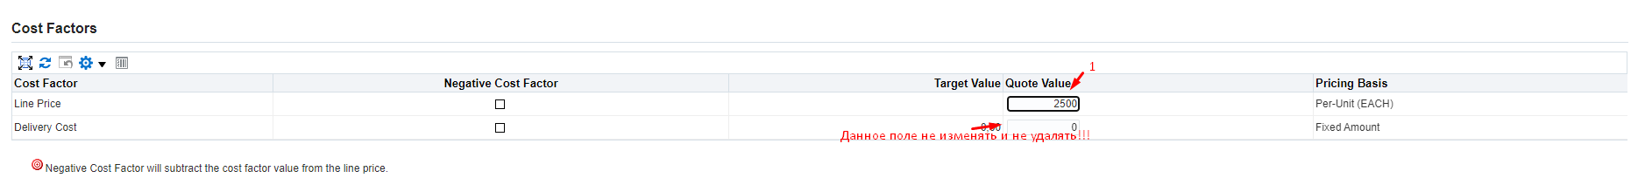
      - To go to the next line in (P) Line (1), click on (К) Go (2)
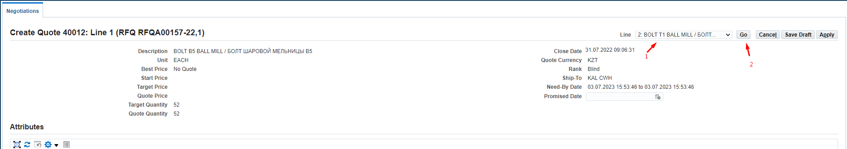
      - After filling data in the last line, click on (К) Apply
      - Please double check all the information you entered on Header and Lines before submitting your response and click on (К) Continue..
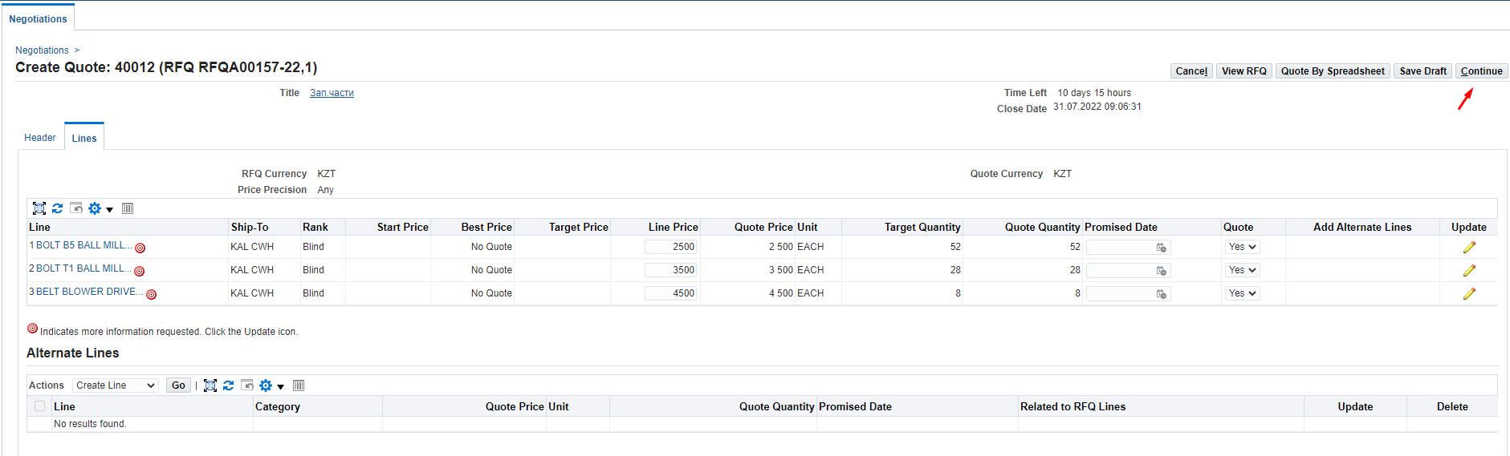
      - For non-resident suppliers of the Republic of Kazakhstan, and if the response currency is not KZT, the following warning will be displayed. If the currency of the answer is chosen by you correctly, click on (К) Yes.
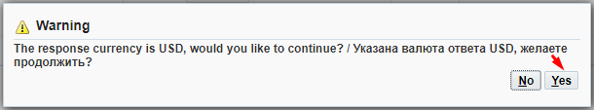
If you made a mistake and indicated an incorrect response currency in the response, press (K) No and return to the response header (Header) to select the correct currency. And, if you made a mistake and entered line prices in the wrong currency, please go back to the Lines and change the prices following the steps above.
      - Then click on (К) Submit
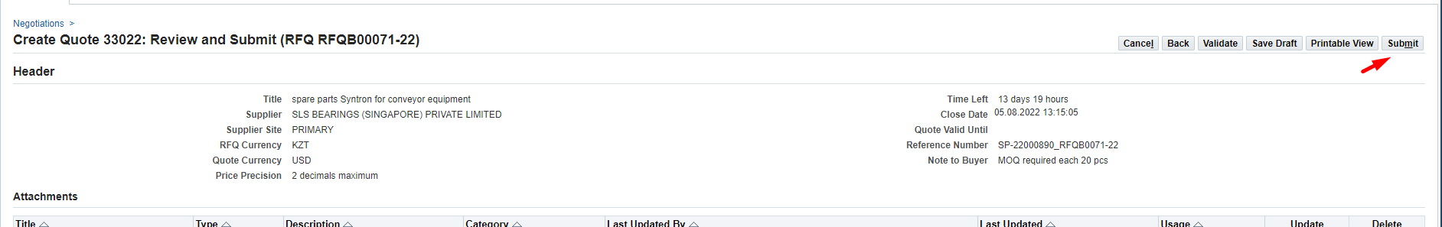
      - After the sending, the following message will appear
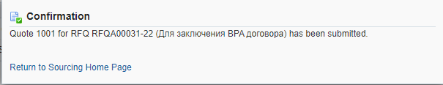

Creating a Response to Request for Quotation (RFQ) using a spreadsheet
      - If you need to response in respect of the Request for Quotation (RFQ), in (П) Action (1), select the Create Quote (2) command and click on (K) Go (3)

      - In (R) Quote Valid Until, enter the valid date for the quote. Click on Calendar (1) > select a date (2) > click on (К) Select (3)
      - For non-residents of the Republic of Kazakhstan, in (P) Quote Currency, you should select the response currency from the drop-down list.
      - If necessary, you can specify any comment for the Buyer in (P) Note to Buyer (1) and/or attach documents using Add Attachment (2)
The availability of attached scans of technical specifications, certificates, technical documentation and other details increases your chances of becoming a contract awardee, when a winning quotation is selected.
      - If you need to attach any documents, click (К) Attachment.
      - In (P) Title (1), enter a short description of the document; in (P) Description (2), enter a detailed description of the document and press (K) Select file (3)
Select the necessary document and press (К) Open
After uploading press (K) Apply (4)
      - For non-residents of the Republic of Kazakhstan, in (P) Quote Currency, you should select the response currency from the drop-down list.
      - Click on (К) Quote By Spreadsheet to download the spreadsheet.
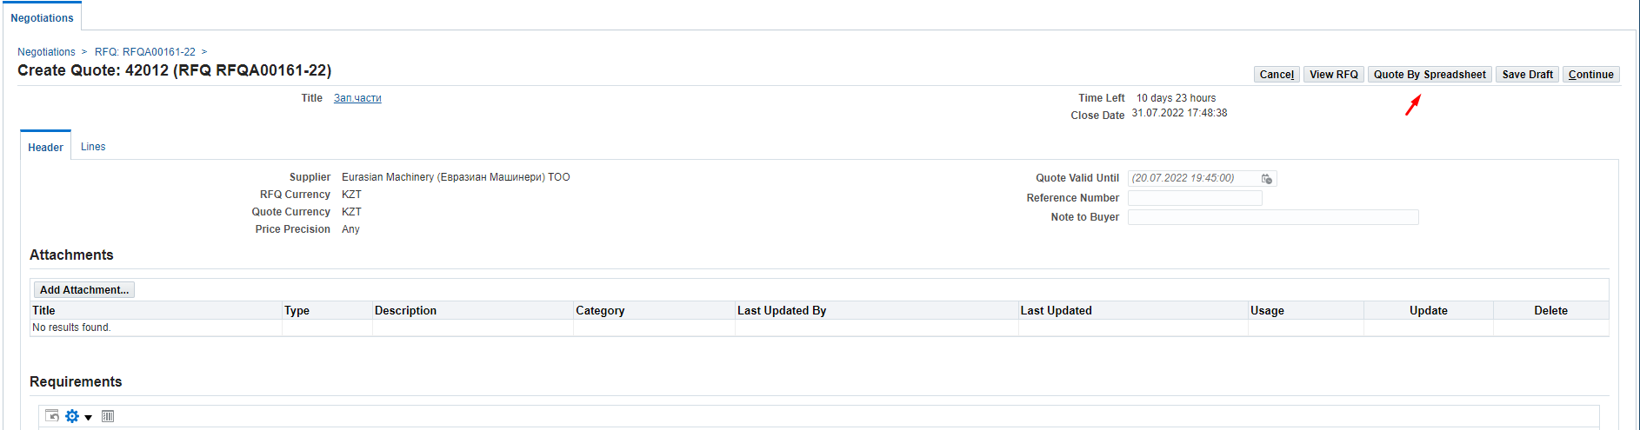
      - In the window that opens, click on (К) Export
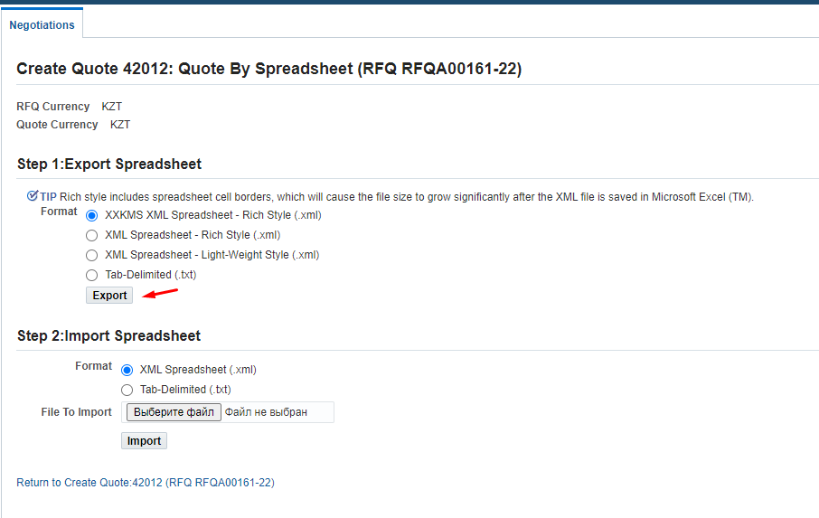
      - The following message will be displayed for Requests for Quotations (RFQs) with a large number of lines. Follow the record “You may check the Request Status on the Download Requests page”.
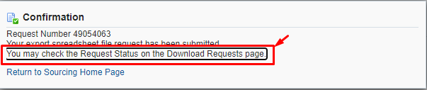
      - Go to and open the archived file in (P) Download
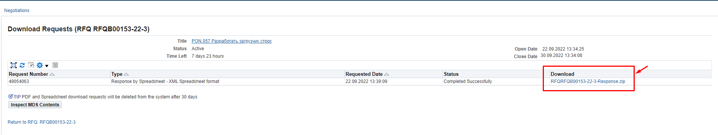
      - Click on (К) Open in the downloaded file
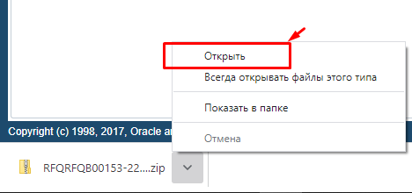
      - The XML file from the zipped folder must be copied and pasted to the desktop.
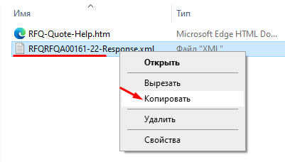
      - XML file must be opened with Open with (1) in the Excel (2) format
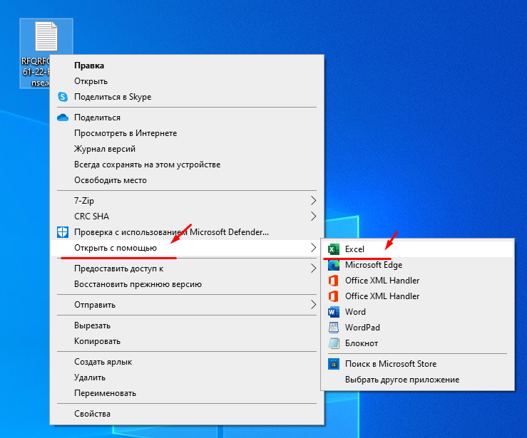
      - If your XML files open by default in a different format, then right-click Excel (1), check the box "Always use this application when opening .xml files" (2) and click (К) OK.
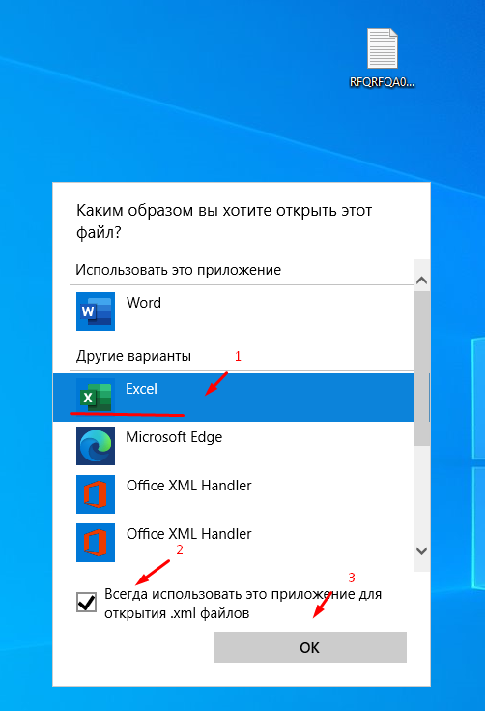
      - All cells in the opened file highlighted in yellow are mandatory for filling in. Cells highlighted in green are optional (not mandatory) for filling in.
      - In the Requirements section, you must enter the data on the values that require your response.
IMPORTANT! If in the response to the terms of delivery, you indicated EXW or FCA, when filling in the data on the Header in the requirements, then you must fill in the data for each line in the attribute “Specify dimensions (WxHxD, cm) / Specify dimensions (WxHxD, cm)”
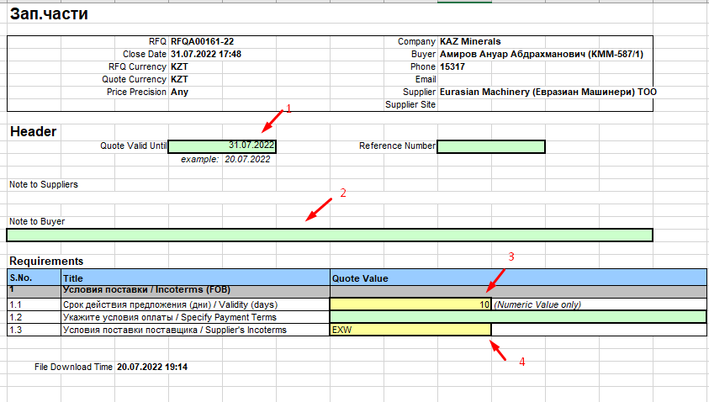
      - Go to the Lines (1 - …) list to populate data related to the lines
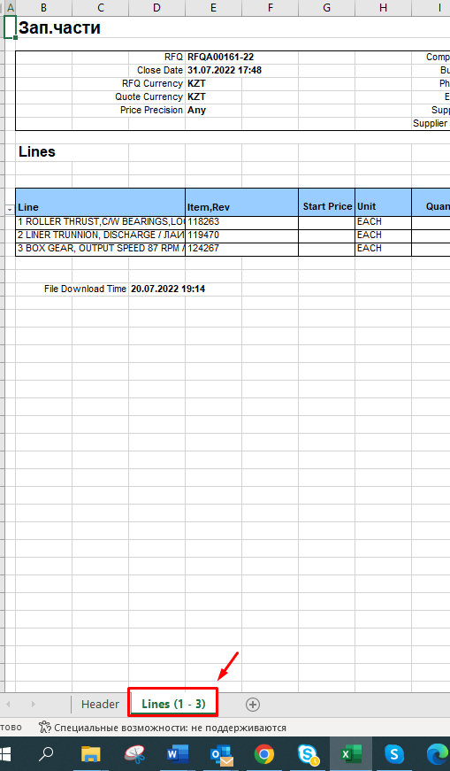
      - Populate data related to the lines: highlighted in yellow are mandatory for filling in; highlighted in green are optional (not mandatory) for filling in.
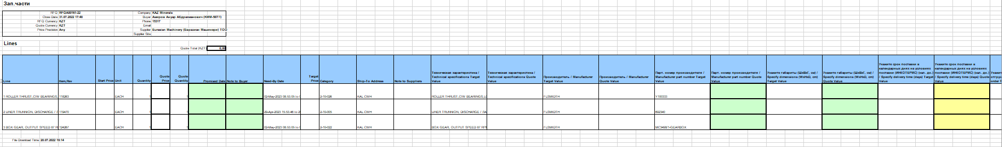
Enter data in the required fields for each line:
Specify (INCOTERMS) delivery time (calendar days) Quote Value
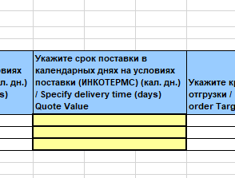
Line Price, Pricing Basis=Per-Unit, Target Value=
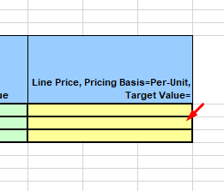
IMPORTANT! If in the response to the terms of delivery, you indicated EXW or FCA, when filling in the data on the Header in the requirements, then you must fill in the data for each line in the attribute “Specify dimensions (WxHxD, cm) / Specify dimensions (WxHxD, cm)”
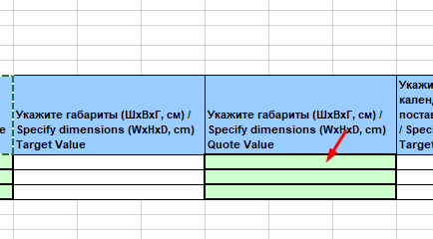
If the specified data is not filled in, the following error will occur when you will be sending the response.
      - If in respect of THE “Manufacturer part number Target Value attribute, incorrect information is specified, you can update it by entering a new value in the Manufacturer part number Quote value field.
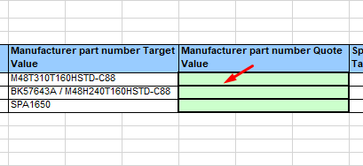
      - After filling in the data, close and save the file.
      - Return into the system and in the Step 2 section: Import Sreadsheet, click on (K) Select the file
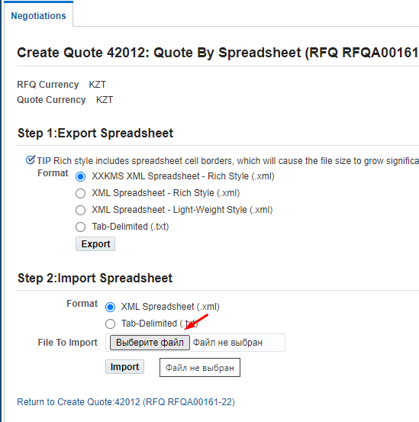
      - Select the XML file saved earlier and click on (К) Open
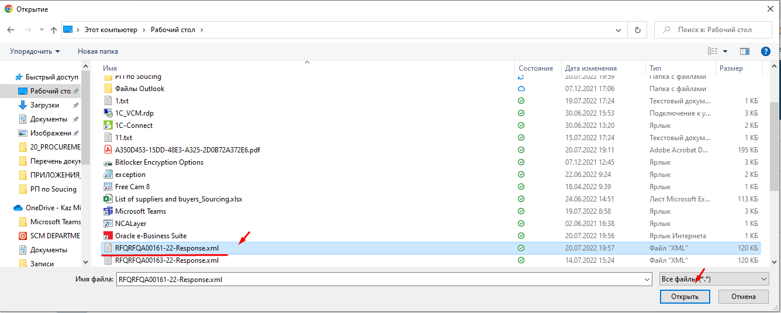
      - Click on (К) Import

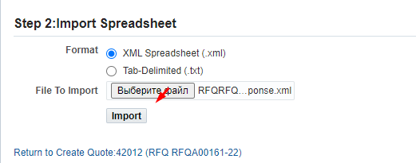
      - For responses with a large number of lines (more than 100), you must return to the Sourcing Home Page and find the response in the list
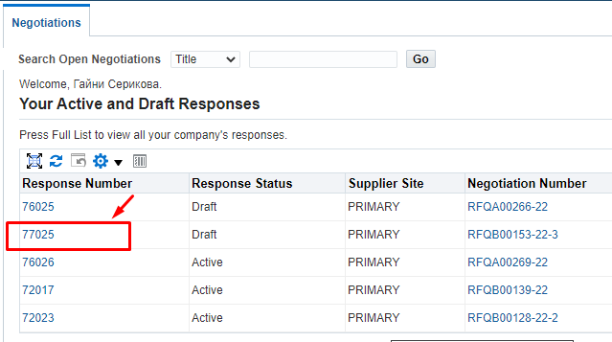
      - Click on (К) Quote By Spreadsheet
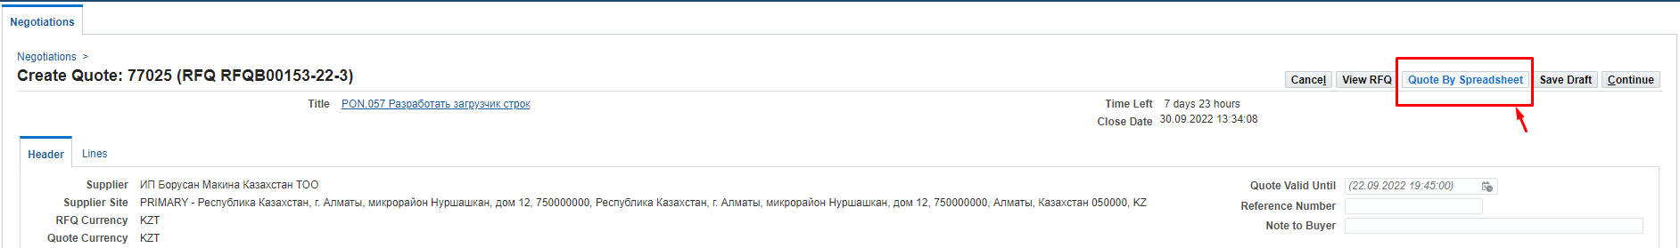
      - in the Step 2 section: Import Sreadsheet, click on (K) Select the file
      - Select the XML file saved earlier and click on (К) Open
      - Click on (К) Import
      - You can track the download status of the response. Follow the record “You may check the Request Status on the Manage Draft Responses page”.
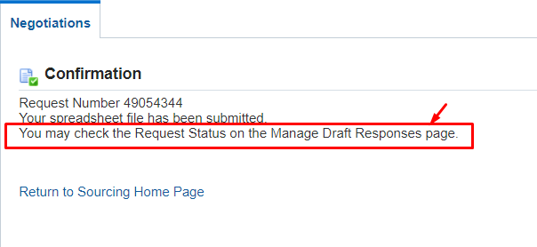
      - The download status of the response will be displayed in (P) Request Status
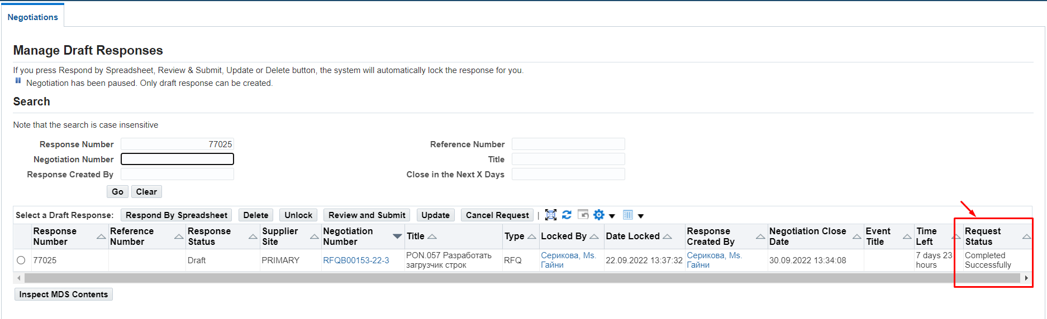
      - If not all the data are filled in correctly, the system will display an error message describing what data has not yet been filled in. For example, it may happen that mandatory attributes have not been entered at the level of lines or requirements in the header. If you uploaded a response using a file, you can supplement or edit the data in the system without having to download/upload the file again.
      - Please double check all the information you entered on Header and Lines before submitting your response and click on (К) Continue..
      - For non-resident suppliers of the Republic of Kazakhstan, and if the response currency is not KZT, the following warning will be displayed. If the currency of the answer is chosen by you correctly, click on (К) Yes.
If you made a mistake and indicated an incorrect response currency in the response, press (K) No and return to the response header (Header) to select the correct currency. And, if you made a mistake and entered line prices in the wrong currency, please go back to the Lines and change the prices following the steps above.
      - Click on (К) Submit to send the response.
      - After the sending, the following message will appear

Creating a Response to Request for Quotation (RFQ) for Works and Services.

Reviewing data in Request for Quotation (RFQ)
      - After the Request for Quotation (RFQ) is published, potential suppliers will be notified via email and the Worklist.
      - Follow to the said message in the Oracle IS
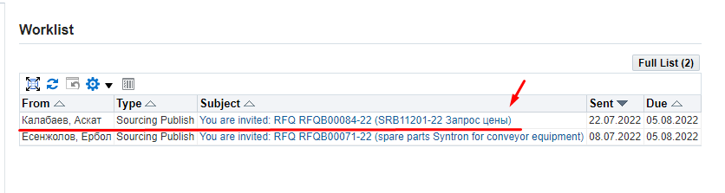
      - In the form that opens, you can confirm your participation in the Request for Quotations (RFQ) by clicking on (K) Yes (1); in this case, the system will automatically create a draft response, the notification will disappear and for further work on the creation of the response, you will need to go to the responsibility Supplier Sourcing > Sourcing > Sourcing Home Page.
Or you can immediately refuse the invitation by indicating the reason in the Note to Buyer field (2) and clicking on (К) No (3)
      - Before making a decision to participate in the Request for Quotations (RFQ), it is recommended that you review and read the details by clicking on the Negotiation Details (4) entry.
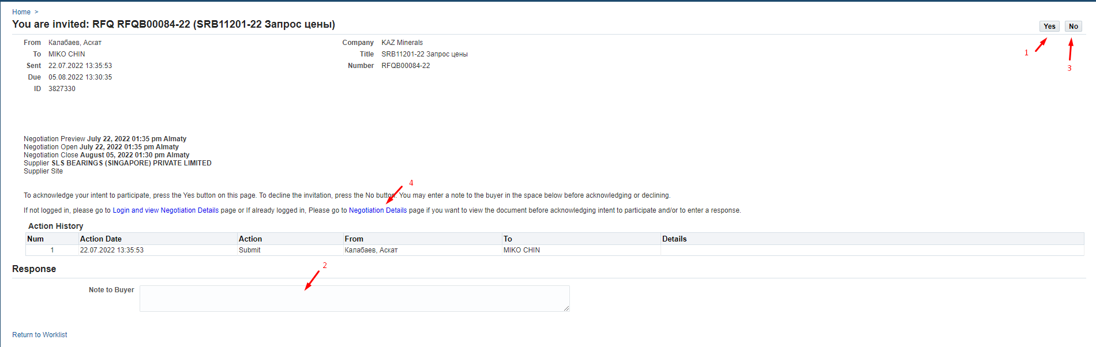
      - In the form that opens, please pay attention to the date in (P) Time Lef, which indicates the number of days and hours until the closing date for receiving answers in (P) Close Date.
Please be guided by the indicated time when preparing your response.
      - The Header tab displays all general information on the Request for Quotations (RFQ).
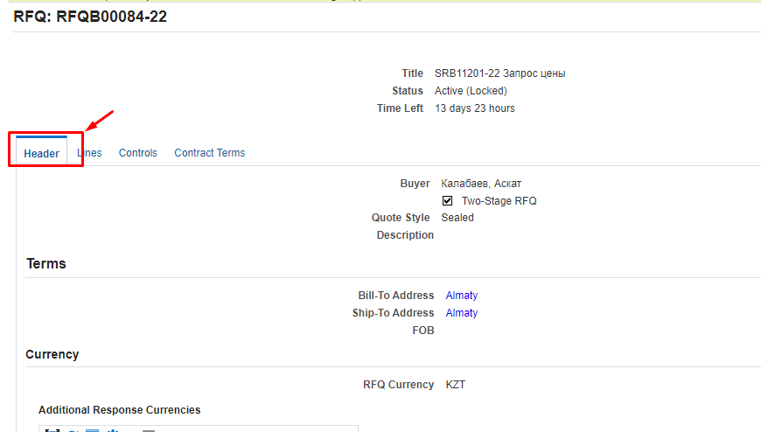
      - Be sure to review the Requirements section, which displays the Request for Quotation (RFQ) requirements. Click on (К) Show All (1). And also pay attention to which requirements are mandatory, and which are for information or optional (non-mandatory) for filling in. Press (K) Vew (2) for each requirement.
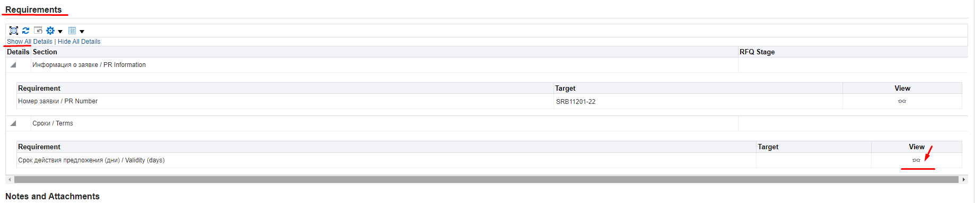
      - (P) Type (1) specifies a value depending on how you should respond to this requirement. Responses may be mandatory or optional. Or the attribute may be for information only.
In (P) Value Type (2), the response format is indicated: date, numeric value, text or link.
(P) Target indicates the target value (if any)
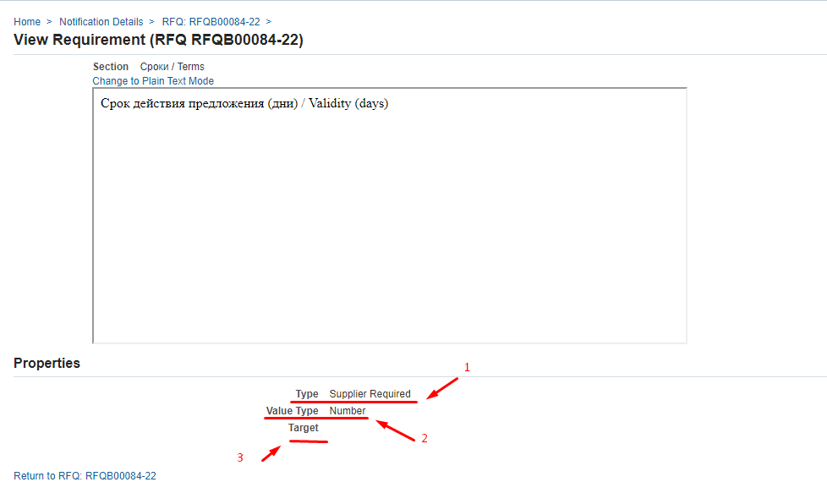
      - To view attachments to the Request for Quotation (RFQ)
      - In the Lines tab, you can review the details of the lines of the Request for Quotations (RFQ)
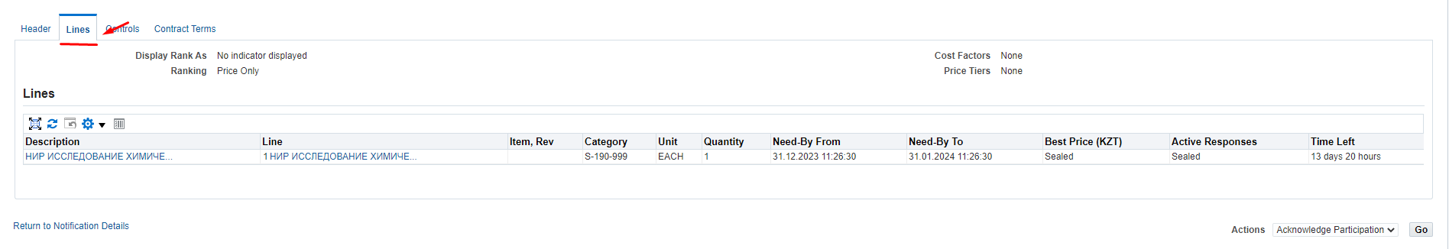
      - On the Controls tab (1), review the response rules that were set when the Request for Quotations (RFQ) was being generated
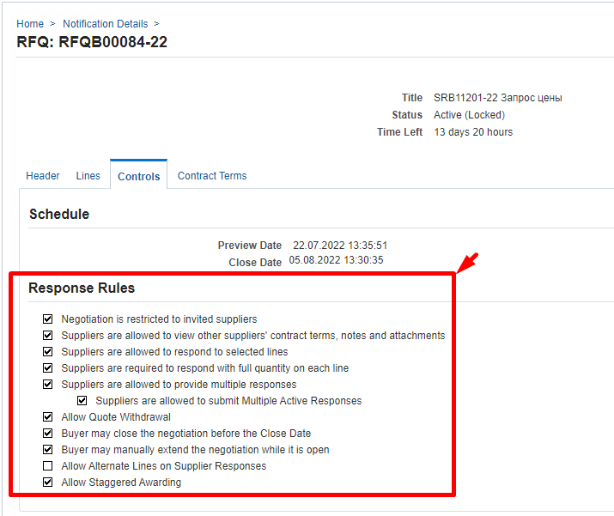
Negotiation is restricted to invited suppliers – if the box is checked, then the provision of responses to the Request for Quotations (RFQ) is limited only to invited suppliers, if the box is not checked, then responses can be received from any suppliers.
Suppliers are allowed to respond to selected lines – if the box is checked, then suppliers are allowed to respond to individual lines in the Request for Quotations (RFQ), if the box is not checked, then suppliers must provide a response only exclusively to all the lines in the Request for Quotations (RFQ).
Suppliers are required to respond with full quantity on each line – if the checkbox is checked, then suppliers must send responses with the full quantity indicated on the line.
Suppliers are allowed to provide multiple responses – if the box is checked, then suppliers are given the option to submit several responses during the opened period, of which only one can be active. When this box is checked, another rule may be displayed:
Suppliers are allowed to submit Multiple Active Responses – if the box is checked, then suppliers are given the option to quote the price once or multiple times (or revise their response) and each latest quote will be an active proposal.
Allow Quote Withdrawal – if the box is checked, all suppliers are allowed to withdraw their responses after they have submitted them. Quotes can only be withdrawn before the closing date. Withdrawn quotes may be revised as required by the request and may be updated by the supplier. The withdrawn proposal will not be visible to the Procurement Specialists during the evaluation and selection process.
Buyer may close the negotiation before the Close Date – if the checkbox is checked, then the Buyer may close the submission of responses before the set closing date, if necessary.
Buyer may manually extend the negotiation while it is open – if the box is checked, then the Buyer can extend the deadline for providing responses, if necessary. The deadline can only bet extended till the closing date.
Allow Alternate Lines on Supplier Responses – if the checkbox is checked, then the supplier is allowed to offer an alternative item and add a new line in the quote.
Allow Staggered Awarding - if the box is checked, then for this Request for Quotations (RFQ) it will be possible to select several winners for different items.
      - On the Contract terms tab, you can read the standard terms and conditions of the Purchase Order by clicking on (К) Preview Contract Terms
Open the downloaded PDF document and read the terms of the Purchase Order
      - You can also review all data on the Request for Quotation (RFQ) by downloading the printed form. In (P) Action (1), select the Printable View (2) value from the dropdown list and press (K) Go (3)
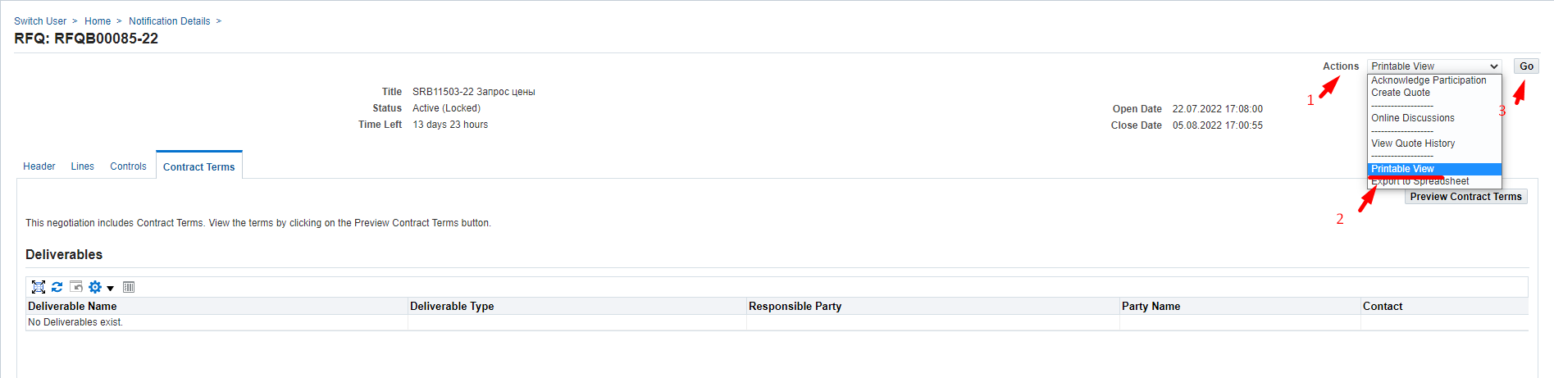
Open the downloaded file
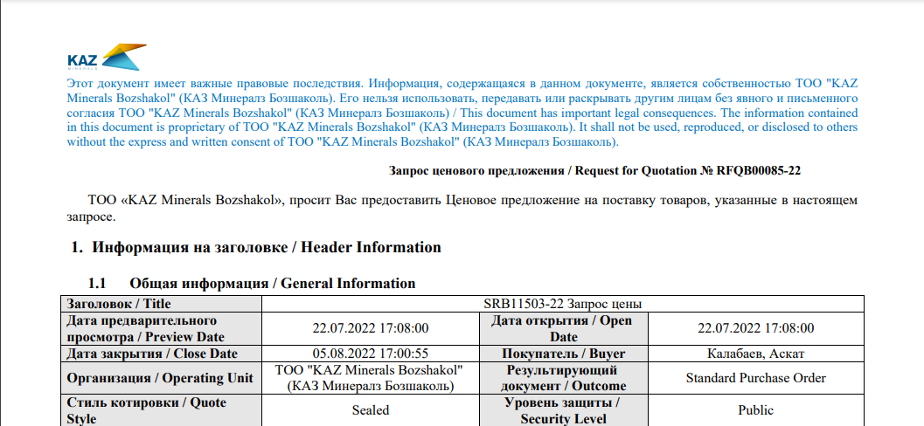

Correspondence and discussion on Request for Quotations (RFQ)
      - If you need to send a request to clarify some details in respect of the Request for Quotation (RFQ) after its review and examination, select the Online Discussion (2) value and click (K) Go (3) in (P) Action (1).
      - In the window that opens, click on (К) New Massage
      - In (П) Subject (1), enter the subject of the message, in (П) Message (2), enter the text of the message. If necessary, attach documents - Attachment (3) - and click (К) Send (4)
      - To return to the home page, click Home or on the left side of the Negotiations window
      - You will receive a notification that your request has been responded via e-mail and the worklist in Oracle IS.
      - In the notification you will see the response to your request (1) and to view the details and attachments (if any) click on (К) here (2)
      - If you need to continue the correspondence, click on (К) Reply

Creating a Response to Request for Quotation (RFQ) via the web page
      - If you need to response in respect of the Request for Quotation (RFQ), in (П) Action (1), select the Create Quote (2) command and click on (K) Go (3)
      - In (R) Quote Valid Until, enter the valid date for the quote. Click on Calendar (1) > select a date (2) > click on (К) Select (3)
      - For non-residents of the Republic of Kazakhstan, in (P) Quote Currency, you should select the response currency from the drop-down list.
      - If necessary, you can specify any comment for the Buyer in (P) Note to Buyer (1) and/or attach documents using Add Attachment (2)
The availability of attached scans of technical specifications, certificates, technical documentation and other details increases your chances of becoming a contract awardee, when a winning quotation is selected.
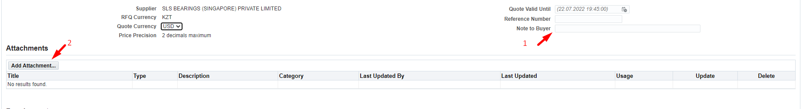
      - If you need to attach any documents, click (К) Attachment.
      - In (P) Title (1), enter a short description of the document; in (P) Description (2), enter a detailed description of the document and press (K) Select file (3)
Select the necessary document and press (К) Open
After uploading press (K) Apply (4)
      - In the Requirements section, you must enter the data on the values that require your response. To view the full list of requirements, you can click on the Expand All link
Please pay attention to the response format (numeric, text, drop-down list, etc.).
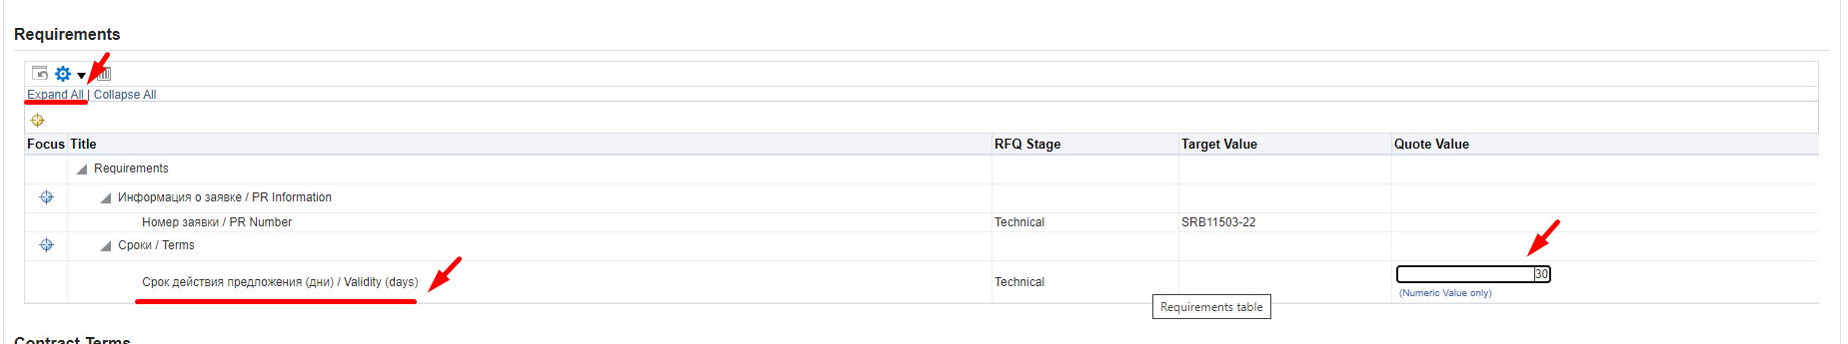
      - Go to the Lines tab to populate data related to the lines
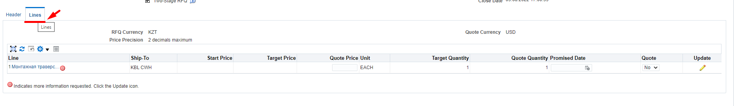
      - Please note that if the icon is indicated on the line, then there is additional information that needs to be filled in.
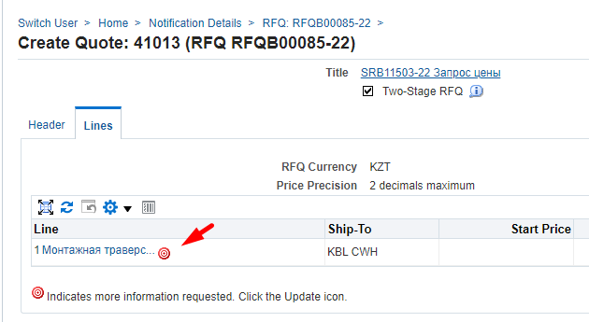
      - To fill in the data for additional information on the line, click on (К) Update
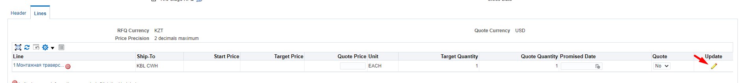
      - In column (P) Quote Price (1), enter the cost in the currency of the response. In (P) Promised Date (2), fill in the date of completion of the works/services. Click on (K) Apply (3)..
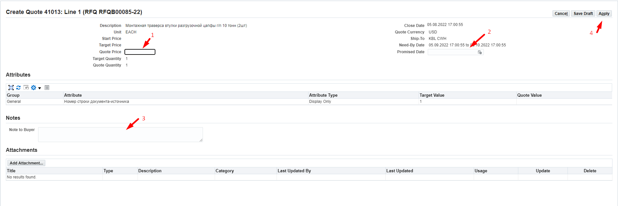
      - If the Request for Quotation (RFQ) line has additional attributes that need to be filled out, go to (P) Quote Value and fill in the data, taking into account the response format.
Attributes for which the Required (2) response format is specified must be mandatorily filled in.
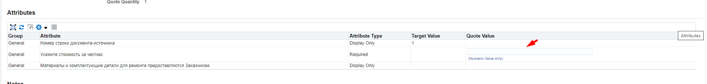
      - After filling data in the line, click on (К) Apply
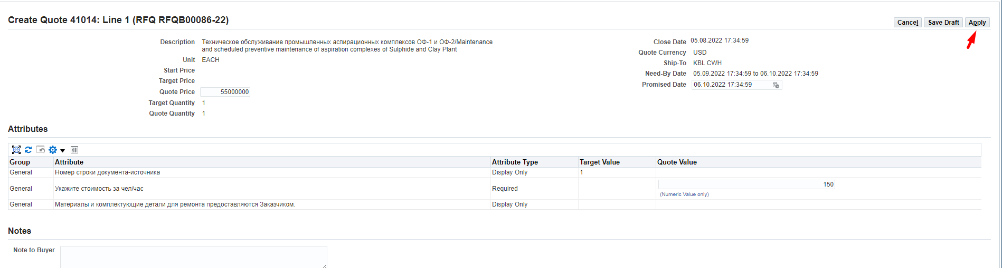
      - Please double check all the information you entered on Header and Lines before submitting your response and click on (К) Continue..
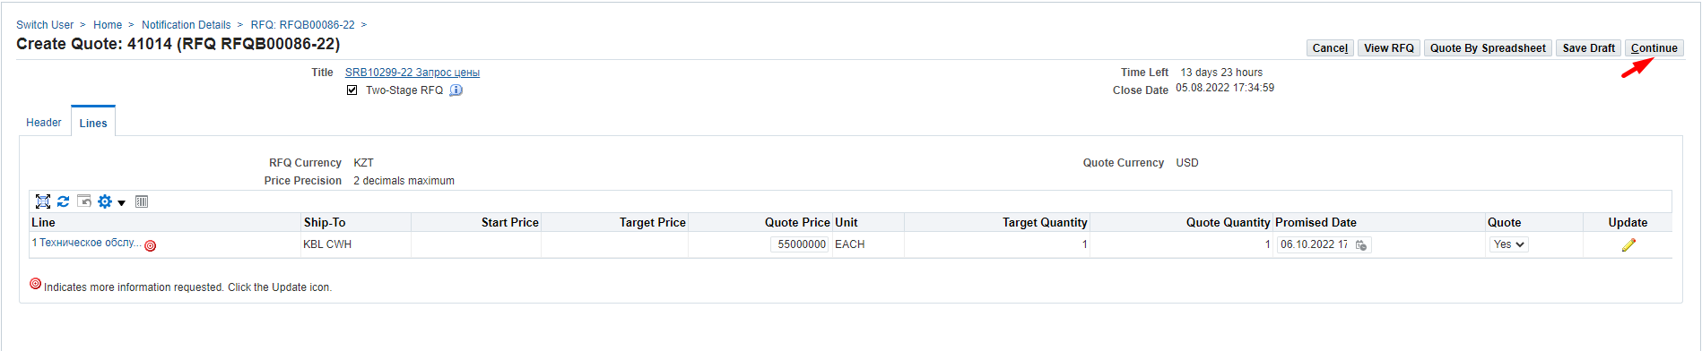
      - For non-resident suppliers of the Republic of Kazakhstan, and if the response currency is not KZT, the following warning will be displayed. If the currency of the answer is chosen by you correctly, click on (К) Yes.
If you made a mistake and indicated an incorrect response currency in the response, press (K) No and return to the response header (Header) to select the correct currency. And, if you made a mistake and entered line prices in the wrong currency, please go back to the Lines and change the prices following the steps above.
      - Click on (К) Submit to send the response.
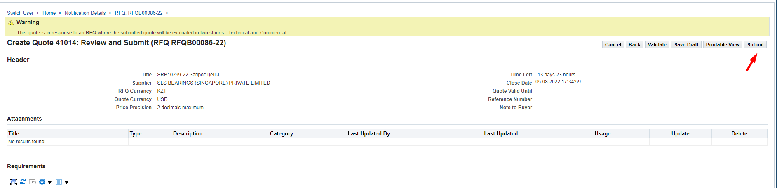
      - After the sending, the following message will appear
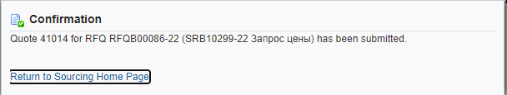

Creating a Response to Request for Information (RFI) for Goods.

Reviewing data in Request for Information (RFI)
      - After the Request for Information (RFI) is published, potential suppliers will be notified via email and the Worklist in the Oracle IS.
      - Follow to the said message in the Oracle IS
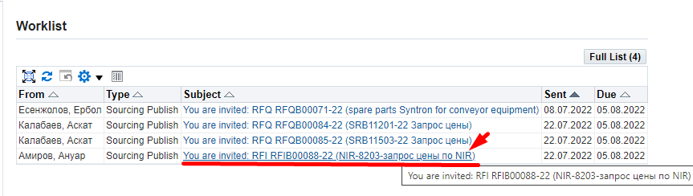
      - In the form that opens, you can confirm your participation in the Request for Information (RFI) by clicking on (K) Yes (1); in this case, the system will automatically create a draft response, the notification will disappear and for further work on the creation of the response, you will need to go to the responsibility Supplier Sourcing > Sourcing > Sourcing Home Page.
Or you can immediately refuse the invitation by indicating the reason in the Note to Buyer field (2) and clicking on (К) No (3)
      - Before making a decision to participate in the Request for Information (RFI), it is recommended that you review and read the details by clicking on the Negotiation Details (4) entry.
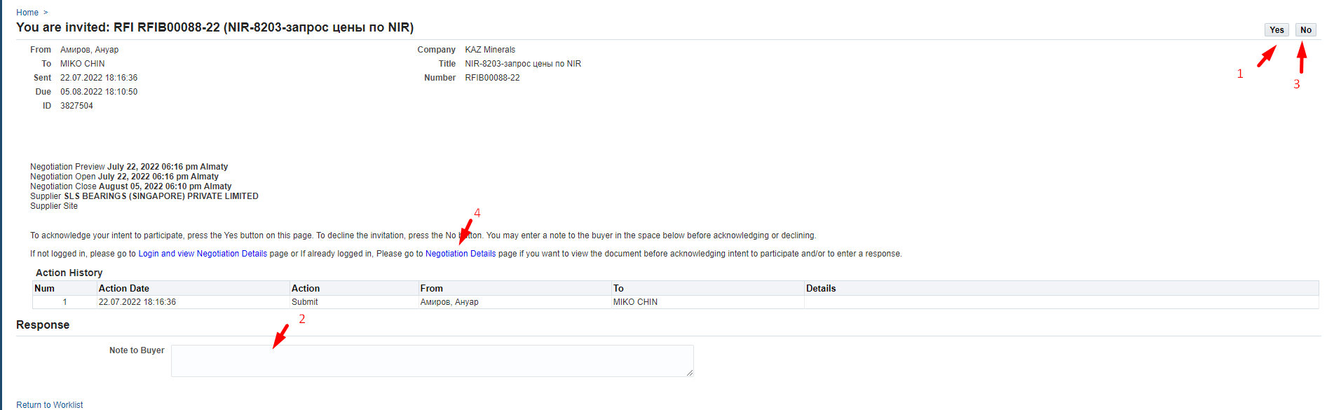
      - In the form that opens, please pay attention to the date in (P) Time Lef, which indicates the number of days and hours until the closing date for receiving answers in (P) Close Date.
Please be guided by the indicated time when preparing your response.
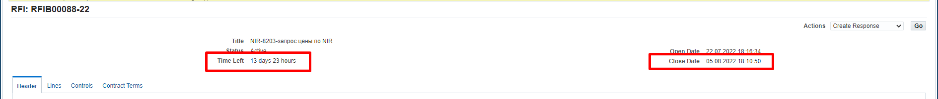
      - The Header tab displays all general information on the Information (RFI).
      - Be sure to review the Requirements section, which displays the Request for Information (RFI) requirements. Click on (К) Show All (1). And also pay attention to which requirements are mandatory, and which are for information or optional (non-mandatory) for filling in. Press (K) Vew (2) for each requirement.
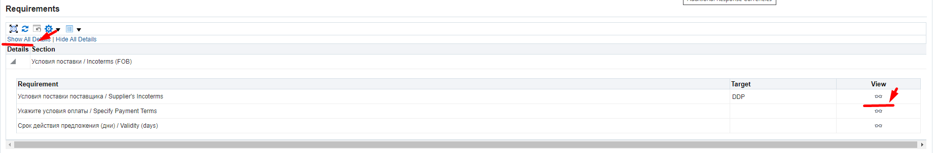
      - (P) Type (1) specifies a value depending on how you should respond to this requirement. Responses may be mandatory or optional. Or the attribute may be for information only.
In (P) Value Type (2), the response format is indicated: date, numeric value, text or link.
(P) Target indicates the target value (if any)
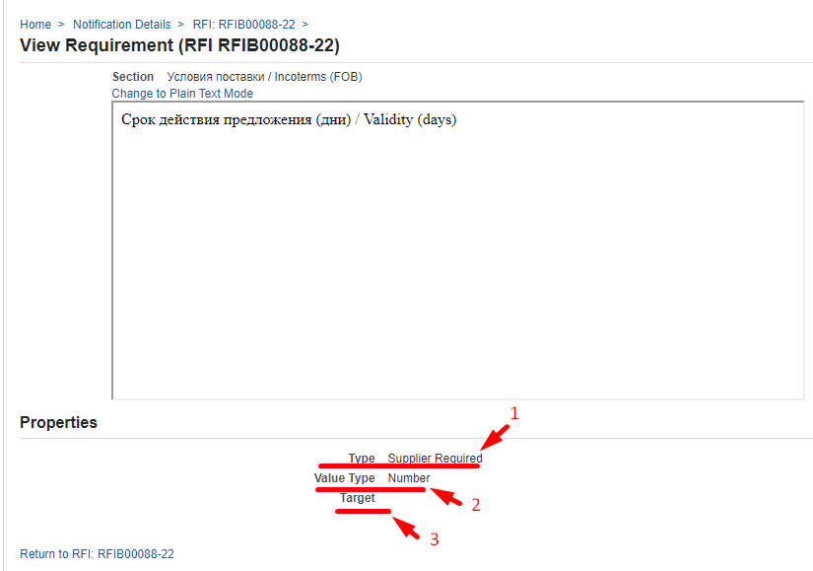
      - To view attachments to the Request for Information (RFI) in the Notes and Attachments section, go to the document name in (P) Title
      - To review additional specifications in the Lines (1) tab, go to Description (2)
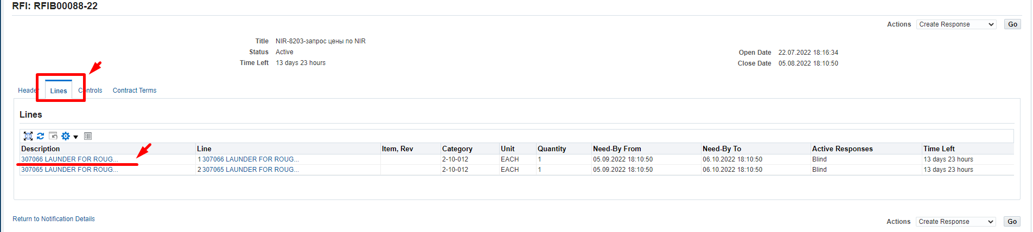
      - In the form that opens, in (P) Quantity (1), specify the quantity for the item. The Attribute column (2) indicates an additional list of attributes using which you need to view in (P) Attribute Type which attributes are mandatory, for information, or optional (not mandatory) and using (P) Value Type view the response format.
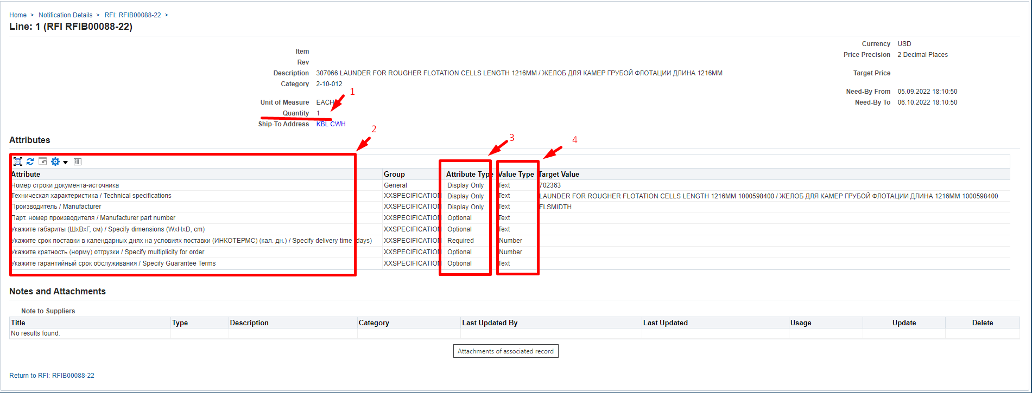
      - To return to view the next line, please click on the Request for Information (RFI) number on the left side of the form.
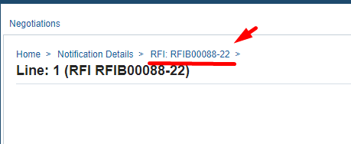
      - On the Controls tab (1), review the response rules that were set when the Request for Information (RFI) was being generated
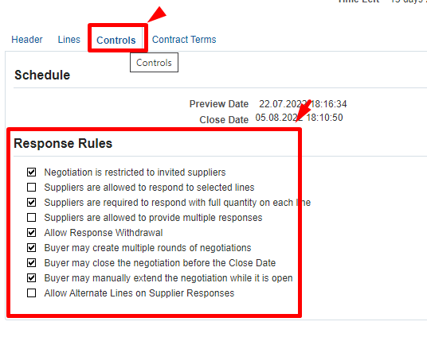
Negotiation is restricted to invited suppliers – if the box is checked, then the provision of responses to the Request for Information (RFI) is limited only to invited suppliers, if the box is not checked, then responses can be received from any suppliers.
Suppliers are allowed to respond to selected lines – if the box is checked, then suppliers are allowed to respond to individual lines in the Request for Information (RFI), if the box is not checked, then suppliers must provide a response only exclusively to all the lines in the Request for Information (RFI).
Suppliers are required to respond with full quantity on each line – if the checkbox is checked, then suppliers must send responses with the full quantity indicated on the line.
Suppliers are allowed to provide multiple responses – if the box is checked, then suppliers are given the option to submit several responses during the opened period, of which only one can be active. When this box is checked, another rule may be displayed:
Suppliers are allowed to submit Multiple Active Responses – if the box is checked, then suppliers are given the option to quote the price once or multiple times (or revise their response) and each latest quote will be an active proposal.
Allow Response Withdrawal – if the box is checked, all suppliers are allowed to withdraw their responses after they have submitted them. Quotes can only be withdrawn before the closing date. Withdrawn quotes may be revised as required by the request and may be updated by the supplier. The withdrawn proposal will not be visible to the Procurement Specialists during the evaluation and selection process.
Buyer may close the negotiation before the Close Date – if the checkbox is checked, then the Buyer may close the submission of responses before the set closing date, if necessary.
Buyer may manually extend the negotiation while it is open – if the box is checked, then the Buyer can extend the deadline for providing responses, if necessary. The deadline can only bet extended till the closing date.
Allow Alternate Lines on Supplier Responses – if the checkbox is checked, then the supplier is allowed to offer an alternative item and add a new line in the quote.
      - On the Contract terms tab, please read the terms and conditions of the Purchase Order by clicking on (К) Preview Contract Terms
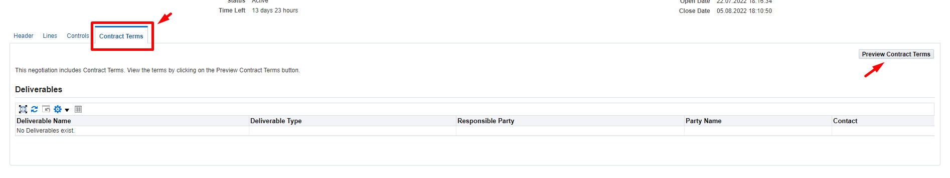
Open the downloaded PDF document and read the terms of the Purchase Order
      - You can also review all data on the Request for Information (RFI) by downloading the printed form. In (P) Action (1), select the Printable View (2) value from the dropdown list and press (K) Go (3)
Open the downloaded file
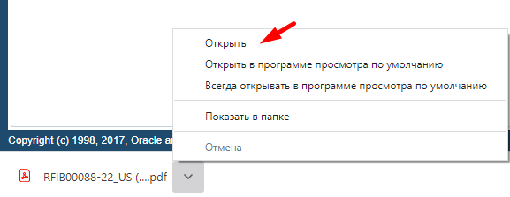
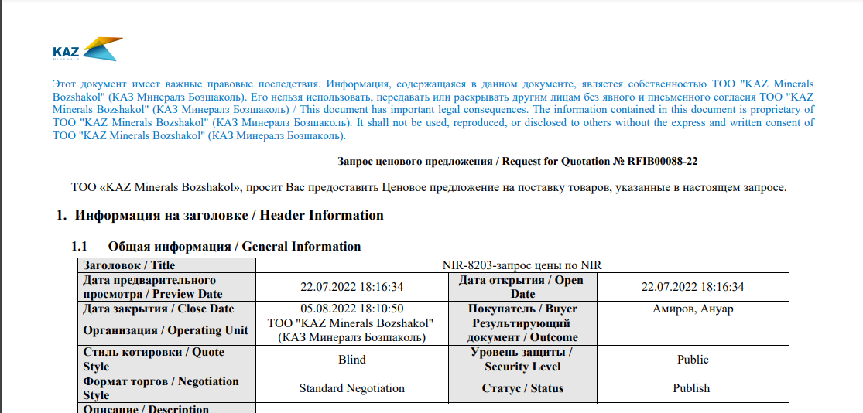

Correspondence and discussion on Request for Information (RFI)
      - If you need to send a request to clarify some details in respect of the a Request for Information (RFI), in (P) Action (1), select the Online Discussion (2) value and click (K) Go (3).
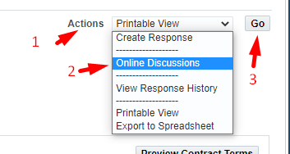
      - In the window that opens, click on (К) New Massage
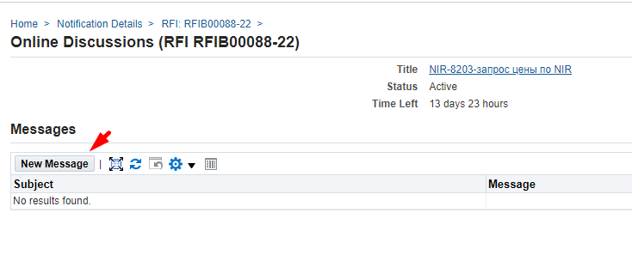
      - In (П) Subject (1), enter the subject of the message, in (П) Message (2), enter the text of the message. If necessary, attach documents - Attachment (3) - and click (К) Send (4)
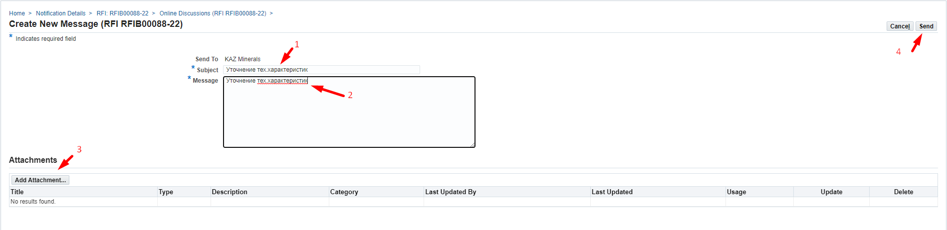
      - To return to the home page, click Home or on the left side of the Negotiations window
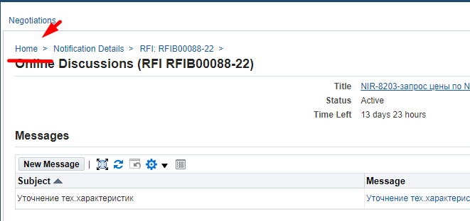
      - You will receive a notification that your request has been responded via e-mail and the worklist in Oracle IS.
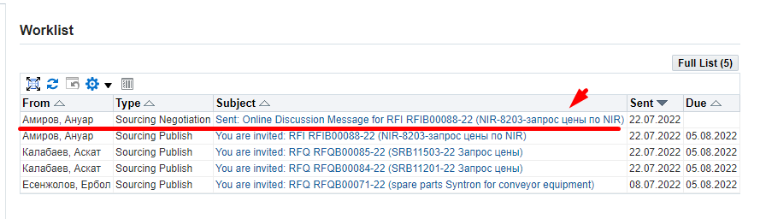
      - In the notification you will see the response to your request (1) and to view the details and attachments (if any) click on (К) here (2)
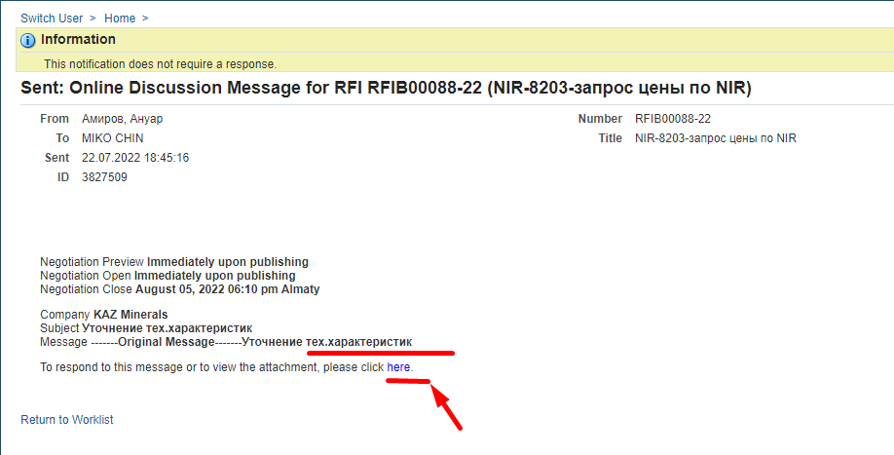
      - If you need to continue the correspondence, click on (К) Reply
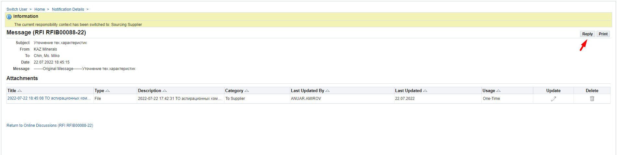

Creating a Response to Request for Information (RFI) ia the web page
      - If you need to response in respect of the Request for Information (RFI), in (P) Action (1), select the Create Quote (2) command and click on (K) Go (3)
      - In (P) Quote Valid Until (1), enter the valid date for the quote. Click on Calendar (2) > select a date (3) > click on (К) Select (4)
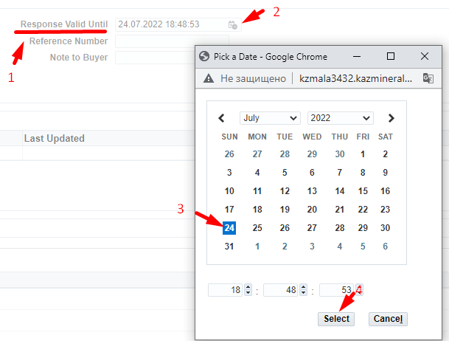
      - For non-residents of the Republic of Kazakhstan, in (P) Quote Currency, you should select the response currency from the drop-down list.
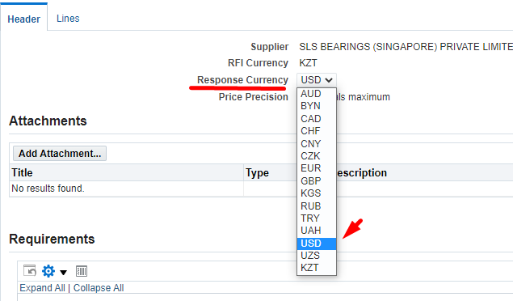
      - If necessary, you can specify any comment for the Buyer in (P) Note to Buyer (1) and/or attach documents using Add Attachment (2)
The availability of attached scans of technical specifications, certificates, technical documentation and other details increases your chances of becoming a contract awardee, when a winning quotation is selected.
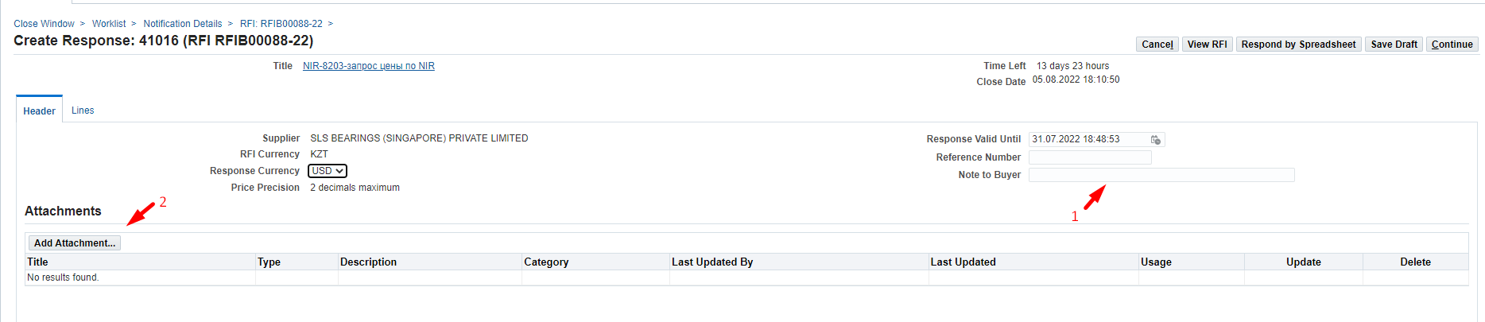
      - If you need to attach any documents, click (К) Attachment.
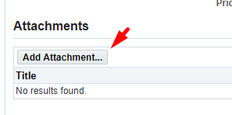
      - In (P) Title (1), enter a short description of the document; in (P) Description (2), enter a detailed description of the document and press (K) Select file (3)
Select the necessary document and press (К) Open
After uploading press (K) Apply (4)
      - In the Requirements (1) section, you must enter the data on the values that require your response in (P) Response Value (3). To view the full list of requirements, you can click on the Expand All (2)link.
Please pay attention to the response format (numeric, text, drop-down list, etc.).
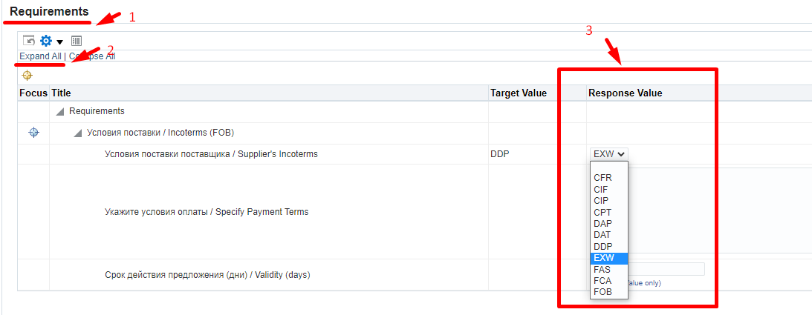
IMPORTANT! If in the response to the terms of delivery, you indicated EXW or FCA, when filling in the data on the Header in the requirements, then you must fill in the data for each line in the attribute “Specify dimensions (WxHxD, cm) / Specify dimensions (WxHxD, cm)”
If the specified data is not filled in, the following error will occur when you will be sending the response.
      - Go to the Lines tab to populate data related to the lines
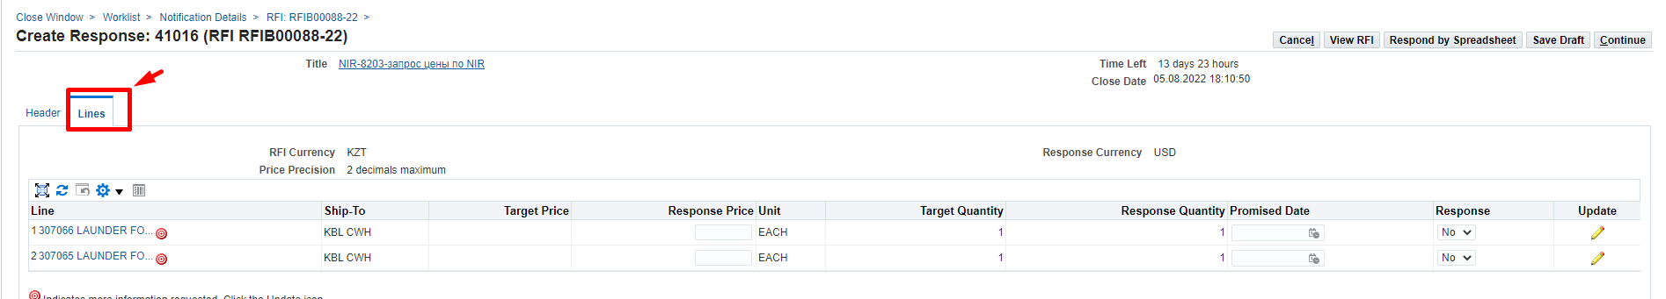
      - Please note that if the icon is indicated on the line, then there is additional information that needs to be filled in.
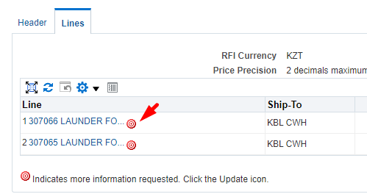
      - To fill in the data for additional information on the line, click on (К) Update
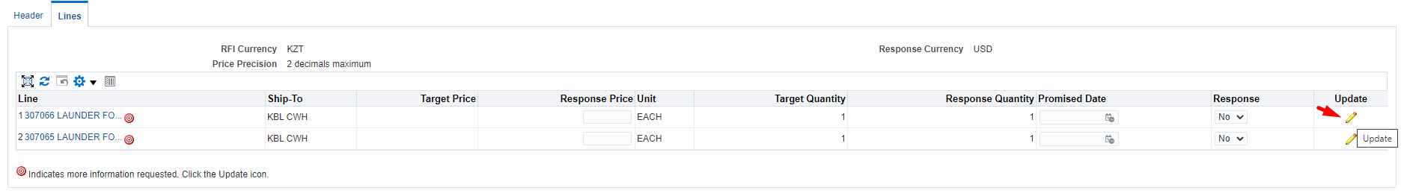
      - In the Quote Value (3) column, fill in the data taking into account the format of the response.
Attributes for which the Required (2) response format is specified must be mandatorily filled in.
IMPORTANT! If in the response to the terms of delivery, you indicated EXW or FCA, when filling in the data on the Header in the requirements, then you must fill in the data for each line in the attribute “Specify dimensions (WxHxD, cm) / Specify dimensions (WxHxD, cm)”
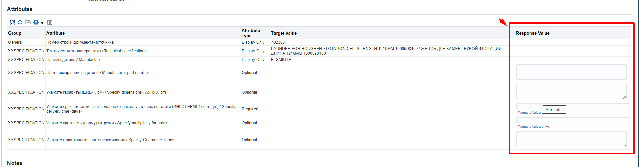
      - If in respect of “Manufacturer part number” (1) attribute in the Target Value (2) column of the Request for Information (RFI), incorrect information is specified, you can update it by entering a new value in the Response value (3) field.
      - In (P) Line Price, specify the price in the currency of the response under the delivery terms of the response and excluding VAT.
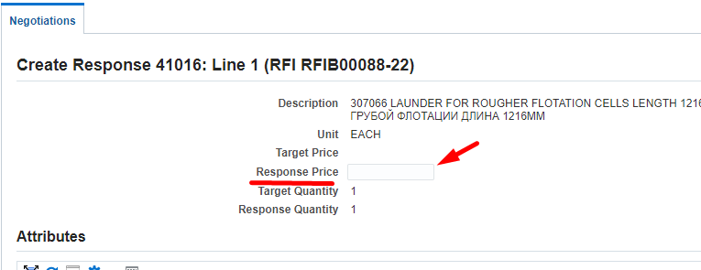
      - To go to the next line in (P) Line (1), click on (К) Go (2)
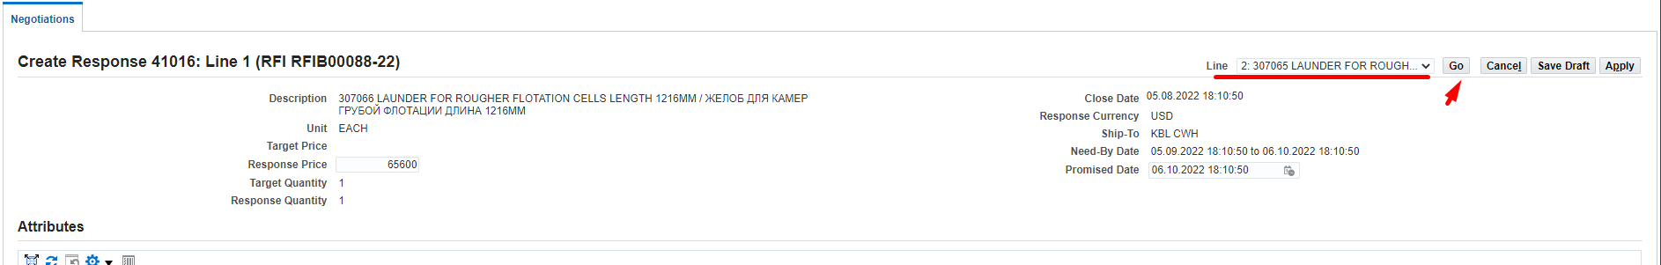
      - After filling data in the last line, click on (К) Apply
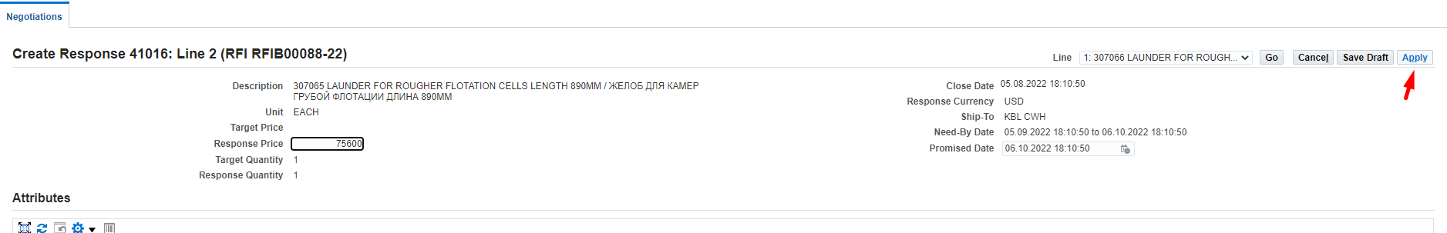
      - Please double check all the information you entered on Header and Lines before submitting your response and click on (К) Continue..
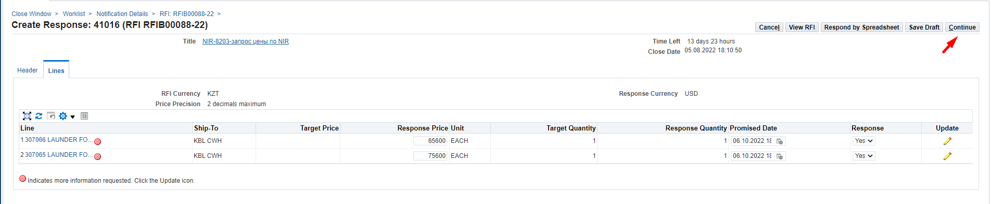
      - For non-resident suppliers of the Republic of Kazakhstan, and if the response currency is not KZT, the following warning will be displayed. If the currency of the answer is chosen by you correctly, click on (К) Yes.
If you made a mistake and indicated an incorrect response currency in the response, press (K) No and return to the response header (Header) to select the correct currency. And, if you made a mistake and entered line prices in the wrong currency, please go back to the Lines and change the prices following the steps above.
      - Click on (К) Submit to send the response.
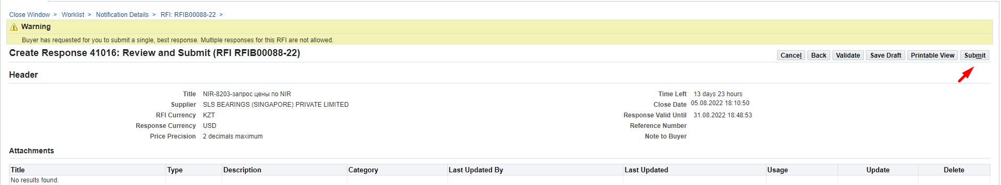
      - After the sending, the following message will appear
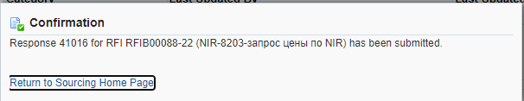

Creating a Response to Request for Information (RFI) using a spreadsheet
      - If you need to response in respect of the Request for Information (RFI), in (P) Action (1), select the Create Quote (2) command and click on (K) Go (3)
      - In (P) Quote Valid Until (1), enter the valid date for the quote. Click on Calendar (2) > select a date (3) > click on (К) Select (4)
      - For non-residents of the Republic of Kazakhstan, in (P) Quote Currency, you should select the response currency from the drop-down list.
      - If necessary, you can specify any comment for the Buyer in (P) Note to Buyer (1) and/or attach documents using Add Attachment (2)
The availability of attached scans of technical specifications, certificates, technical documentation and other details increases your chances of becoming a contract awardee, when a winning quotation is selected.
      - If you need to attach any documents, click (К) Attachment.
      - In (P) Title (1), enter a short description of the document; in (P) Description (2), enter a detailed description of the document and press (K) Select file (3)
Select the necessary document and press (К) Open
After uploading press (K) Apply (4)
      - Click (К) Respond By Spreadsheet to download the spreadsheet
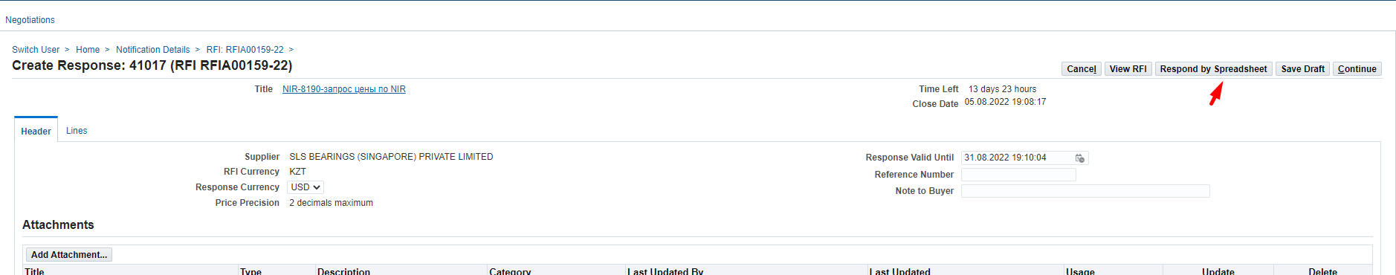
      - In the window that opens, click on (К) Export
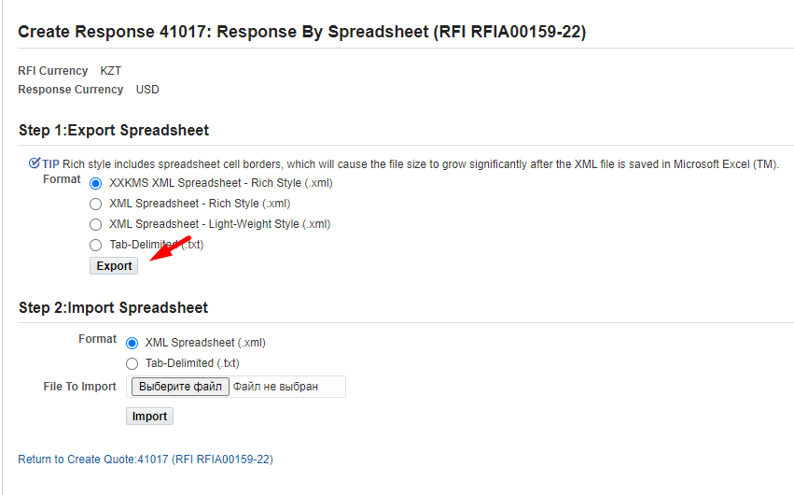
      - Click on (К) Open in the downloaded file
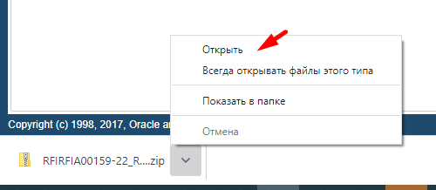
      - The XML file from the zipped folder must be copied and pasted to the desktop.
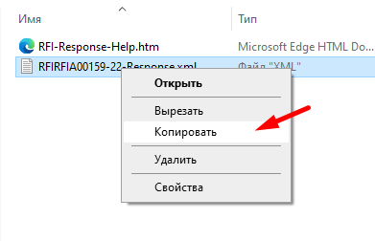
      - XML file must be opened with Open with (1) in the Excel (2) format
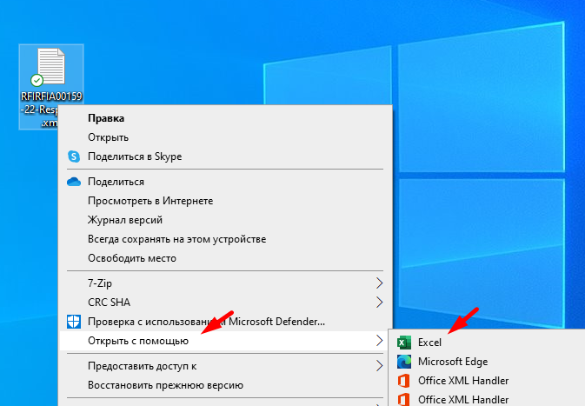
      - If your XML files open by default in a different format, then right-click Excel (1), check the box "Always use this application when opening .xml files" (2) and click (К) OK.
      - All cells in the opened file highlighted in yellow are mandatory for filling in. Cells highlighted in green are optional (not mandatory) for filling in.
      - In the Requirements section, you must enter the data on the values that require your response.
IMPORTANT! If in the response to the terms of delivery, you indicated EXW or FCA, when filling in the data on the Header in the requirements, then you must fill in the data for each line in the attribute “Specify dimensions (WxHxD, cm) / Specify dimensions (WxHxD, cm)”
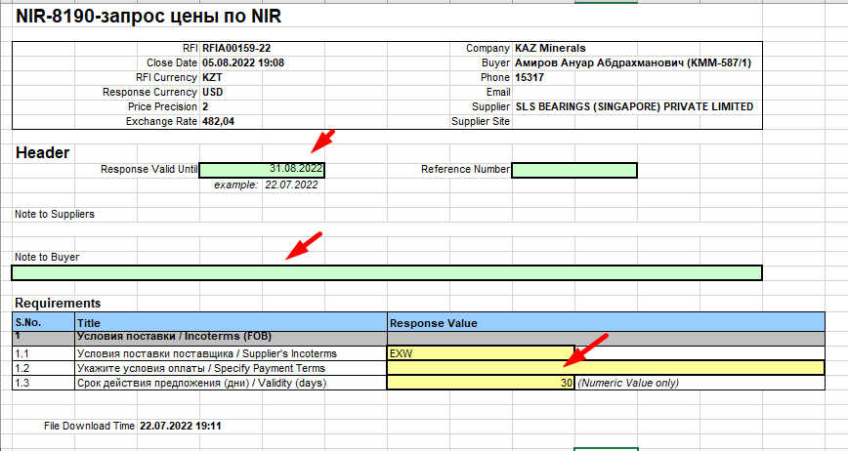
      - Go to the Lines (1 - …) list to populate data related to the lines
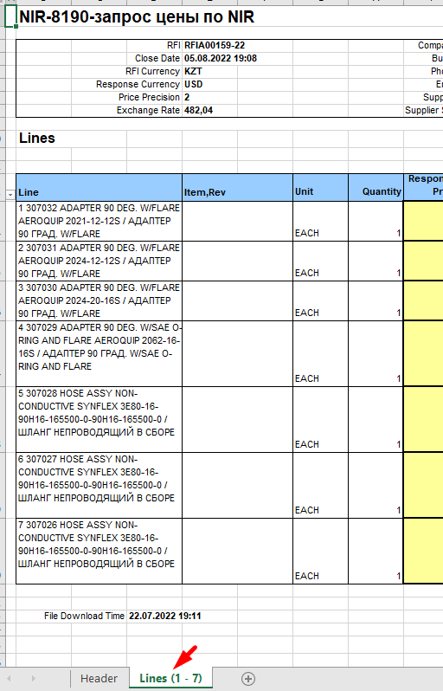
      - Populate data related to the lines: highlighted in yellow are mandatory for filling in; highlighted in green are optional (not mandatory) for filling in.
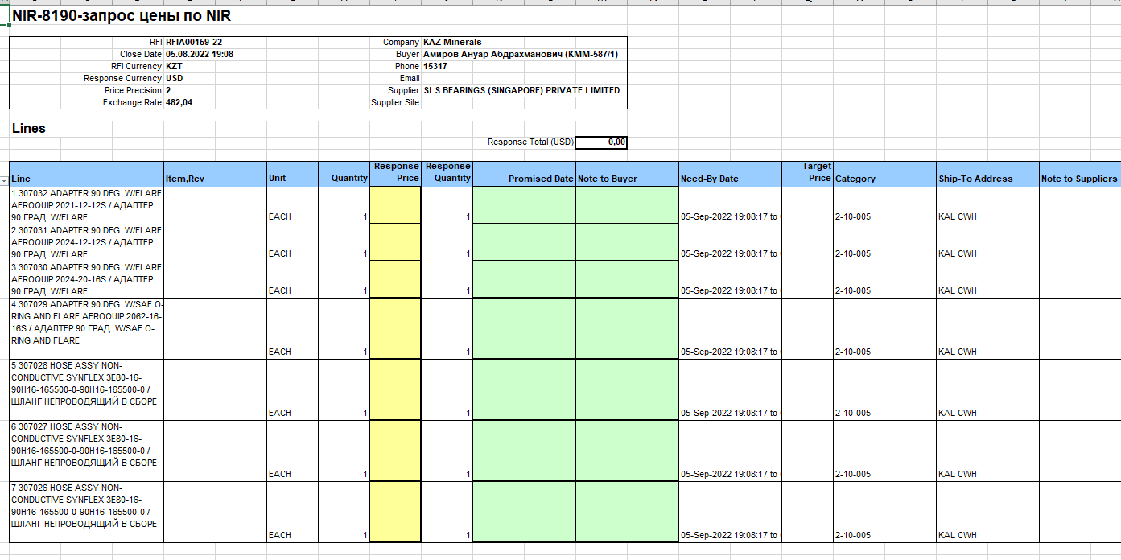
Enter data in the required fields for each line:
Specify (INCOTERMS) delivery time (calendar days) Quote Value
Response Price
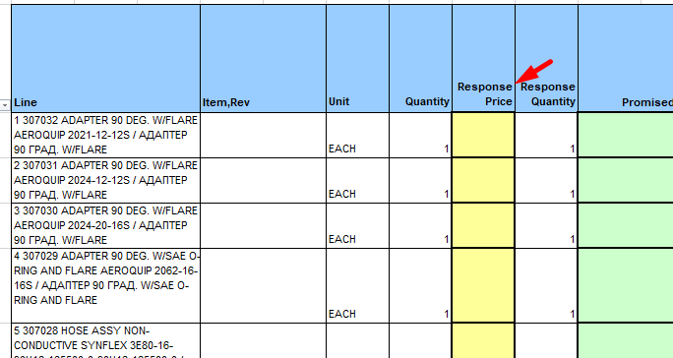
IMPORTANT! If in the response to the terms of delivery, you indicated EXW or FCA, when filling in the data on the Header in the requirements, then you must fill in the data for each line in the attribute “Specify dimensions (WxHxD, cm) / Specify dimensions (WxHxD, cm)”
If the specified data is not filled in, the following error will occur when you will be sending the response.
      - If in respect of THE “Manufacturer part number Target Value attribute, incorrect information is specified, you can update it by entering a new value in the Manufacturer part number Quote value field.
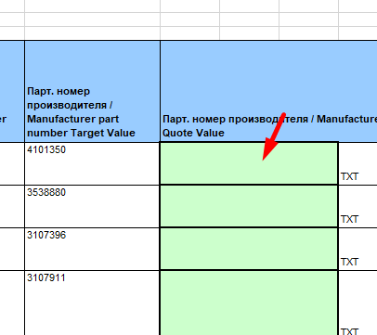
      - After filling in the data, close and save the file.
      - Return into the system and in the Step 2 section: Import Sreadsheet, click on (K) Select the file
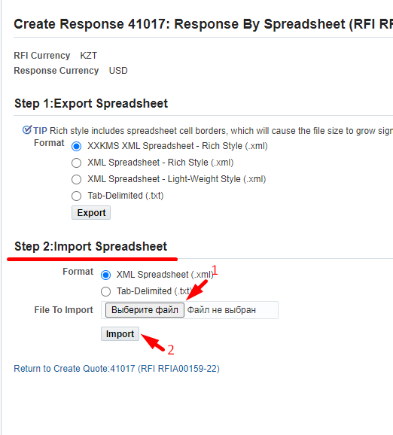
      - Select the XML file saved earlier and click on (К) Open
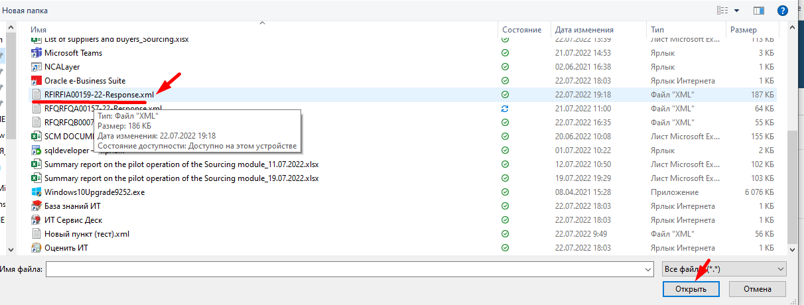
      - Click on (К) Import

      - If not all the data is filled in correctly, the system will display an error message describing what data has not yet been filled in. For example, it may happen that mandatory attributes have not been entered at the level of lines or requirements in the header. If you uploaded a response using a file, you can supplement or edit the data in the system without having to download/upload the file again.
      - Please double check all the information you entered on Header and Lines before submitting your response and click on (К) Continue..
      - For non-resident suppliers of the Republic of Kazakhstan, and if the response currency is not KZT, the following warning will be displayed. If the currency of the answer is chosen by you correctly, click on (К) Yes.
If you made a mistake and indicated an incorrect response currency in the response, press (K) No and return to the response header (Header) to select the correct currency. And, if you made a mistake and entered line prices in the wrong currency, please go back to the Lines and change the prices following the steps above.
      - Click on (К) Submit to send the response.
      - After the sending, the following message will appear
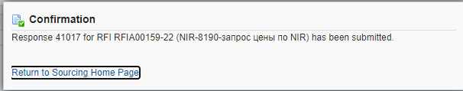

Withdrawing a Response to Request for Quotation RFQ / Request for Information RFI

    - If the Allow Response Withdrawal check box is checked in Options, the supplier can withdraw a previously sent response before the closing date.
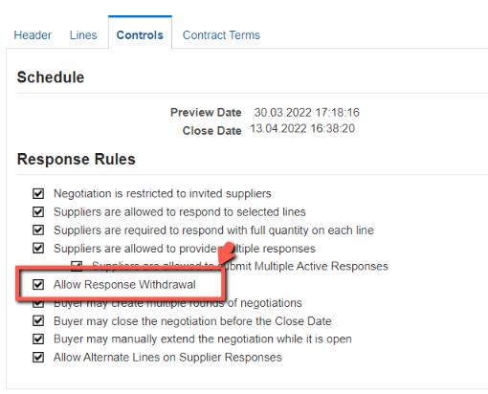
    - Go to the Sourcing Home Page responsibility
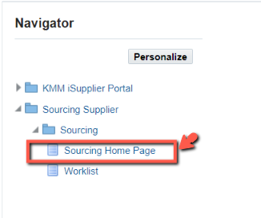
    - In Negotiations, in the Your Active and Draft Responses section, find a previously submitted active response
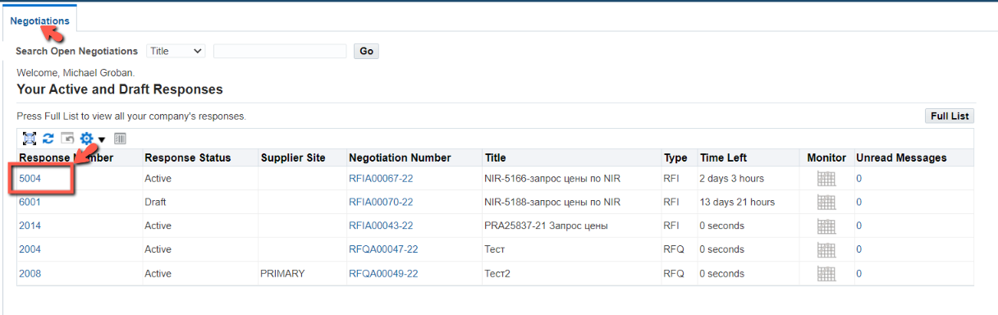
    - In (P) Action (1), select the value Withdraw Response (2)/Withdraw Quote
    - In the form that opens, enter the reason for the withdrawal of the response in (P) Withdrawal Reason (1) and click on (К) Submit (2)
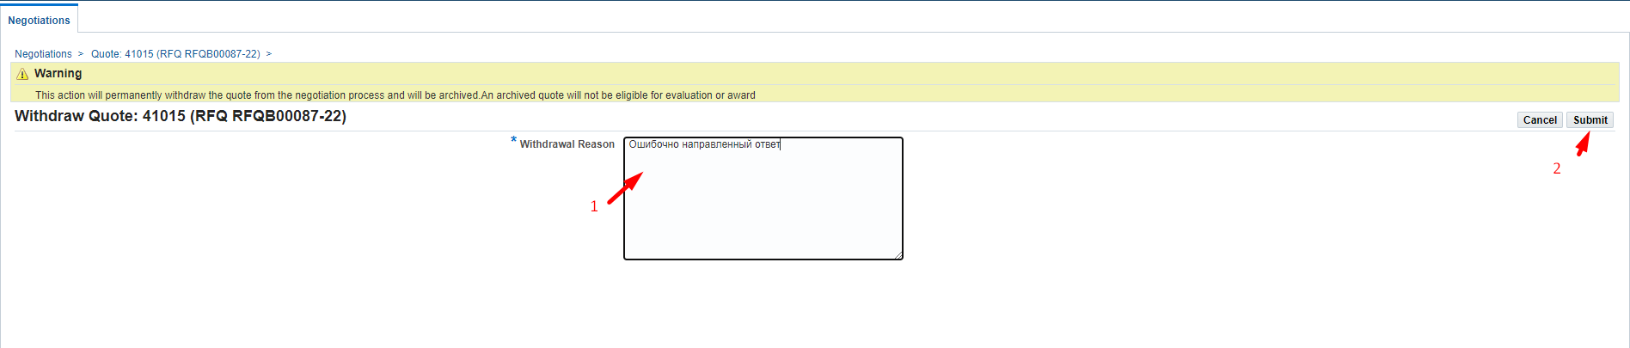
    - After the sending, the following message will appear Click on (К) Return to Previous page
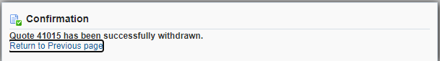
    - If you need to amend a previously submitted response, in (P) Action (1), select the Create Quote (2) command and click on (K) Go (3)
    - If you plan to change a previously submitted response, check the box next to the value Modify or Revise existing quotes? (1). If you plan to create a new response, canceling the previous one, check the box next to the value Create a new quote?. Then click on (К) OK (3)

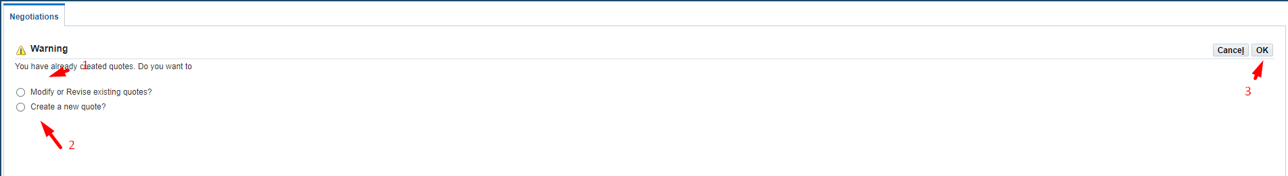
    - If you decide to make a change to a previously submitted response, then, in the window that opens, check the box next to the response number and click on (К) Revise
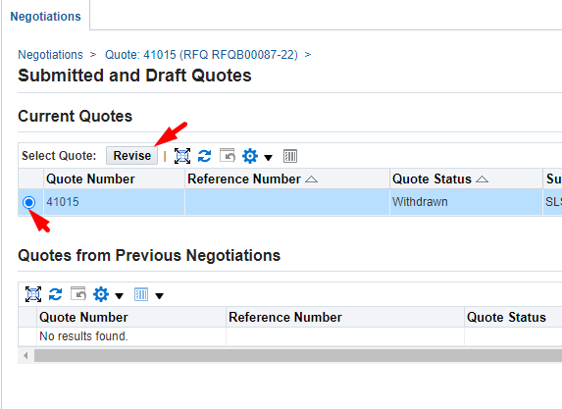
    - If you decide to create a new response, click on (К) Create New Quote
    - All further steps for creating/editing responses are described above in this User Guide.

