APPROVED BY
Development Director,
Procurement Department KAL/KBL
KAZ Minerals Management LLC
Christopher J. Brodie
___ __________ 20___

USER GUIDE

KAZ MINERALS ASSESSMENT BY SUPPLIER

Drafted by:
Chief Specialist
E.G. Korotina

Created on: 13 December 2021
Updated on: 13 December 2021

Almaty, 2021
Table of Changes
10
Date | Created by | Revision | Description of changes
00033 | Gorbunov D., Karanovich A, Pyatkov A., Belykh L.
13.12.2021 | E. Korotina | 1.0 | New document

Contents

I. PURPOSE AND SCOPE 4
II. ROLES AND RESPONSIBILITIES 4
III. BACKGROUND EVENTS 4
IV. DETAILED STEPS 4
1. Logging in the system 4
2. Filling in the Assessment form 5

PURPOSE AND SCOPE

This User Guide will help you (as an approved supplier) to assess KAZ Minerals in your Personal Account of the Oracle system, Version 12.2.7.

ROLES AND RESPONSIBILITIES

The authority for accessing and editing data in your Personal Account of Oracle, Version 12.2.7, is provided to all approved suppliers.

BACKGROUND EVENTS

The Approved Supplier has been notified in the Oracle System Worklist that they have been invited to assess KAZ Minerals in the Oracle System version 12.2.7.

DETAILED STEPS

Follow the link to enter your Personal Account:
https://suppliers.kazminerals.com

Logging in the system
  - Enter your login and password. Choose the language Press Log in button
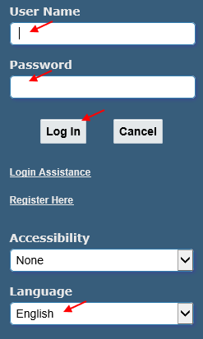

  - When you log in for the first time, the system will prompt you to change the default password. Create, enter and confirm a new password.

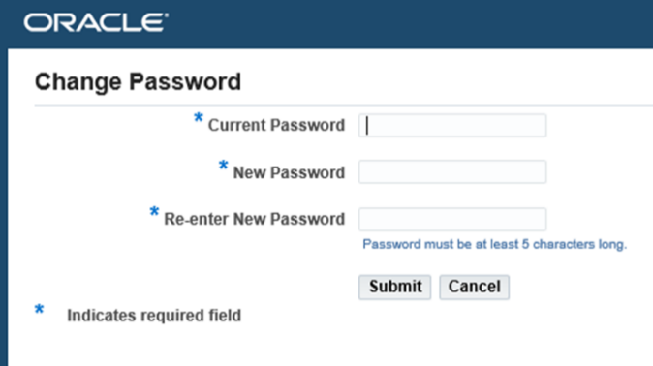

  - Upon successful login, the following window will appear:
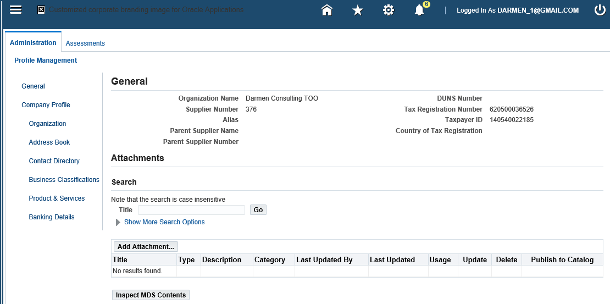

Filling in the Assessment form
  - Click on the sign . In the Worklist area, follow the link by stepping on the relevant invitation. Start creating a Response.
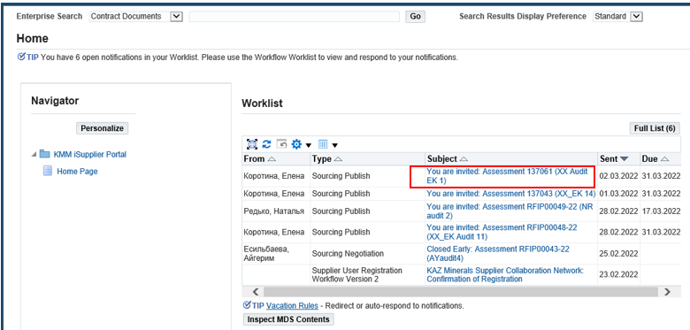

  - To confirm your participation in the Assessment, you must click on Yes button, to refuse - on No button. You can add Note to Buyer - the area below. To view the Assessment click on the link Assessment Details
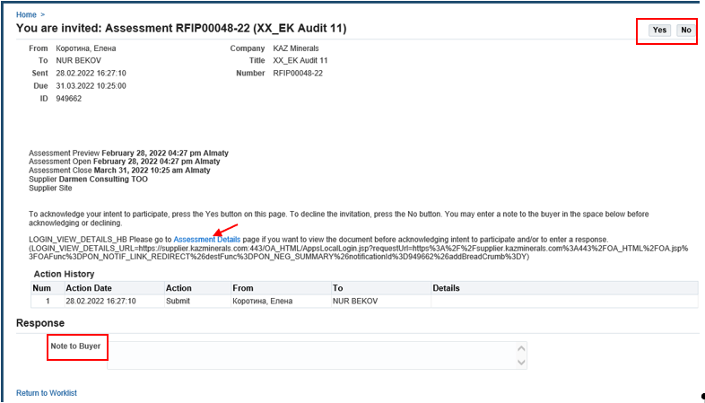
  - To get started, you need to be in the Assessments tab. In the area Your Company's Open Invitation click on the desired Assessment (for example, 137061).
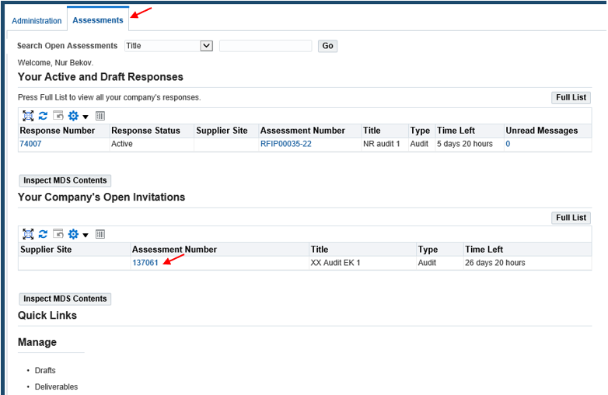
  - On the Assessments form, proceed to Create an Assessment Response: select in Actions - Create Response, click on Go button
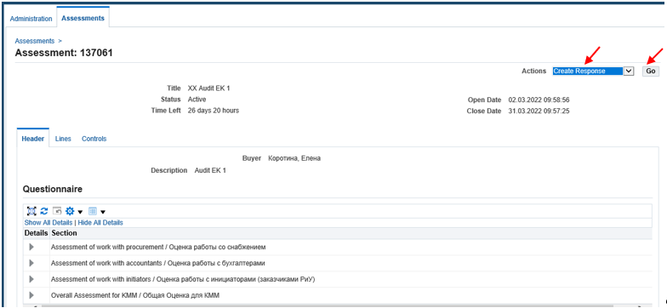
  - To enter answers to questions in the Questionnaire area, select values from the list or enter a text comment, in accordance with the proposed question. Use the buttons at the top and bottom of the Response form:
View Assessments – preview;
Respond by Spreadsheet - a way to fill in the response using a file (we will consider it below, see paragraph 2.10);
Save Draft - save an unfinished response to continue filling it later;
Continue - click when you have completed filling in the response for assessment.
In the Questionnaire area, use the links Expand All / Collapse All - expand / collapse the questionnaire.
Enter answers to all questions: select from the list, make comments.
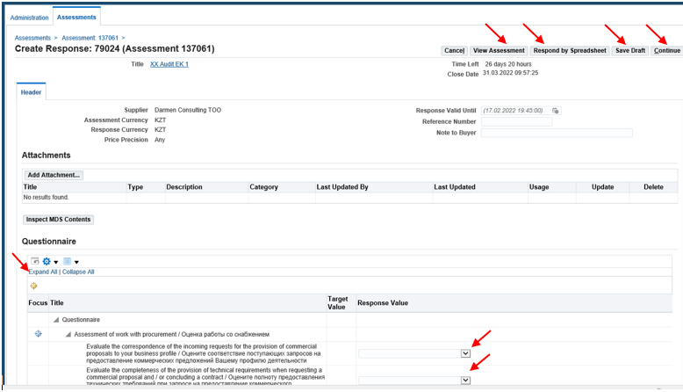
In addition to the questionnaire, you can check or change (if necessary) information on the Supplier Profile Attributes - the area following the Questionnaire.

  - Press on Continue button to continue. The system informs that a single Response is expected from the supplier for the assessment, multiple Responses are excluded.
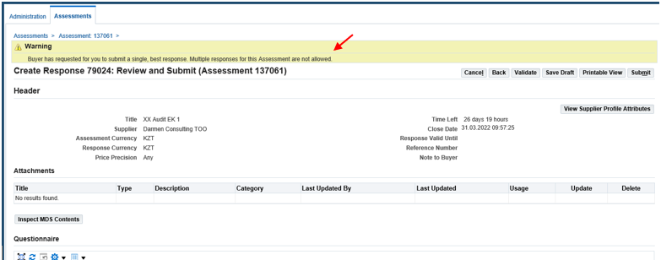
  - In the Review and Submit form, use the buttons
Validate - the system will check the answer for the correctness of the data and
report the result. In our example: no errors found;
Printable View - printable form of the response;
View Supplier Attributes - checking and changing supplier attributes (if necessary);
Submit - completion of work with the Response form.
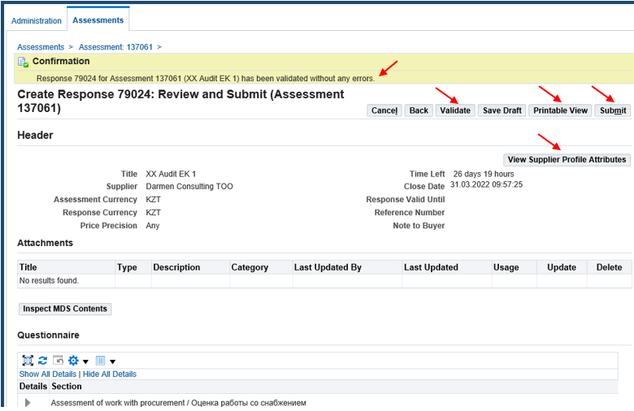
  - After clicking on Submit button, the system provides Confirmation that the Response has been sent for assessment.
To return to the Assessments tab, click on the link Assessments Home Page
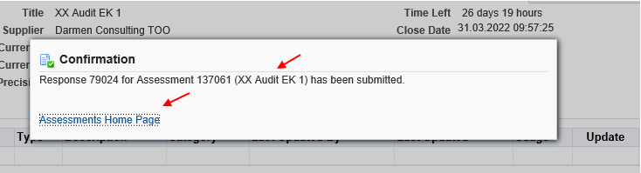
  - On the Assessments tab, the status of the Response submitted changed from Draft to Active. You can use the Full List button to manage Assessments. To Search open assessments you can use the filter and click on Go button
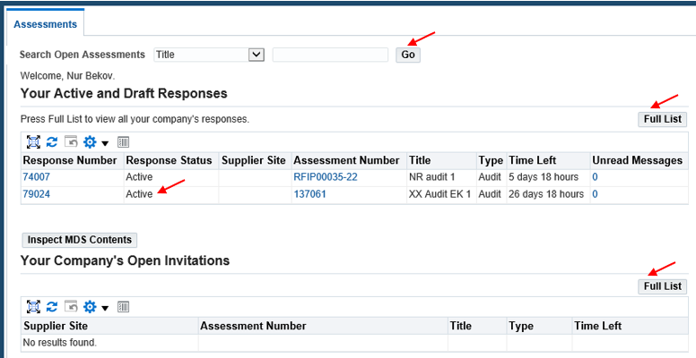
2.10. Completing the Response for assessment using the spreadsheet. Click on Respond by Spreadsheet button.
Click on Format:
Click on Export button
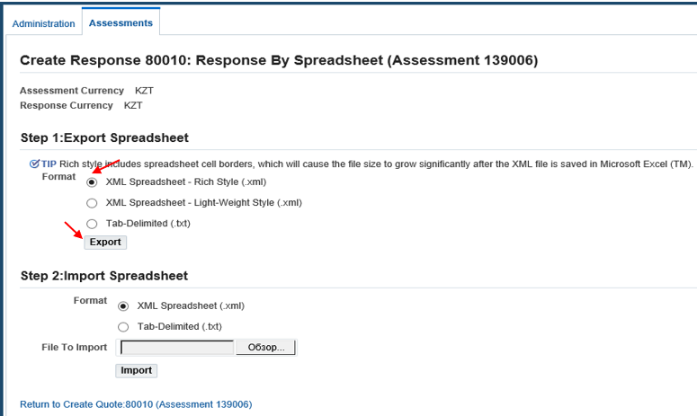
In the downloaded format, enter the assessment information by selecting values from the list or by entering a text comment. Save the file.
Use the same format (.xml) to upload the file to the system.
Click on Format:
Click on Browse button to select your file.
Click on Import button.
To continue working with the Response, click on the link
