APPROVED BY
Development Director
Supply Chain Department KAL/KBL
KAZ Minerals Management LLC
Christopher J. Brodie
___ __________ 20___

USER GUIDE

SUPPLIER REGISTRATION

Developed by:
Head of the Methodology Section of the Procurement Support Division, SCM Department
KAZ Minerals Management LLC
К.А. Abildinova

Created on: 07 September 2021
Date of update: 11 March 2022

Almaty, 2021
Table of Changes
19
Date | Created by | Revision | Description of changes
00033 | Gorbunov D., Karanovich A, Pyatkov A., Belykh L.
07.09.2021 | K. Abildinova | 1.0 | New document
12.02.2022 | N.K Kalenova | 1.1 | Information and screenshots updates
11.03.2022 | N.K. Kalenova | 1.2 | Additional section: FYI

Table of contents
I. PURPOSE AND SCOPE 4
II. ROLES AND RESPONSIBILITIES 4
III. BACKGROUND EVENTS 4
IV. DETAILED STEPS 4
1. The Prospective Supplier Registration page. 4
2. Additional Details page. 6
3. General Information Page. 12
4. Annex page. 16
5. FYI 19

PURPOSE AND SCOPE

This User Guide will help you (as a potential supplier) to fill in the Questionnaire for registering your company in the Oracle system, Version 12.2.7.

ROLES AND RESPONSIBILITIES

The role for registering a new supplier in Oracle, Version 12.2.7, is provided to all potential suppliers.

BACKGROUND EVENTS

An invitation was sent to the potential supplier to register in the Oracle system, Version 12.2.7, or the potential supplier independently followed the link below, posted on the Company website: https://www.kazminerals.com/
Before filling in the form in the Oracle system, Version 12.2.7, a potential supplier should review this User manual, prepare the data and a list of certain documents stated in this document.

DETAILED STEPS
Follow the link to fill in the Russian version:
https://suppliers.kazminerals.com/OA_HTML/jsp/pos/suppreg/SupplierRegister.jsp?ouid=C978373F89498127&lang=RU
to fill in the English version:
https://suppliers.kazminerals.com/OA_HTML/jsp/pos/suppreg/SupplierRegister.jsp?ouid=C978373F89498127&lang=US
Fields marked with * are mandatory for filling in.

The Prospective Supplier Registration page.
  - Section: Company Details.
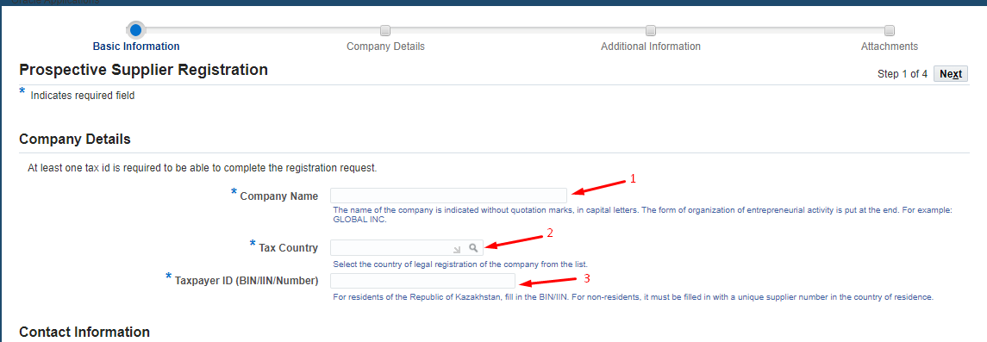
(1) In the "Company Name" field, enter the company name without quotation marks, in capital (uppercase) letters. The organizational form of the business shall be indicated at the end. For instance, GLOBAL INC.
(2) In the “Tax Country” field, select from the list the country of official registration of the company. For instance, United States.
(3) In the "Taxpayer ID(BIN/IIN/Number)” field:
a. for the residents of the RoK, please fill in:
    - BIN for legal entities;
    - IIN for individual entrepreneurs;
  - for non-residents, it can also be filled in with a unique supplier number assigned in their country of residence.

  - Section: Contact Information.

In this section, the data of the employee (person) filling in the questionnaire shall be entered.
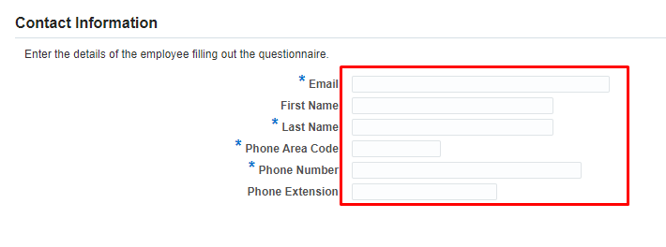
Click on Next.
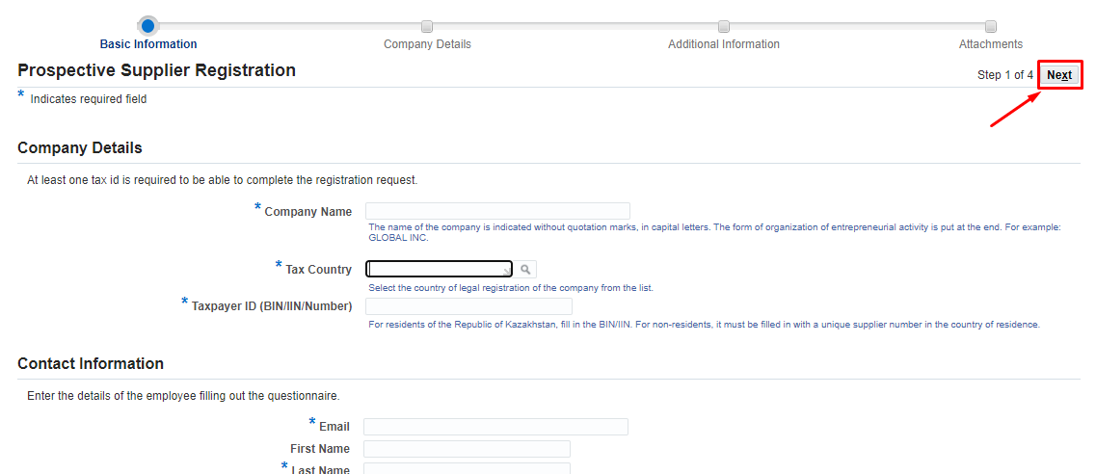

Additional Details page.
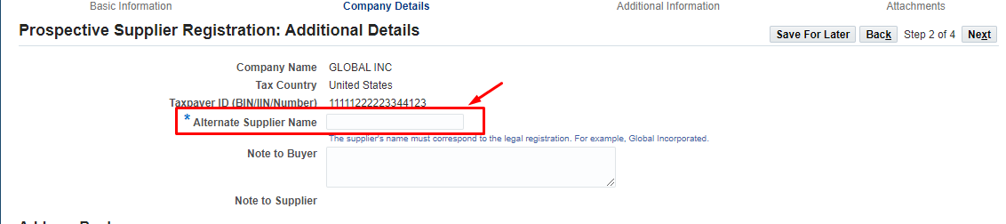
- In the ‘Alternate Supplier Name’ field, enter the full company name that must correspond to its official registration. For example, Global Incorporated.

  - Section: Address Book.

In the Address Book Section, click on ‘Create’
In the form that opens in the Russian interface for the Residents of the Republic of Kazakhstan, fill in the following data:
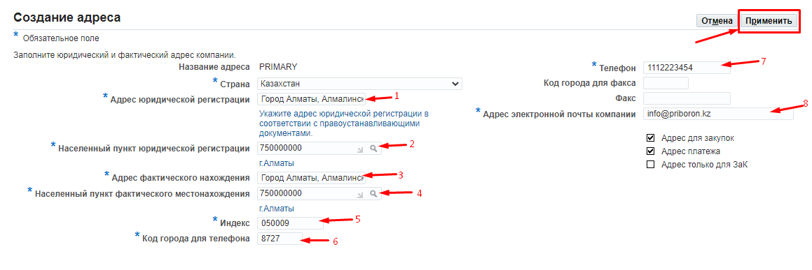
(1) in the "Адрес юридической регистрации"(Official Registration Address) field, indicate the address of official registration in accordance with the documents of title. For example, 185 Kurmangazy Street, Almalinsky District, Almaty City
(2) in the "Населенный пункт юридической регистрации”(Settlement of Official Registration) field, select the settlement of registration from the Directory Classifier of Units of Administrative and Territorial Distribution (KATO).
(3) In the field "Адрес фактического нахождения"(Address of Actual Location), indicate the full address of the actual location of the company. For example, 24a M.Zhusup Street. Ekibastuz City, Pavlodar Region.
(4) in the "Населенный пункт фактического нахождения"(Settlement of Actual Location) field, select the settlement of actual location from the Directory Classifier of Units of Administrative and Territorial Distribution (KATO).
(5) in the "Индекс"(Index) field, indicate the index of official registration
(6) in the field “Код города для телефона"(City Phone Area Code) enter the city area code
(7) in the "Телефон"(Telephone) field, enter the phone number of the company
(8) In the "Адрес электронной почты компании"(Company Email Address) field, enter the company email address. This address will be used to send messages and notifications.
After filling in, press Apply

For the non-residents of the RoK :
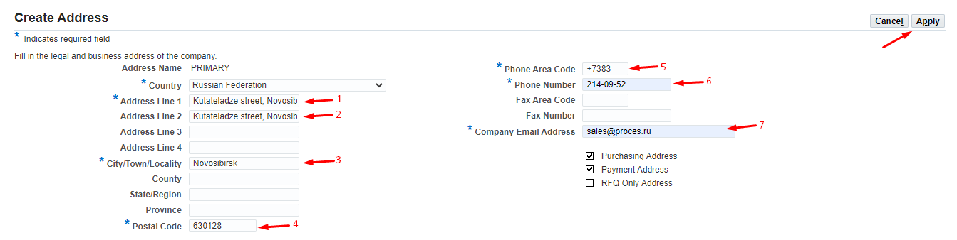
(1) in the "Address Line 1" field, indicate the address of official registration in accordance with the documents of title. For example, 4g-238 Kutateladze Street, Novosibirsk
(2) In the field "Address Line 2", indicate the full address of the actual location of the company.
(3) In the "City/Town/Locality “field, indicate the city of the official location of your company.
(4) in the "Postal Code" field, indicate the index of the official registration
(5) in the "Phone Area Code" field, enter the area code
(6) in the “Phone Number" field, enter the phone number of the company
(7) In the "Company Email Address" field, enter the company email address. This address will be used to send messages and notifications.
After filling in the fields, press Apply

  - Section: Contact Directory
It is mandatory to indicate the contract signatory.
Click on Create.
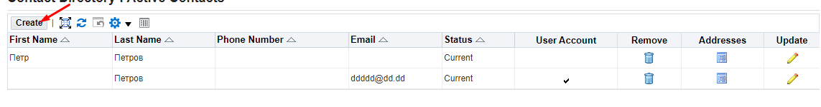
On the opened page fill in data on contract signatory.
- In the field “Contact Title” select a value from the list.
- In the field “First Name” enter the First Name.
- In the field “Middle Name” enter the Middle Name.
- In the field “Last Name” enter the Last Name.
- In the field “Job Title” enter job description in accordance with local documents of the company.
- In the filed “Contact Email” indicate E-mail address.
- In the field “Phone Area Code” enter the area code.
- In the field “Phone number” enter the phone number.
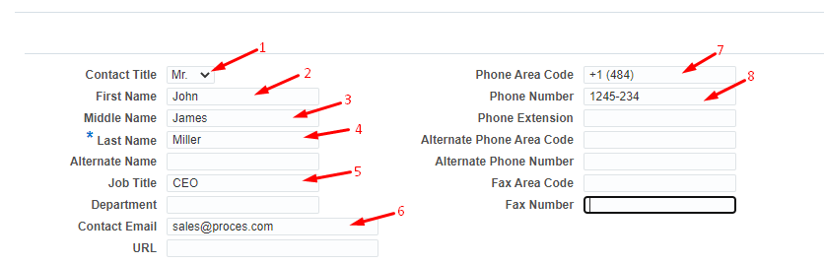

In Contact Purpose click on “Add new row” button (1) => from the directory select the value Contract Signatory (2).
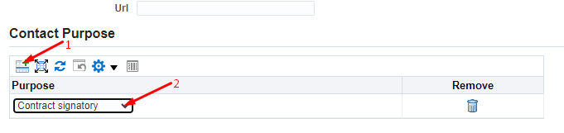
If several employees have the right to sign supply contracts in your company, then you need to create contacts for each employee.
Click on Apply.
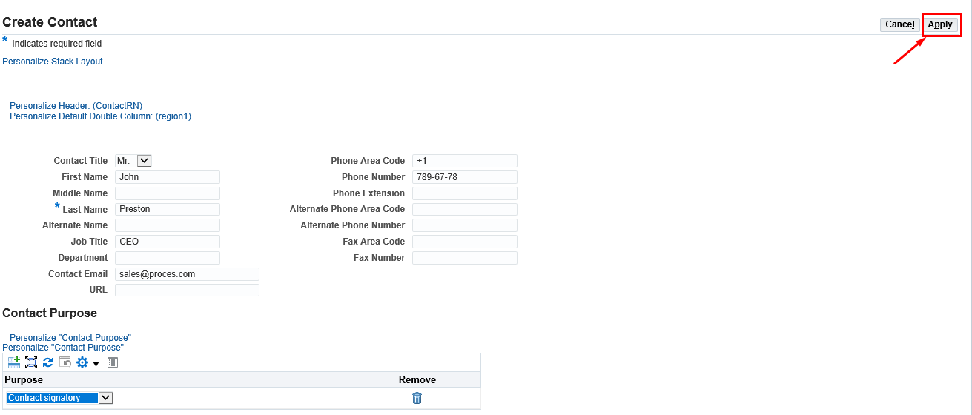

  - Section: Company Purpose.

In the Company Purpose section, select one or more values appropriate for your company
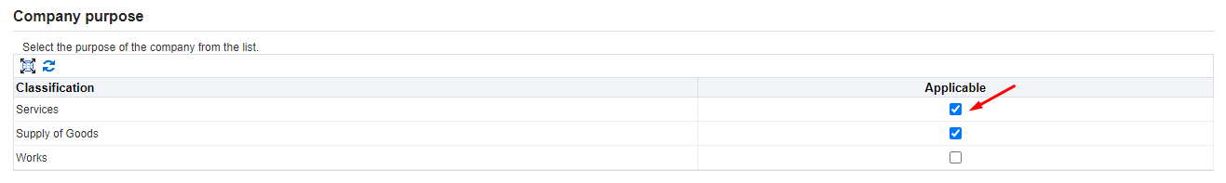

  - Section: Goods and Services.

Click on Create
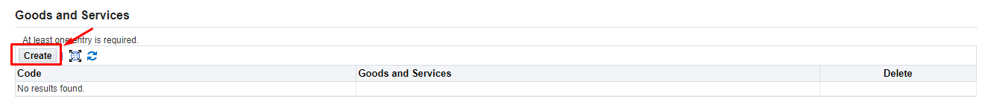
- Select the categories of goods you plan to supply /work to perform / services to provide
- Click on the "Apply" button to save the selected category. You can continue to search for the required categories and save your selection with the "Apply" button.
If you need to preview the entire list of categories of goods, works and services (4), click on the "Export list" button.

- To close the form, click on the "Save and Exit" button
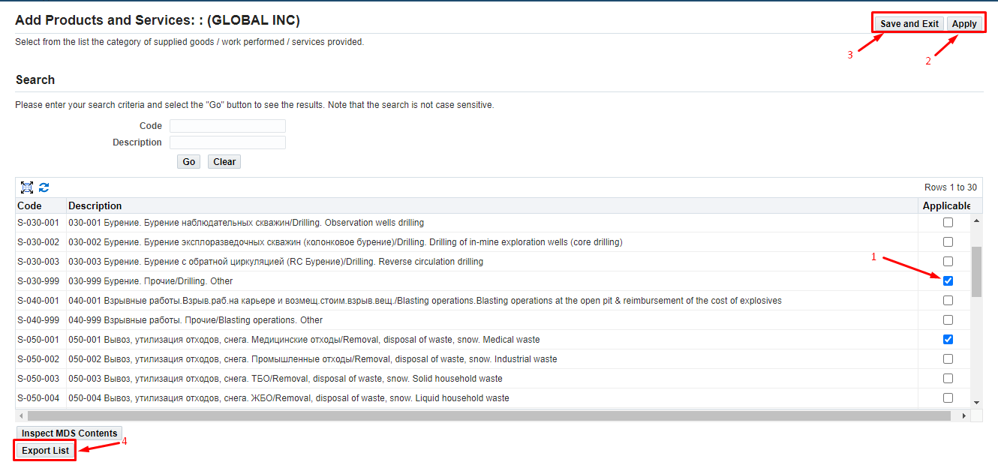
The selected categories will be displayed in the "Products and Services" section.
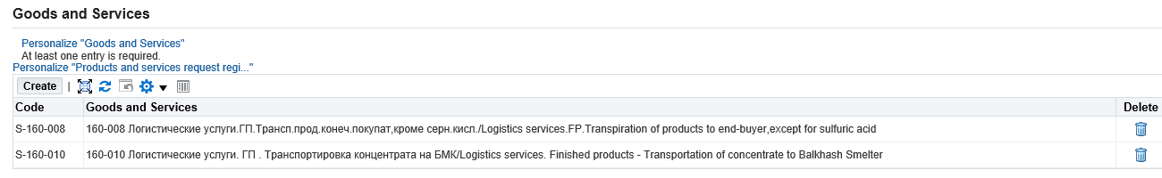
  - Section: Banking Details.

Click on the Create button

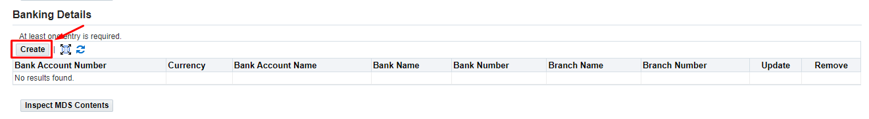
In the opened form, fill in the following data:

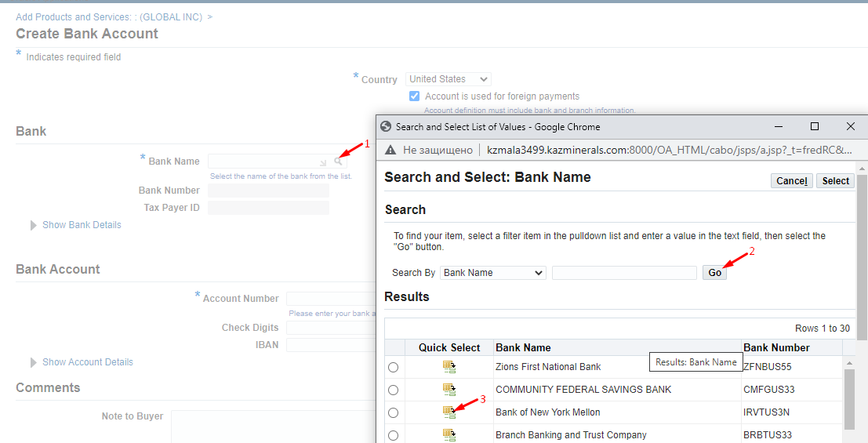
(1) in the "Bank Name" field, click on the magnifying glass=> in the window that opens (2) click the "Go" button => select the required bank from the list and (3) click on the "Quick Select" button

To fill in the Branch Name:
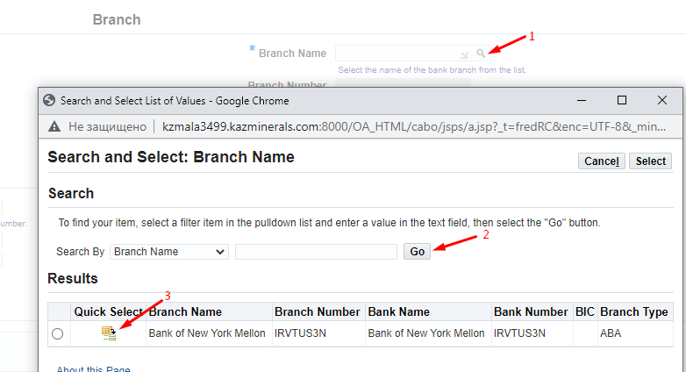

(1) in the "Branch Name" field, click on the magnifying glass=> in the window that opens (2) click the "Go" button => select the required bank from the list and (3) click on the "Quick Select" button

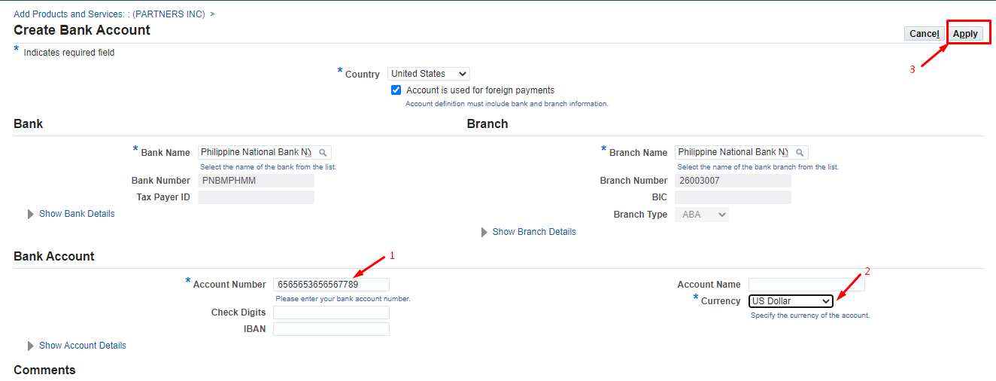

Enter the bank account number (1) in the "Account number " field.
(2) In the “Currency” field, select bank account currency from the list. (3) Click on Apply.
To add new lines, if your company has several current bank accounts in different currencies, repeat all the steps indicated in this section.

After completing the "Additional Details" page, click "Next"
If necessary, you can save the entered data and continue filling in the questionnaire after a while. To do so, in the upper right corner, click the "Save for Later"
After that, the following message will appear.
- Your registration details have been saved. You will need to bookmark the following link to be able to return to your registration request at a later date. An email with these details has also been sent to you.
- http://kzmala3518.kazminerals.com:8000/OA_HTML/jsp/pos/suppreg/SupplierRegister.jsp?regkey=4356511EFFBE065EC306D88960AE84D3658A827C67CD28316D9219AC9CD87C60&lang=US
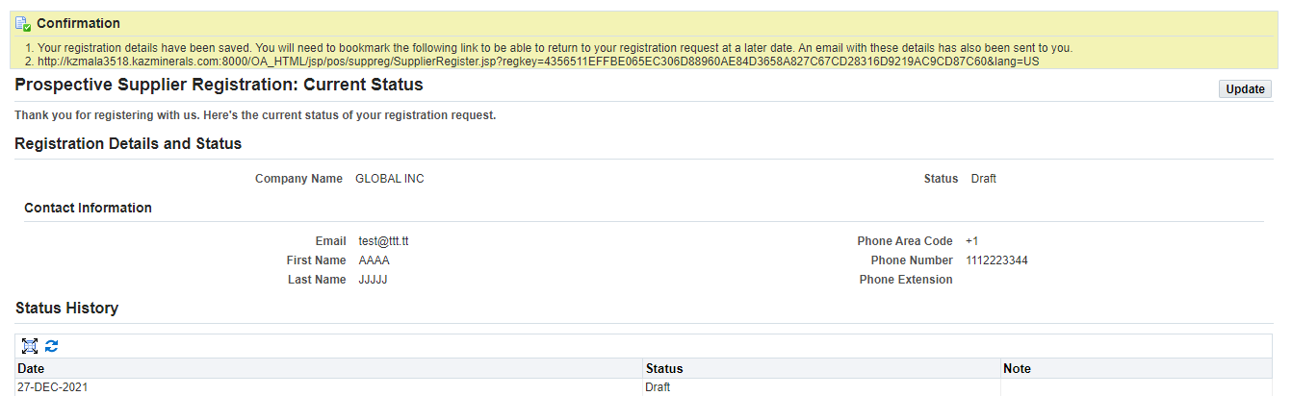

To continue filling in the questionnaire, follow the saved link

General Information Page.
  - Section: Contacts.
In the form that opens, you have to continue filling in the data about your company

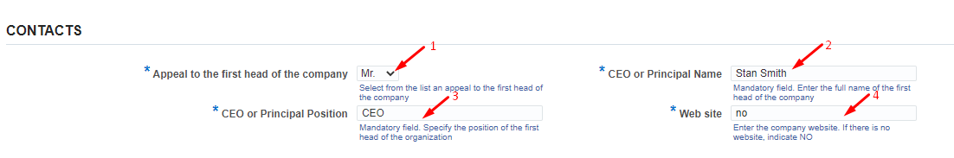
(1) in the “Appeal to the first head of the company” field, select a required value from the list.
(2) in the "CEO or Principal Name" field, indicate the full name of the head of the company for sending official letters.
(3) in the "CEO or Principal Position" field, indicate the position in accordance with the internal documents of the company.
(4) In the "Web site" field, enter the name of the company website. If there is no website, enter the word "no".

  - Section: LEGAL.
(1) in the "Legal " field, click on the magnifying glass => in the window that opens (2) click the "Go" button => select the required legal form appropriate for your company from the list and (3) click on the "Quick Select" button

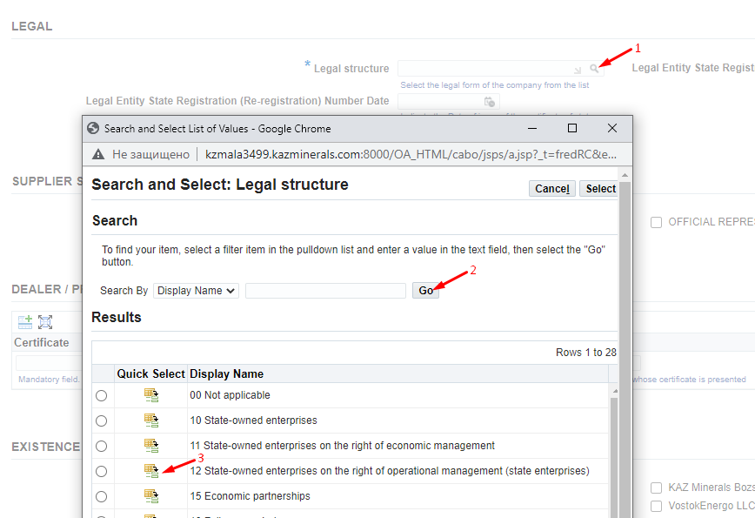

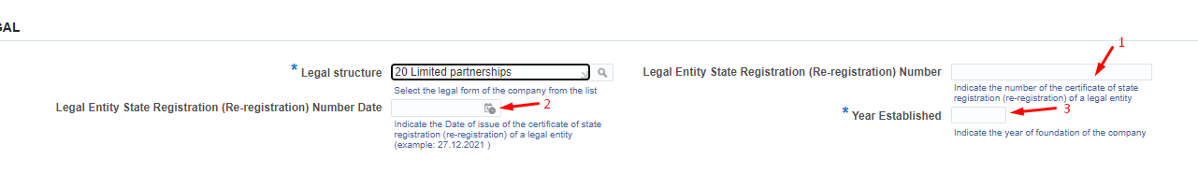

(1) and (2), in the “Legal Entity State Registration (Re-Registration) Number” and “Legal Entity State Registration (Re-Registration) Number Date” , fill in the number and date of the certificate of state registration (re-registration) of a legal entity. For the residents of the Republic of Kazakhstan, these fields are mandatory to be filled in. (3) in the “Year Established” field, fill in the year of initial state registration.

  - Section: SUPPLIER STATUS.

Check the checkbox of your company’s status:

  - Section: DEALER / PRODUCT MANUFACTURER CERTIFICATES.
If your company is a manufacturer of a product (Factory) or an Official Representative (dealer, distributor), it is mandatory to list the certificates. Scanned copies of certificates should be attached on page 4

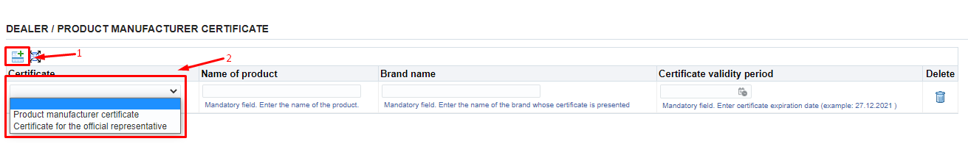
(1) Click on the “Add New Row” button => (2) select the required value from the list.
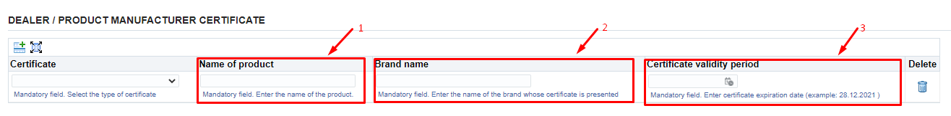
(1) in the "Name of product" field, enter the name of the certified product => (2) in the "Brand name" field, enter the manufacturer's name => (3) in the "Certificate validity period" field, enter the certificate validity period.
Repeat the steps as needed to add several lines.

  - Section: EXISTENCE OF POSITIVE TESTS OF THE SUPPLIED GOODS IN THE COMPANIES OF THE GROUP.

If your products have been successfully tested by KAZ Minerals companies, please check the checkboxes of those companies. Otherwise, leave this section blank.

  - Section: LICENSES/LICENCES FOR WORK/SERVICES
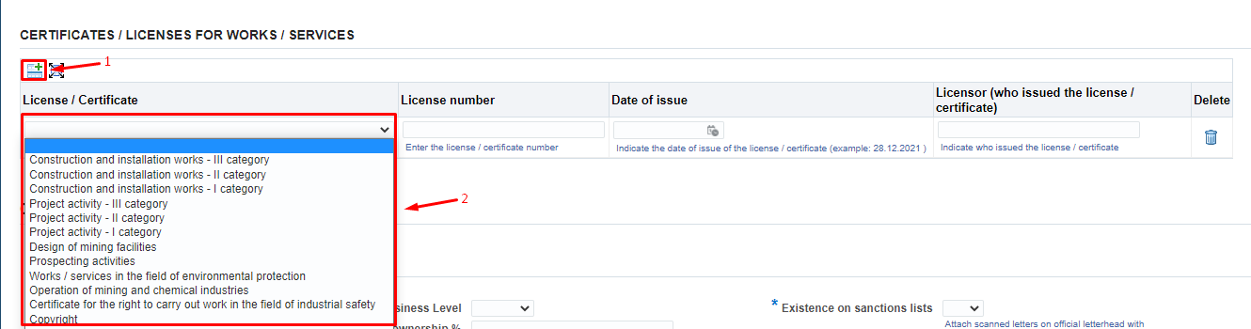

- (1) Click on the “Add New Row” button => (2) select the license/certificate for performance of work/services from the list. If the work/service is licensed, but you do not have the relevant document, select "No". If the work / service is not licensed, select “Not Required”.
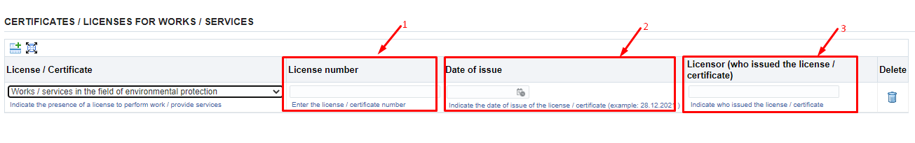
- in the "License number" field, enter the license/certificate number=> (2) in the "Date of issue" field, indicate the date of issue of the license/certificate (DD.MM.YYYY.) => (3) in the "Licensor (who issued the license/certificate)" field, indicate who issued the license/certificate. Repeat the steps as needed to add several lines.
  - Section: COMPANY DATA
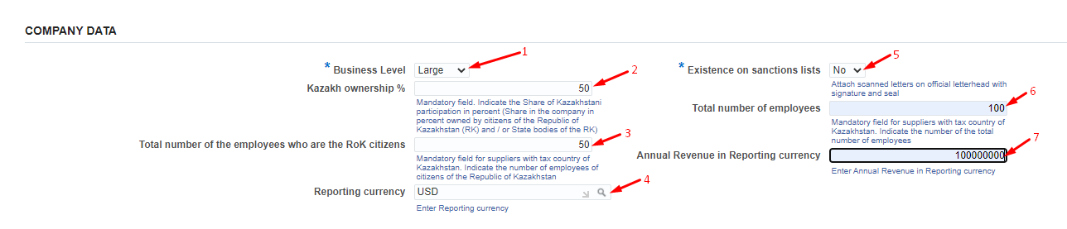
(1) in the mandatory field "Business level“, select the appropriate value for your company from the list.
(2) in the mandatory field “Kazakh ownership%”, the Residents of the Republic of Kazakhstan, should indicate the share in the company in percentage owned by the citizens of the Republic of Kazakhstan. For the non-residents of the RoK this field is not required to be filled in.
(3) in the mandatory field "Total number of employees who are the RoK citizens" for residents of the Republic of Kazakhstan it is necessary to specify the number of citizens of the Republic of Kazakhstan. For the non-residents of the RoK this filed is not required to be filled in.
(4) in the "Reporting currency" field, click on the magnifying glass=> in the window that opens, click the "Go" button=> select the reporting currency or click on the "Quick Select" button
(5) in this mandatory field “Existence on sanctions lists”, you should specify whether your Company is subject or target to the sanctions introduced by the USA Government, UN Security Council, European Union, Her Majesty's Treasury or other respective sanctions authorities. It is mandatory to attach a confirmation letter on an official letterhead signed and stamped by your Company.
(6) in the field "Total number of employees”, the residents of the Republic of Kazakhstan must indicate the total number of employees in your Company. For the non-residents of the RoK this field is not required to be filled in.
(7) in the "Annual Revenue in Reporting currency" field, enter the Annual Revenue in the reporting currency in the numerical format.

  - Section: EXPERIENCE WITH THE COMPANIES OF THE GROUP OF KAZ MINERALS

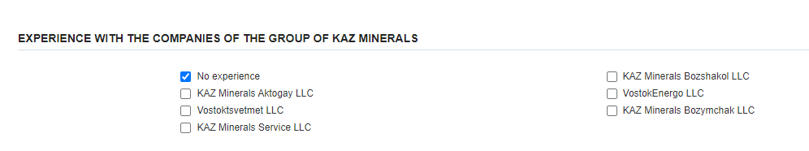

If your Company has cooperation experience with other KAZ Minerals companies, please list those companies or select “No experience with KAZ Minerals”.

  - Section: FINANCIAL DATA
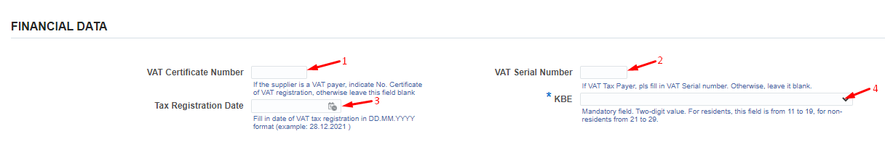

(1) the "VAT Certificate Number", (2) "VAT Serial Number" and (3) "Tax Registration Date" fields should be filled only by the residents of the Republic of Kazakhstan, if your Company is a VAT payer. Otherwise, leave this field blank.
(4) in the "KBE" field, select the appropriate value for your Company from the list.

Upon completion of the General Information page, click the "Next" button

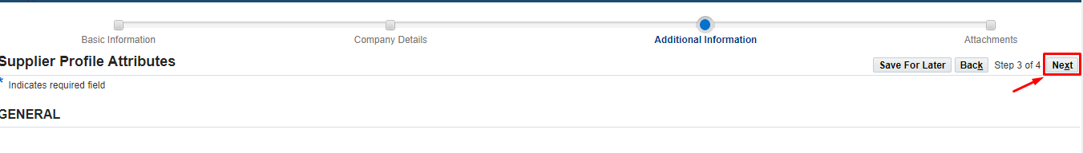

Annex page.

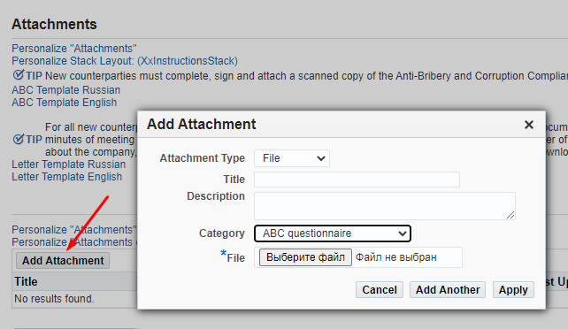

You need to attach scanned documents in accordance with the following classification.

Category Description |  | No. | List of Documents
*Documents confirming the authority of the contract signatory | Resident of the Republic of Kazakhstan |  | The minutes of meeting (decision) of the executive body on the election (appointment) of the chief executive officer or the power of attorney for an authorized representative, if the signatory is not the chief executive officer of the said legal entity.
 | Non-Resident of the Republic of Kazakhstan |  | The minutes of meeting (decision) of the executive body on the election (appointment) of the chief executive officer or the power of attorney for an authorized representative, if the signatory is not the chief executive officer of the said counterparty;
 | Branch of the non-residents of the RoK: |  | A document confirming the authorities of the counterparty’s signatory (decision or PoA)
 | IE, the Resident of the Republic of Kazakhstan |  | Identity Document
 |  |  | Power of Attorney for an authorized representative, if the signatory of a respective GWS purchase contract is different from the said individual entrepreneur
*Foundation documents | Resident of the Republic of Kazakhstan |  | The articles of association of the legal entity. If a representative of the counterparty is its structural business unit (a branch or a representative office), then, in addition to the articles of association, such a party must provid the branch or representative office regulations and documents on the appointment of the head of the structural business unit
 |  |  | The certificate or the confirmation of the state registration (re-registration) of the legal entity
 | Non-Resident of the Republic of Kazakhstan |  | Constitutional documents (the Articles of Association or an equivalent document)
 |  |  | Document confirming the registration of a legal entity with an authorized state body or chamber of commerce.
 | IE, the Resident of the Republic of Kazakhstan |  | Certificate or notification of the individual entrepreneur’s state registration with tax authorities, if such registration is required in accordance with the statutory regulations of the Republic of Kazakhstan;
 | Branch of the non-residents of the RoK: |  | The articles of association of the legal entity
 |  |  | The Provisions of the Branch or Representative Office
 |  |  | Document on the appointment of the head of a branch or representative office
 |  |  | Certificate of Branch or Representative Office registration
*Tax Details | Resident |  | The certificate of VAT registration (if applicable)
 |  |  | In case the counterparty is a VAT payer, a tax authority’s statement of the absence of outstanding tax and other payment debts to the state budget; in case the counterparty is not a VAT payer, a relevant confirmation statement from a tax authority;
 | IE, the Resident of the Republic of Kazakhstan |  | The certificate of VAT registration (if applicable)
 |  |  | In case the counterparty is a VAT payer, a tax authority’s statement of the absence of outstanding tax and other payment debts to the state budget; in case the counterparty is not a VAT payer, a relevant confirmation statement from a tax authority;
 | Branch of the non-residents of the RoK: |  | The certificate of VAT registration (if applicable)
 |  |  | In case the counterparty is a VAT payer, a tax authority’s statement of the absence of outstanding tax and other payment debts to the state budget; in case the counterparty is not a VAT payer, a relevant confirmation statement from a tax authority;
*Banking data | Resident of the Republic of Kazakhstan |  | Certificate of the existence of a current account and the absence of loan indebtedness from the servicing bank with bank details
 | IE, the Resident of the Republic of Kazakhstan |  | Certificate of the existence of a current account and the absence of loan indebtedness from the servicing bank with bank details
 | Branch of the non-residents of the RoK: |  | Certificate of the existence of a current account and the absence of loan indebtedness from the servicing bank with bank details
Licenses/certificates | Resident of the Republic of Kazakhstan |  | The state license of the Republic of Kazakhstan for carrying out licensed activities and permits for performing works (rendering services) (if applicable), including the copies of all the appendices to the state license
 |  |  | Goods manufacturer certificate
 | Non-Resident of the Republic of Kazakhstan |  | The state license of the Republic of Kazakhstan for carrying out licensed activities and permits for performing works (rendering services) (if applicable), including the copies of all the Appendices to the state license
 |  |  | Goods manufacturer certificate
 | Branch of the non-residents of the RoK: |  | The state license of the Republic of Kazakhstan for carrying out licensed activities and permits for performing works (rendering services), where such works (services) are subject to licensing, including the copies of all the Appendices to the state license (if applicable)
 |  |  | Goods manufacturer certificate
*Anti-Bribery and Corruption Compliance Questionnaire | For all suppliers |  | Anti-Bribery and Corruption Compliance Questionnaire, filled in and signed by the counterparty
*Misc | For all suppliers |  | (5) A letter confirming that your Company is/is not subject or target to the sanctions introduced by the USA Government, UN Security Council, European Union, Her Majesty's Treasury or other respective sanctions authorities.

To download the letter templates, use the following links
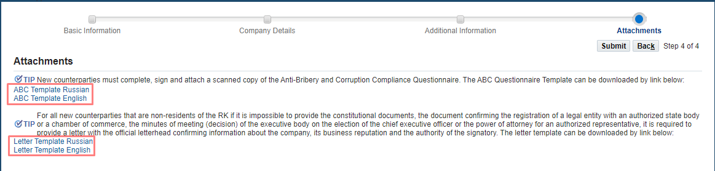

If it is impossible to submit the documents referred to in Subparagraphs 2, 8, and 9, it is required to provide a letter on the official letterhead, confirming information about the company, business reputation and the responsibilities of the person authorized to sign documents. Draft Letter (see below)

The draft of the letter to be provided by the non-resident supplier in case it is impossible to provide documents specified in Subparagraphs 2, 8, and 9

ON A COMPANY LETTERHEAD
Date _______________
To: KAZ Minerals Aktogay LLC / KAZ Minerals Bozshakol LLC (keep the required)

Confirmation of the information on the company, its business reputation and the authority of the signatory
We hereby certify that _________________ (company name) (Company) is a duly incorporated and registered organization with good business reputation (solvent, not in liquidation or bankruptcy and not having any other liabilities), and that the following information and documents are complete, valid and accurate as of the date of this letter:
1. Country of registration / residence:
2. Registration number:
3. Date of registration / incorporation:
4. Documents attached (electronic copies of originals):
4.1. The certificate of registration and / or statement of good business reputation
4.2. [Documents confirming that a person (persons) appointed as the signatory has the right to sign a contract for the supply of the offered goods / works / services on behalf of the Company, based on:
a. The Articles of Association; and / or
b. The Decision of the Board of Directors or the executive body; and / or
с. Power of attorney (or all of the above documents, jointly confirming the powers of the signatory)]
[Note to the Company: if those documents are not available or cannot be fully disclosed due to confidentiality, the Company shall replace the documents requested for in Paragraph b) above with the following]
[The Company confirms that the person (s) appointed as the signatory _________________ (state the full name and position of that authorised person) is an employee of the Company and has the right to sign contracts for supply of goods / works / services and all supporting documents on behalf of the Company.]
Information on the registration of the company and its constituent documents are available for verification and control on the following official web portal of the state registrar:
_____________________________________________________________
(Please provide a valid link to the relevant portal and include it in the text of the email).
We certify that the supporting documentation and / or information available on this website is complete, valid and accurate as of the date of this letter.

Kind regards,
Signature _____________
Full name_______________
Position _________________ [Note for the Company: This letter shall be signed by persons (excluding the employee appointed as the signatory) in a position higher than the employee appointed as the signatory, who has the authority to provide such representations, for example, the Company Secretary, Directors, Executive Management, etc.]

Seal (if the Company has a seal)

After filling in all the information and attaching all the necessary documents, click on Submit.

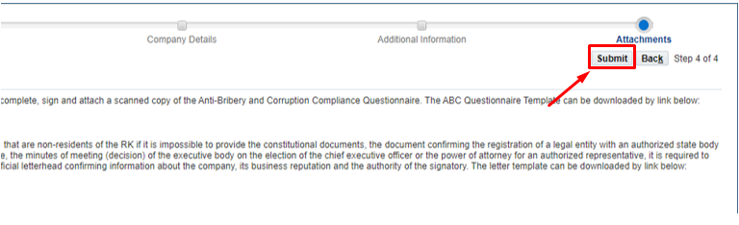

FYI
After registration, the questionnaire is sent to the KAZ Minerals Supplier Administrator to check the data.
In case if the Administrator asks you for the missing information, a notification will be sent to your email. Click on the link in the notification.
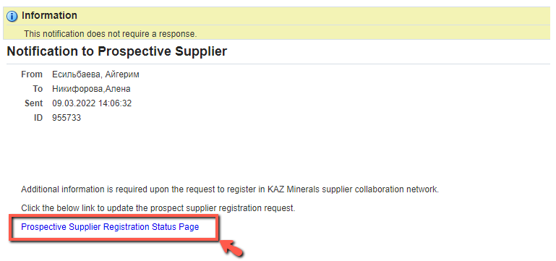
On the page that opens, click on Respond.
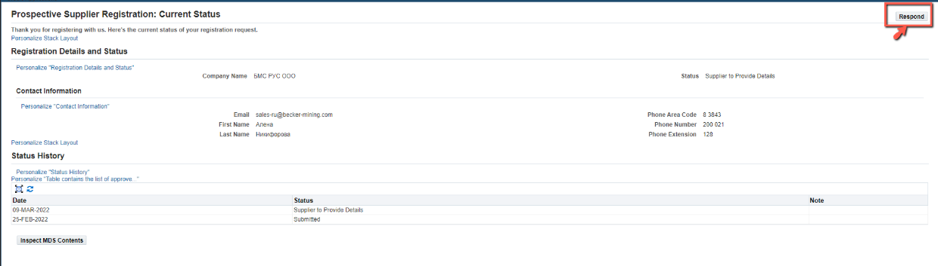
The registration form will open. Fill in the missing information and click on Submit at the Attachments Page.
Upon successful registration, you will receive an email notification with your Username and Password.
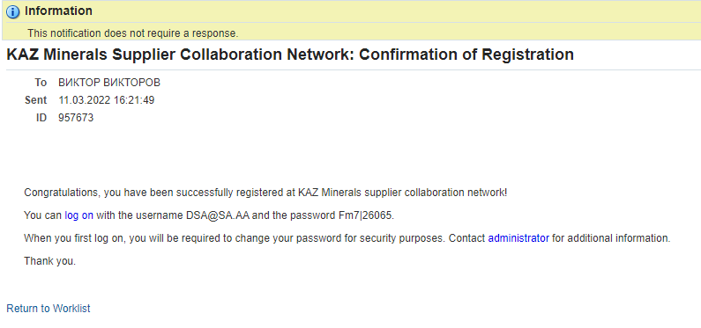

Also, after registering your account, you will receive the following notification.
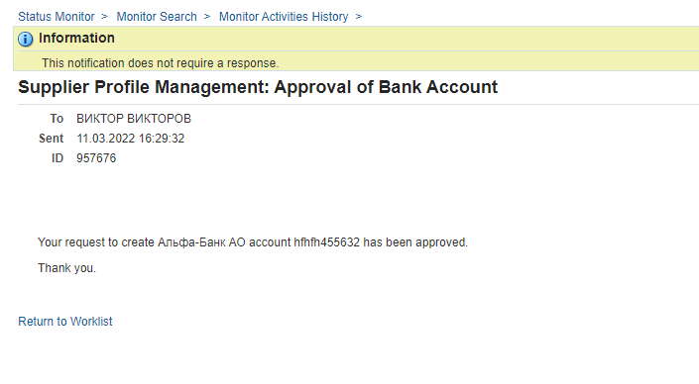

For this field, the controls are set to check: 1) the uniqueness of the number; 2) the 12 digit length of the number for the residents of the Republic of Kazakhstan, when the following numbers are being entered.
While this field is being filled in, the set controls check the following: 1) for the residents of the Republic of Kazakhstan, the value in this field is 20 characters; 2) for non-residents it is up to 30 characters; 3) this field can contain only numbers and Latin letters.
For the Residents of the RoK Individual entrepreneurs and legal entities that carry out operations listed below cannot be recognized as small businesses, including micro-businesses: 1) operations related to the turnover of narcotic drugs, psychotropic substances and precursors; 2) manufacturing and (or) wholesale of excisable products; 3) grain storage operations at grain receiving units; 4) lottery holding activities; 5) operations in the field of gambling business; 6) activities related to the circulation of radioactive materials; 7) banking operations (or certain types of banking operations) and activities in the insurance market (except for insurance agent activities) 8) audit operations; 9) professional activities in the securities market; 10) credit bureau operations; 11) security operations; 12) operations related to the circulation of civilian and service weapons and ammunition for them. Medium-sized businesses are individual entrepreneurs and legal entities engaged in entrepreneurship that are not related to small and large businesses. Large business entities are individual entrepreneurs and legal entities engaged in entrepreneurship and meeting one or two of the following criteria: the average annual number of employees is more than two hundred and fifty persons and (or) the average annual revenue is more than the three million-fold monthly calculated indicator, established by the state budget law and effective as of 1 January of the corresponding financial year. For the non-residents of the RoK: Small businesses are companies with an average annual number of employees no more than 100 persons and an average annual revenue of no more than $2 million. Large businesses are companies that meet one or two of the following criteria: the average annual number of employees is more than 250 persons and/or the average annual revenue is more than $21 million. Medium businesses are companies that are not small and large businesses.
KBE is a 2-digit code. For the residents of the Republic of Kazakhstan, this field is to be from 11 to 19, and for the non-residents from 21 to 29. The first digit means residence (1 - resident, 2 - non-resident). The second digit is the supplier's economic sector code: 1 - Central Government 2 - Regional and local governments 3 - Central (national) banks 4 - Other depository institutions 5 - Other financial institutions 6 - State non-financial institutions 7 - Non-state non-financial institutions 8 - Non-profit organizations serving households 9 – Households.

