
APPROVED BY
SCM Development Director
KAL/KBL
KAZ Minerals Management LLC
Christopher J. Brodie
_____________ __, 20___

USER GUIDE

“SUPPLIER REGISTRATION”

Drafted by:
Head of Methodology Section, Procurement Support Division, Procurement Department,
KAZ Minerals Management LLC
К.А. Abildinova

Drafted on: September 7, 2021
Updated on: July 04, 2026

Almaty, 2021
Table of Changes
9
Date | Author | Revision | Change Description
07.09.2021 | K. Abildinova | 1.0 | New document
11.02.2022 | N. K. Kalenova | 1.1 | Information and Screenshot Updates
11.03.2022 | N. K. Kalenova | 1.2 | Adding information, as per additional data
20.01.2023 | N. K. Kalenova | 1.3 | Adding information in cl. 1.1 – KPP (Tax Registration Reason Code) field, cl.2.5 – correspondent account
29.08.2023 | M. Nurmukhambetova | 1.4 | Important in cl.2.4
12.09.2023 | M. Nurmukhambetova | 1.5 | Update in the Company Details section
11.12.2023 | M. Nurmukhambetova | 1.6 | Update in the Contact Directory section
15.04.2025 | A. Kordabayeva | 1.7 | Updated the Required Document List section
04.07.2025 | A. Kordabayeva | 1.8 | Adding the Financial Status section
04.07.2026 | A. Kordabayeva | 1.9 | Information and Screenshot Updates

Table of Contents
I. PURPOSE AND SCOPE 4
II. ROLES AND RESPONSIBILITIES 4
III. BACKGROUND EVENTS 4
IV. DETAILED STEPS 4
1. The Prospective Supplier Registration page. 5
2. Additional information Page. 6
3. General Information page. 13
4. Annex page. 19
5. For your information. 23

SCOPE AND APPLICATION

This User Guide will help you (as a potential supplier) to fill in the Questionnaire for registering your company in the Oracle system, Version 12.2.7.

ROLES AND RESPONSIBILITIES

The role for registering a new supplier in Oracle, Version 12.2.7, is provided to all potential suppliers.

BACKGROUND EVENTS

An invitation was sent to the potential supplier to register in the Oracle system, Version 12.2.7, or the potential supplier independently followed the link below, posted on the Company website: https://www.kazminerals.com/
Before filling in the form in the Oracle system, Version 12.2.7, a potential supplier should review this user manual, prepare the data and a list of certain documents stated herein.

ACTION DETAILS

Note:
We kindly ask you to fill out the registration form in the Internet Explorer or Google Chrome browser, after turning off automatic translation.
Follow the link to fill in the Russian version:
https://suppliers.kazminerals.com/OA_HTML/jsp/pos/suppreg/SupplierRegister.jsp?ouid=C978373F89498127&lang=RU
to fill in the English version:
https://suppliers.kazminerals.com/OA_HTML/jsp/pos/suppreg/SupplierRegister.jsp?ouid=C978373F89498127&lang=US
to fill out the Kazakh version:
https://suppliers.kazminerals.com/OA_HTML/jsp/pos/suppreg/SupplierRegister.jsp?ouid=C978373F89498127&lang=CKK

Fields marked with * are mandatory for filling in.

The Prospective Supplier Registration page.
  - Section: COMPANY PROFILE
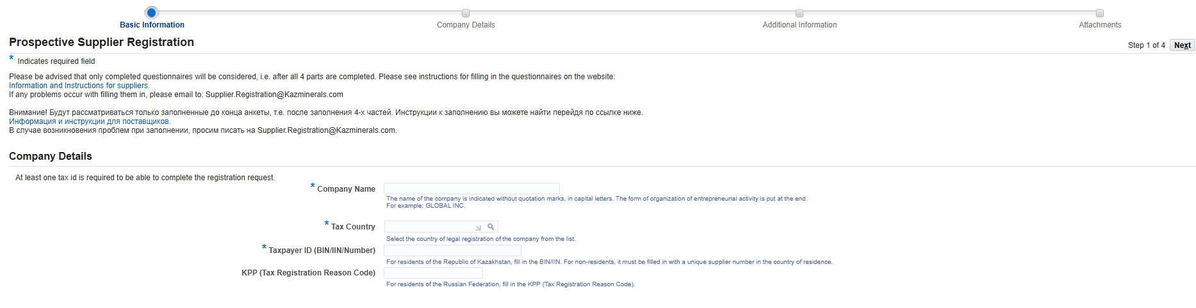
2
3
1
(1) In the "Company name" field, enter the company name without quotation marks, in capital (uppercase) letters. The organizational form of the business shall be indicated at the end. For instance, PANORAMA LLP.
(2) In the “Country of Taxation” field, select from the list the country of official registration of the company. For instance, Kazakhstan.
(3) In the "Taxpayer code” field:
a. for the residents of the RoK, please fill in:
    - BIN for legal entities;
    - IIN for individual entrepreneurs;
  - for non-residents, fill in a unique supplier number assigned in their country of residence.
(4) For residents of the Russian Federation, the “KPP” (Tax Registration Reason Code) field shall contain the Tax Registration Reason Code

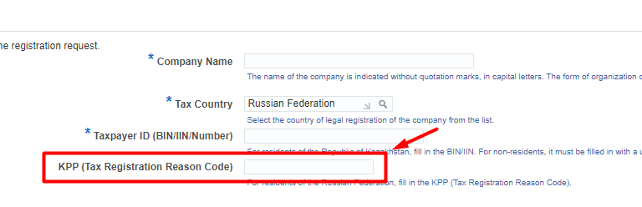

  - Section: CONTACT DETAILS

In this section, the data of the employee (person) filling in the questionnaire shall be entered.
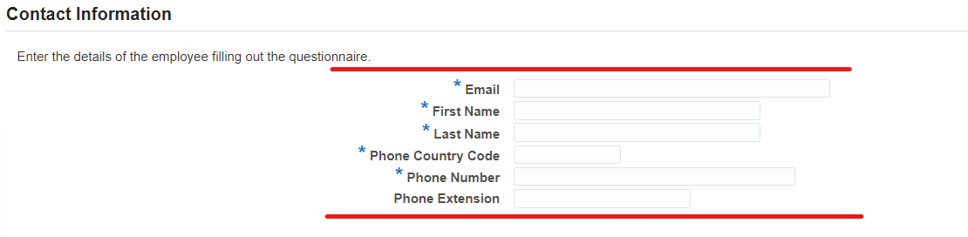
Click on (К) Next

Additional Data Page.

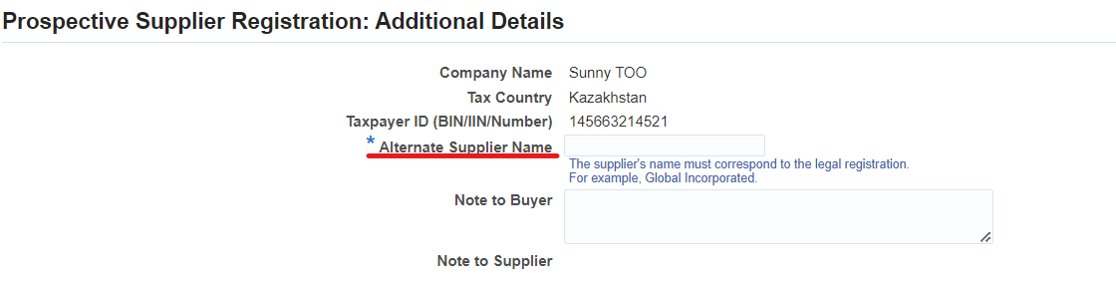
- In the ‘Supplier Alternative Name’ field, enter the full company name that shall correspond to its official registration. For example, Panorama Limited Liability Partnership.

  - Section: ADDRESS BOOK

In the Address Book Section, click on (К) ‘Create’
In the form that opens for the Residents of the Republic of Kazakhstan, fill in the following data using the Russian interface:
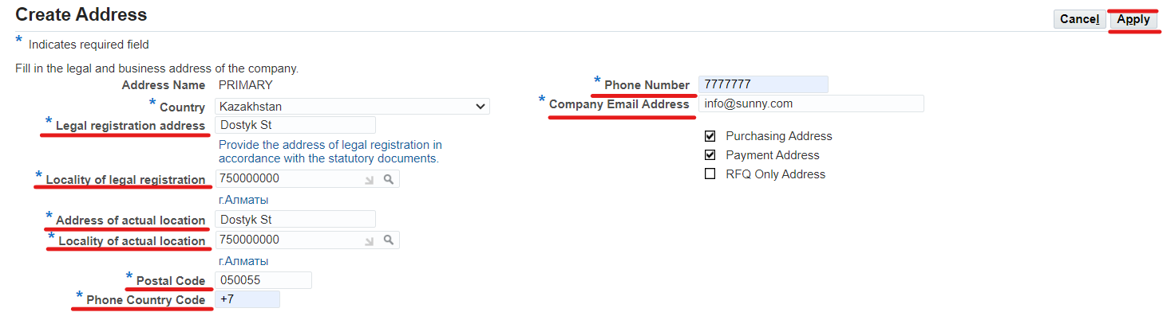
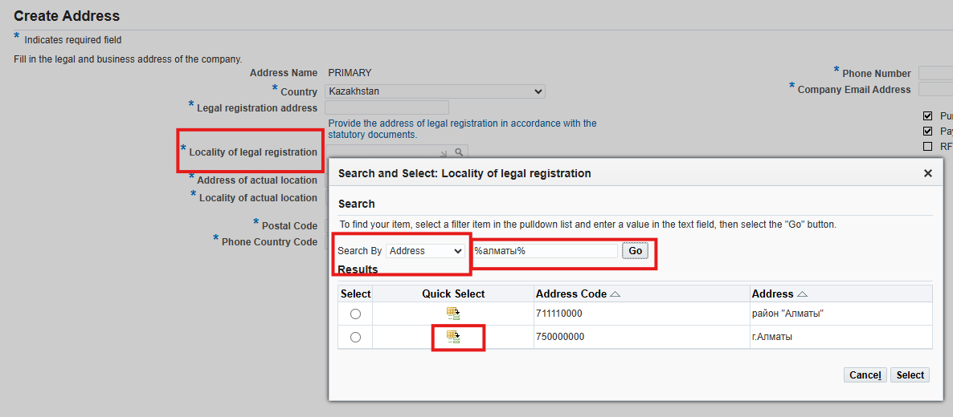
(1) in the “Legal Address" field, enter the legal address conforming to the title documentation. For example, 185 Kurmangazy Street, Almalinsky District, Almaty
(2) in the “Locality of Legal Registration" field, select the locality of legal registration from the reference directory of the Classifier of Administrative and Territorial Units (KATO). To find the required value, use a keyword enclosed between percent symbols (for example: %Almaty%).
(3) In the field "Address of Actual Location", indicate the full address of the actual location of the company. For example, 24a M. Zhussup Street, Ekibastuz, Pavlodar Oblast.
(4) in the “Locality of Actual Location" field, select the locality of actual location from the reference directory of the Classifier of Administrative and Territorial Units (KATO). To find the required value, use a keyword enclosed between percent symbols (for example: %Almaty%).
(5) in the "Index" field, enter the index of the legal address
(6) in the field “City Phone Area Code" enter the city area code
(7) in the "Phone" field, enter the phone number of the company
(8) In the "Email Address" field, enter the company email address. This address will be used to send messages and notifications.
After filling in, click on (К) Apply.

For the non-residents of the RoK:
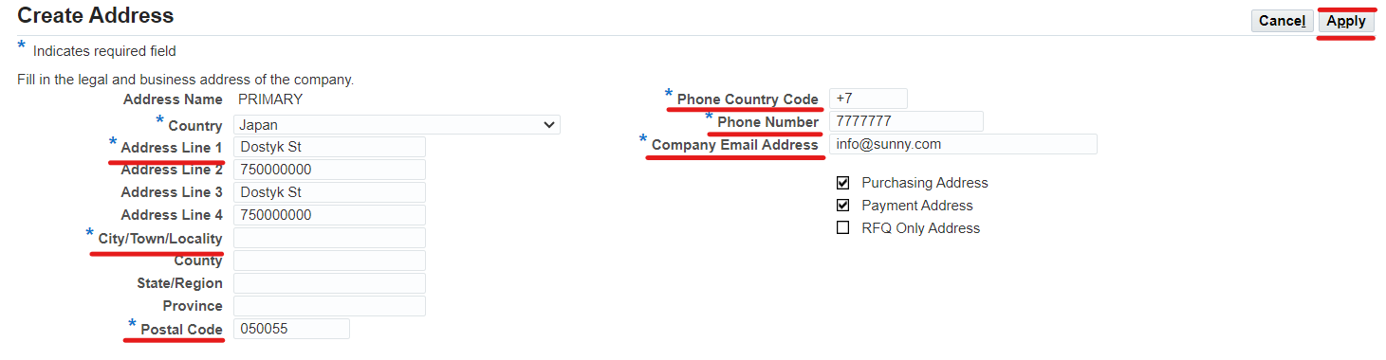
(1) in the "Address Line 1" field, indicate the address of official registration in accordance with the documents of title. For example, 4g-238 Kutateladze Street, Novosibirsk
(2) In the "Address Line 2” field, indicate the full address of the actual location of the company.
(3) In the "City/Locality “ field, enter the city of the legal registration of your company
(4) in the "Index" field, indicate the postal index of the legal registration
(5) in the “City Phone Area Code" field, enter the city area code
(6) in the "Phone" field, enter the phone number of the company
(7) In the “Company’s Email Address" field, enter the company’s email address. This address will be used to send messages and notifications.
After filling in, click on (К) Apply.

  - Section: CONTACT DIRECTORY
It is mandatory to indicate the contact details of the contract signatory.
Click on (К) Create.
If a user with the relevant powers has been created, click the Update button and assign this user the role of contract signatory.

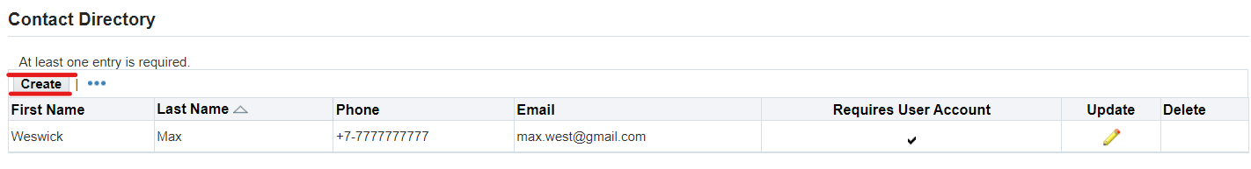

On the page that opens, fill in the required data of the contract signatory.
- in the ”Title of the Contact Person” field, select a required value from the list.
- in the “First Name" field, enter the first name.
- in the "Patronymic" field, enter the patronymic.
(4) in the “Last Name” field, enter the last name.
(5) in the "Position" field, enter the position in accordance with the internal documents of the company.
(6) In the “Contact’s Email Address" field, enter the email address.
(7) In the “City Phone Area Code” field, enter the city area code.
(8) In the "Phone" field, enter the phone number.
(9) In the "IIN" field indicate an individual identification number (RoK residents)
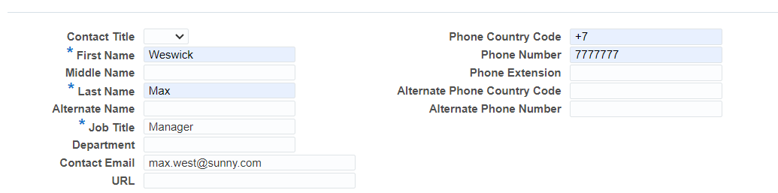
IMPORTANT! For contract signatories, it is mandatory to fill in the IIN field (for RoK residents)

In (P) Purpose of Contact, click on the "Add a new line" button (1) => select the Contract Signatory (2) value from the reference list.

If several employees in your company have the right to sign supply contracts, then you need to create contacts for each of such employees.
Click on (К) Apply.
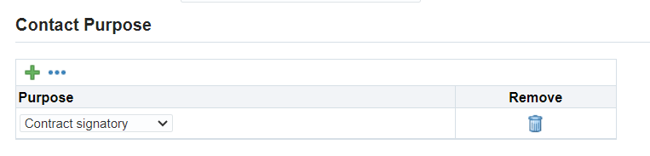
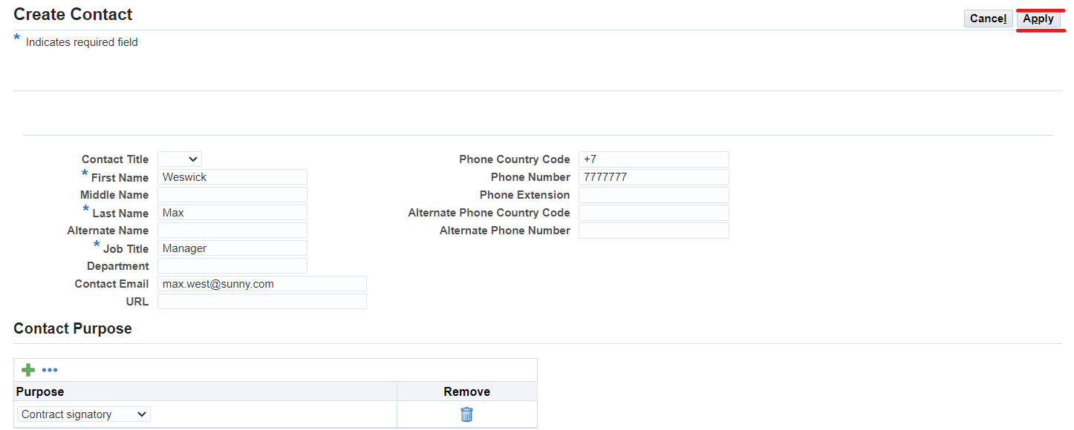

  - Section: PURPOSE

In the Purpose section, select one or more values corresponding to your company
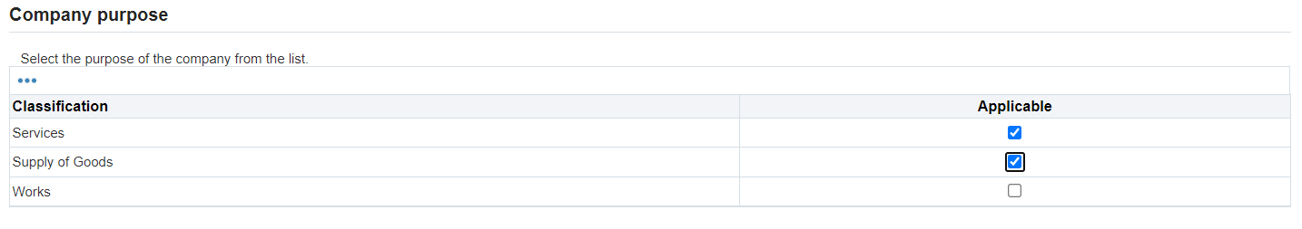

  - Section: GOODS AND SERVICES

Click on (К) Create

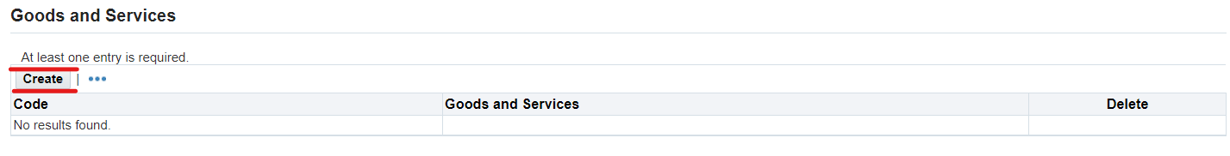

Select the categories of goods you plan to supply/works to perform/services to provide
Click on the (К) "Apply" to save the selected category. You can continue to search for the required categories and save your selection with the (К) "Apply" button
f you need to preview the entire list of categories of goods, works and services , click on (К) "Export list".

To close the form, click on (К) "Save and Exit"

To find the required value in the Description field, use a keyword enclosed between percent symbols (for example: %spare parts%).

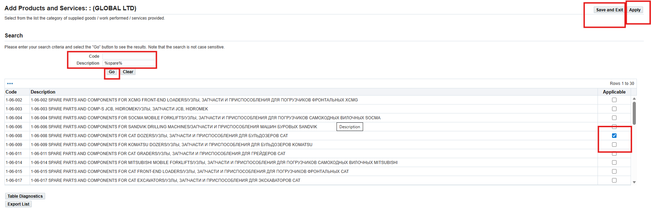

The selected categories will be displayed in the “Goods and Services” section
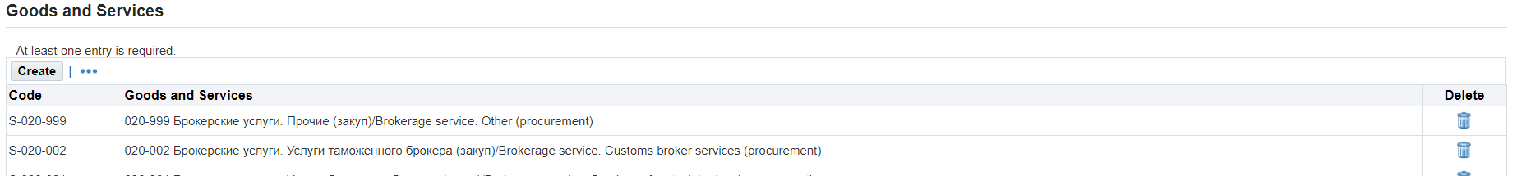

IMPORTANT!!! If, during participation in the RFQ/RFI, the supplier under the selected category of goods, works and services has not responded 10 times in a row or within 3 months, then the category will be automatically excluded from the list.

  - Section: BANKING DETAILS

Click on (К) Create
In the opened form, fill in the following data:

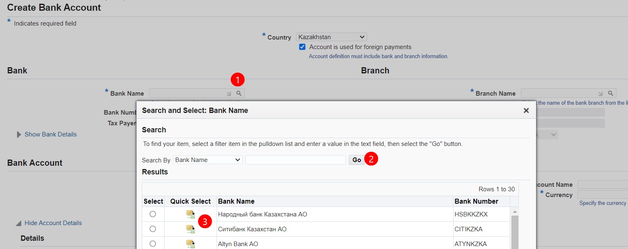
(1) in the "Bank" field, click on the magnifying glass => in the window that opens (2) click on (К) "Start" => select the required bank from the list and (3) click on (К) "Express Selection”.

To fill in the bank branch:
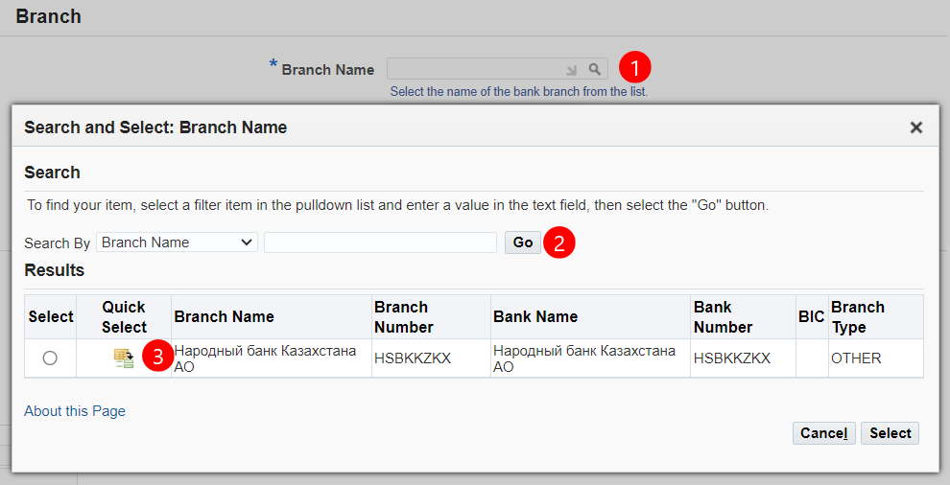

(1) in the “Branch Office Name” field, click on the magnifying glass => in the window that opens (2) click on (К) "Start" => select the bank branch office from the list and (3) click on (К)"Express Selection"

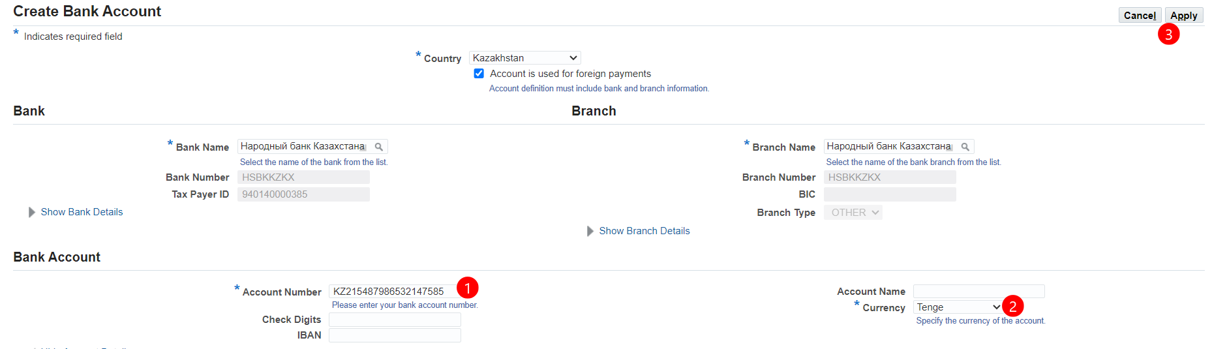

Enter the bank account number (1) in the "Account number" field.
(2) In the “Currency ” field, select bank account currency from the list. (3) Click on (К) Apply.
To add new lines, if your company has several current bank accounts in different currencies, repeat all the steps indicated in this section.

(3) In the field "Corresponding account " indicate the correspondent account.



After completing the "Additional Information" page, click on (К) "Next"

If necessary, you can save the entered data and continue filling in the questionnaire after a while. To do so, in the upper right corner, click (К) "Save for further use"
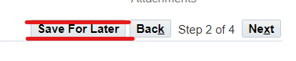
After that, the following message will appear.
Registration data have been saved. Bookmark the following link to make it easy to return to your registration request at a later time. An email containing this information will also be sent to you.
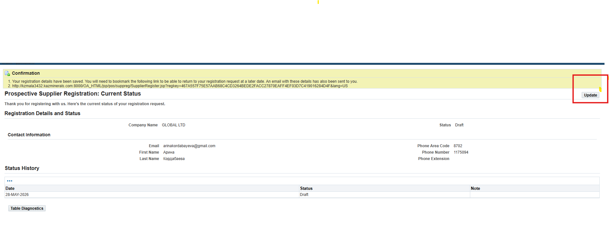

To continue filling in the questionnaire, click on the saved link

General Information page.
  - Section: CONTACT DETAILS

In the form that opens, you have to continue filling in the data about your company

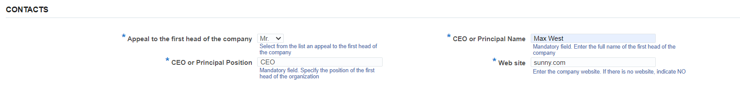
(1) in the “Title of the top executive of the company” field, select a required value from the list.
(2) in the "Full name of the top executive of the company" field, indicate the full name of the head of the company for sending official letters.
(3) in the "Position of the top executive" field, indicate the position in accordance with the internal documents of the company.
(4) In the "Company Website" field, enter the name of the company’s website. If there is no website, enter the word "no".

  - Section: LEGAL DATA

(1) in the “Legal Structure” field, click on the magnifying glass => in the window that opens (2) click on (К) "Start" => select the legal organizational structure relevant for your company from the list and (3) click on (К) "Express Selection"

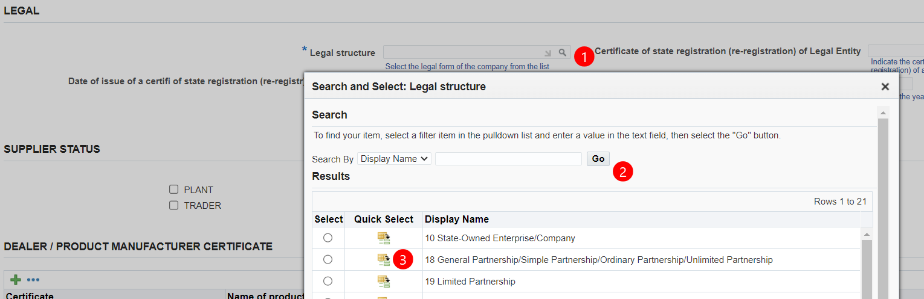

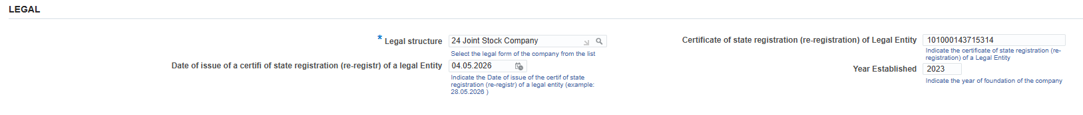
3
2
1

(1) and (2), in the “Number and date of the certificate of state registration (re-registration) of legal entity”, fill in the number and date of the certificate of state registration (re-registration) of a legal entity. For the RoK residents, these fields are mandatory. (3) in the “Year of foundation” field, fill in the year of initial state registration.

  - Section: SUPPLIER STATUS
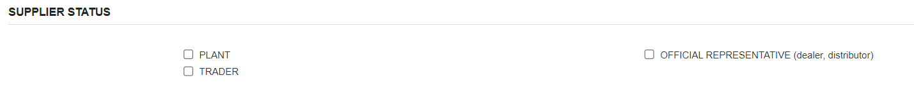

Check the checkbox of your company’s status:

  - Section: DEALER / MANUFACTURER CERTIFICATES
If your company is a manufacturer of a product (Factory) or an Official Representative (dealer, distributor), it is mandatory to list the certificates. Scanned copies of certificates should be attached on page 4

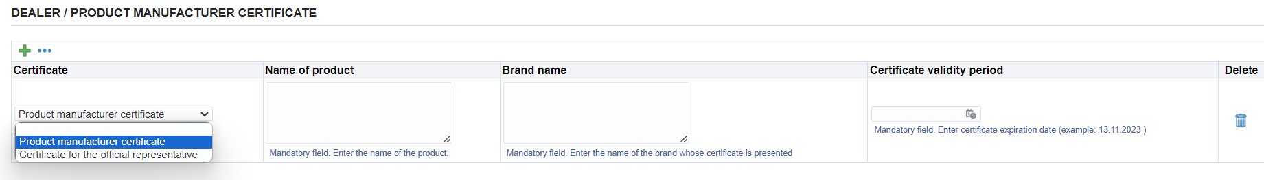
(1) Click on the “Add New Line” => (2) select the required entry from the list.
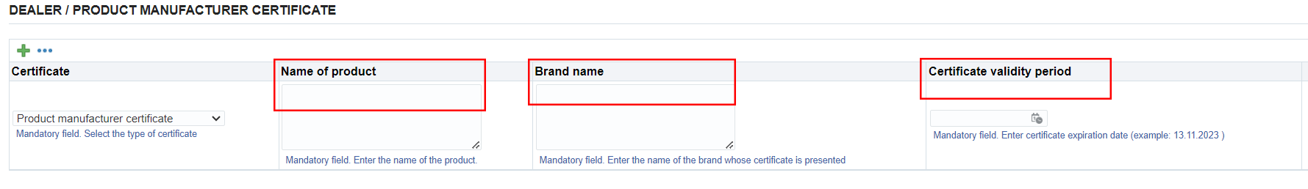
(1) in the "Product name" field, enter the name of the certified product => (2) in the "Brand name" field, enter the manufacturer's name => (3) in the "Certificate validity period" field, enter the certificate validity period.
Repeat the steps as needed to add several lines.

  - Section: SUCCESSFUL TRIALS OF GOODS AT KAZ MINERALS

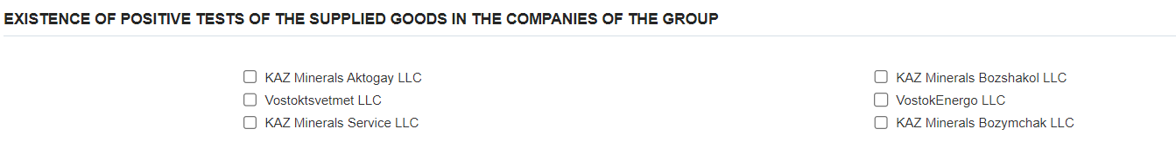
If your goods have been successfully tested by the KAZ Minerals companies, please check the checkboxes of those companies. Otherwise, leave this section blank.

  - Section: WORK/SERVICE LICENSE/CERTIFICATE
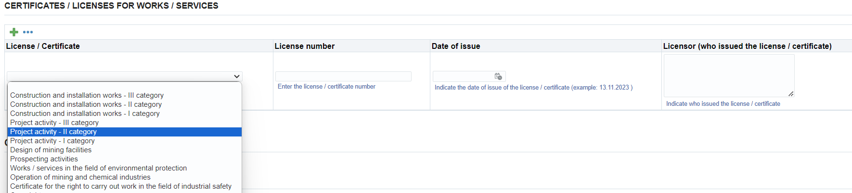
- (1) Click on the “Add New Row” button => (2) select the license/certificate for performance of work/rendering services from the list. If the work/service is licensed, but you do not have the relevant document, select "No". If the work/service is not licensed, select “Not Required”.

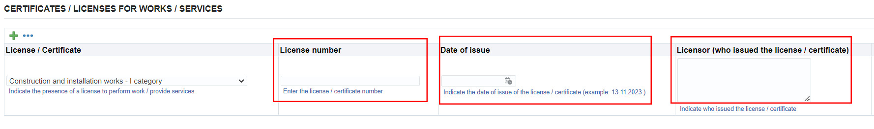
- in the "License No." field, enter the license/certificate number => (2) in the "Issue date" field, indicate the date of issue of the license/certificate (DD.MM.YYYY.) => (3) in the "Licensor (who issued the license/certificate)" field, indicate who issued the license/certificate. Repeat the steps as needed to add several lines.
  - Section: COMPANY DETAILS
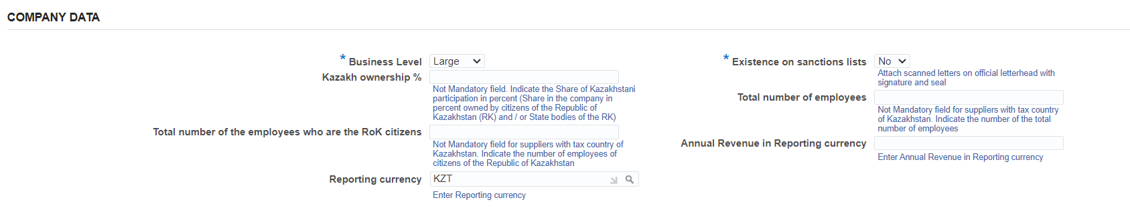

(1) in the mandatory field "Business level“, select the appropriate value for your company from the list.
(2) in the field “Local Share in %”, the Residents of the Republic of Kazakhstan, should indicate the share in the company in percentage owned by the citizens of the Republic of Kazakhstan. For the non-residents of the RoK:
(3) in the field "Total number of employees of citizens of the Republic of Kazakhstan" for residents of the Republic of Kazakhstan. For the non-residents of the RoK:
(4) in the "Reporting currency" field, click on the magnifying glass => in the window that opens, click the "Start" button => select the reporting currency or click on the "Express selection" button
(5) in this mandatory field “Presence in the sanctions lists”, you should specify whether your Company is subject or target to the sanctions introduced by the USA Government, UN Security Council, European Union, Her Majesty's Treasury or other respective sanctions authorities. It is mandatory to attach a confirmation letter on an official letterhead signed and stamped by your Company.
(6) in the field "Total number of employees”, the residents of the Republic of Kazakhstan must indicate the total number of employees in your Company. For the non-residents of the RoK:
(7) in the "Annual turnover in reporting currency" field, enter the Annual turnover in the reporting currency in the numerical format.
(8) In the “Supplier’s Name KAZ” field, enter the name of the supplier in Kazakh language.
  - Section: EXPERIENCE OF COOPERATION WITH KAZ MINERALS GROUP COMPANIES

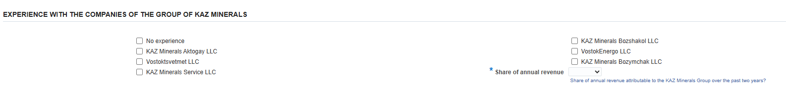

If your Company has cooperation experience with other KAZ Minerals companies, please list those companies or select “No experience with KAZ Minerals”.

  - Section: FINANCIAL DATA

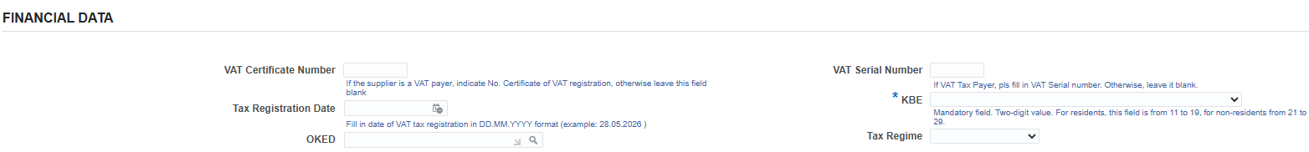
The fields “VAT Registration Certificate No.”, “VAT Registration Certificate Series No.” and “ VAT Registration Certificate Issue Date ” shall be filled in only by the RoK residents, if your company is a VAT payer. Otherwise, leave this field blank.
In the "KBE" field, select the appropriate value for your Company from the list.
The OKED and Tax Regime fields shall be filled in only by the RoK residents.

  - Section: FINANCIAL STATUS

(1) In the mandatory field “Revenue indicators for the two previous years” : Specify revenue figures for the previous two years (approximately, broken down by year).
(2) In the mandatory field “Average number of employees”: Indicate the average number of employees in the organization for the past three years.

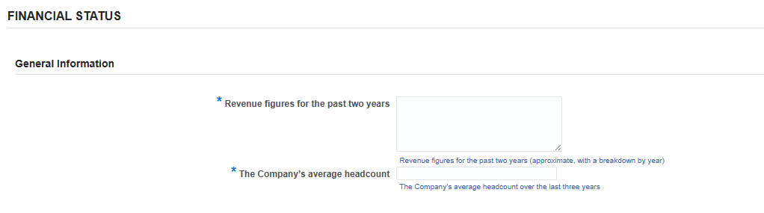
1
2

(3)In the mandatory field “Number of active clients”: Select the number of active clients for the last 12 months from the drop-down list.
(4) In the mandatory field “Revenue more than 10%”: Select the number of clients contributing to 10% of your annual revenue.
(5) In the mandatory field “Indicate the largest client”: Specify the name of your largest client.
(6)In the mandatory field “Share of annual revenue from the large client” : Indicate what percentage of your annual revenue comes from your largest client.
(7) In the mandatory field “Share of revenue from TOP-3 clients”: Provide the estimated combined revenue share of your top three clients over the last two years (as a percentage of total revenue).
(8) In the mandatory field “Names of top 3 clients”: Enter the names of your three largest clients.
(9) In the mandatory field “Government contracts”: Select what share of the organization's total revenue for the last two reporting years comes from income from the fulfillment of government contracts.

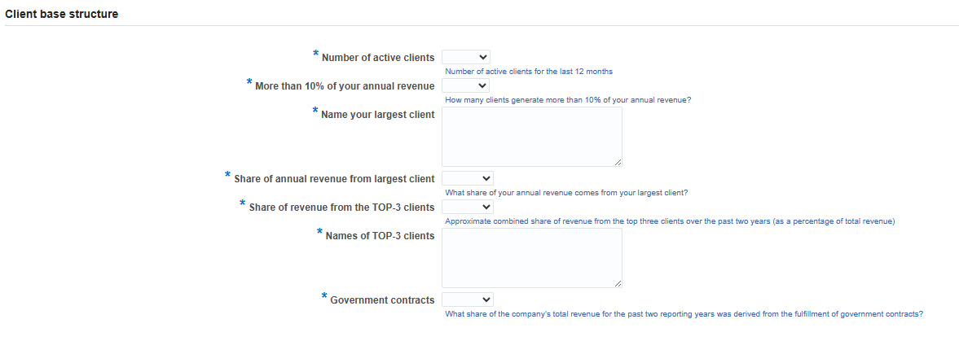
9

8

7

6

5

4

3

(10) In the mandatory field “Long-term contracts”: Indicate whether your organization has long-term contracts with key clients.

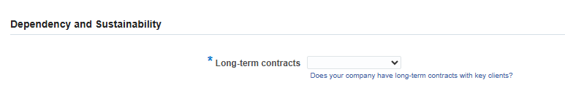
10

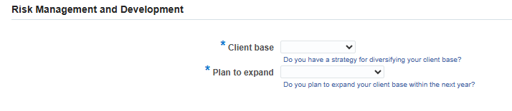
11

12

(11)In the mandatory field “Client base”: Indicate whether you have a strategy to diversify your client base.
(12)In the mandatory field “Expansion”: Indicate whether you plan to expand your client base in the coming year.

13) In the mandatory field “Assets owned”: Indicate whether your organization owns assets such as buildings, structures, land, vehicles, etc. If yes, please list these assets: If you selected "yes", please describe these assets in the text box.

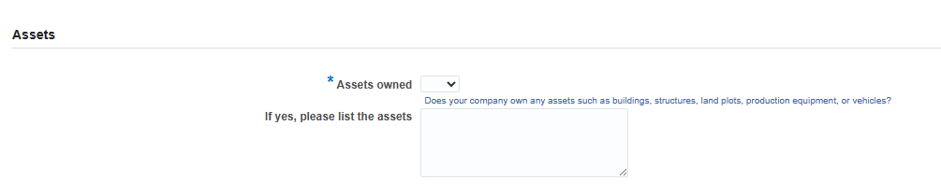
13

(14)In the mandatory field “Assets under lease”: Indicate whether your organization has assets such as equipment, vehicles, or real estate that are rented or leased. If yes, indicate these assets: If you selected "yes", please describe these assets in the text box. Time period: Please indicate the date until which your organization's lease or rental agreements are valid.

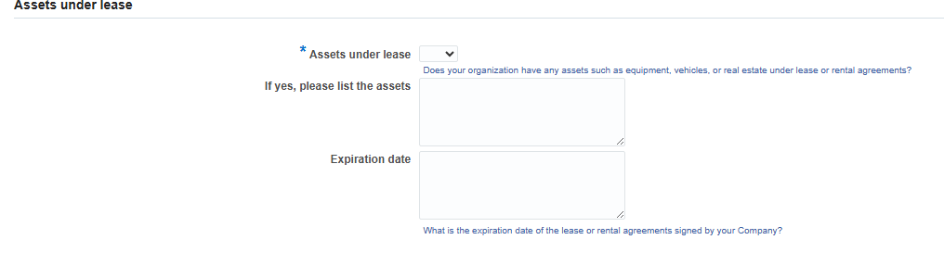
14

Upon completion of the General Information page, click the "Next" button

Annex page.
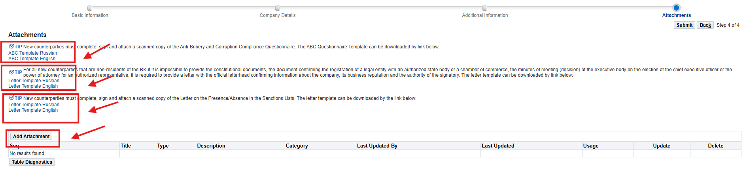

In the Attachments section, it is necessary to download the templates, complete them, and attach scanned copies.

For all new suppliers, the ABC template shall be completed, signed, and accompanied by a scanned copy of the Anti-Bribery and Anti-Corruption Compliance Questionnaire.
Letter Template for all new RoK NON-RESIDENT suppliers, if it is impossible to provide the constituent documents, the document confirming registration of the legal entity with the competent state authority or chamber of commerce, and the minutes (resolution) of the governing authority on the appointment of the head of the executive body or a power of attorney for the authorized representative, it is necessary to provide a scanned copy of a letter on the official letterhead confirming the company details, business reputation, and the authority of the signatory.
For all new suppliers, the template letter shall be completed, signed, and accompanied by a scanned copy of the Letter on Inclusion/Non-Inclusion in Sanctions Lists.

The documents shall be uploaded in scanned form in accordance with the attached list of requested documents.
The list of documents is provided in the table below.
To attach documents, use the Add add-on button.
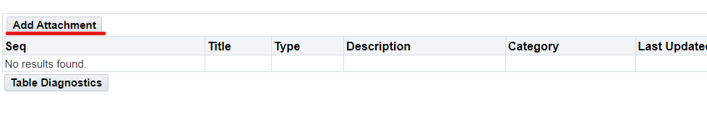
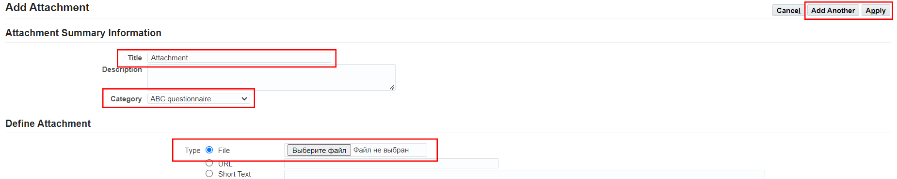
In the Name field, specify the name of the document
(for example: Anti-Corruption Questionnaire, Sanctions Letter, etc.).
In the Category field, select the appropriate document category.
Click Choose File, select the file on your computer, and click Open.
After the file is uploaded, click Apply.

Category Name |  | No. | List of Documents
*Documents confirming the authority of the contract signatory | RoK Resident |  | The minutes of meeting (Resolution) of the executive body on the election (appointment) of the chief executive officer or the power of attorney for an authorized representative, if the signatory is not the chief executive officer of the said legal entity.
 | Non-Resident of the Republic of Kazakhstan |  | The Minutes (Resolution) of the executive body on the election (appointment) of the chief executive officer or the power of attorney for an authorized representative, if the Signatory is not the chief executive officer of the Counterparty;
 | Branch of the non-residents of the RoK: |  | A document confirming the authorities of the counterparty’s signatory (decision or PoA)
 | IE, the RoK Resident |  | Identity Document
 | IE, the RoK Resident |  | Power of Attorney for an authorized representative, if the signatory of a respective GWS purchase contract is not an individual entrepreneur
*Constituent documents | RoK Resident |  | Articles of association of the legal entity. If a representative of the counterparty is its structural business unit (a branch or a representative office), then, in addition to the articles of association, such a party shall provide the branch or representative office regulations and documents on the appointment of the head of the structural business unit
*Constituent documents | RoK Resident |  | The certificate or the confirmation of the state registration (re-registration) of the legal entity
*Constituent documents | Non-Resident of the Republic of Kazakhstan |  | Constituent documents (the Articles of Association or an equivalent document)
*Constituent documents | Non-Resident of the Republic of Kazakhstan |  | Document confirming the registration of a legal entity with an authorized state body or chamber of commerce.
*Constituent documents | IE, the RoK Resident |  | Certificate or notification of the individual entrepreneur’s state registration with tax authorities, if such registration is required in accordance with the statutory regulations of the Republic of Kazakhstan;
*Constituent documents | Branch of the non-residents of the RoK: |  | Articles of association of the legal entity
*Constituent documents | Branch of the non-residents of the RoK: |  | The Provisions on the Branch or Representative Office
*Constituent documents | Branch of the non-residents of the RoK: |  | Document on the appointment of the head of a branch or representative office
*Constituent documents | Branch of the non-residents of the RoK: |  | A certificate of the record registration of a Branch or a Representative Office;
*Tax Details | Resident |  | Confirmation of VAT payer status (if any), including the date of VAT registration; if the counterparty is not a payer, provide a letter of guarantee.
*Tax Details | Resident |  | Certificate from the tax authority stating that the counterparty has no outstanding debts on payments and taxes to the budget.
*Tax Details | IE, the RoK Resident |  | Confirmation of VAT payer status (if any), including the date of VAT registration; if the counterparty is not a payer, provide a letter of guarantee.
*Tax Details | IE, the RoK Resident |  | Certificate from the tax authority stating that the counterparty has no outstanding debts on payments and taxes to the budget.
*Tax Details | Branch of the non-residents of the RoK: |  | Confirmation of VAT payer status (if any), including the date of VAT registration; if the counterparty is not a payer, provide a letter of guarantee.
*Tax Details | Branch of the non-residents of the RoK: |  | Certificate from the tax authority stating that the counterparty has no outstanding debts on payments and taxes to the budget.
*Bank account details | RoK Resident |  | Certificate of the existence of a current account and the absence of loan indebtedness from the servicing bank with bank details
*Bank account details | IE, the RoK Resident |  | Certificate of the existence of a current account and the absence of loan indebtedness from the servicing bank with bank details
*Bank account details | Branch of the non-residents of the RoK: |  | Certificate of the existence of a current account and the absence of loan indebtedness from the servicing bank with bank details
*Bank account details | Non-Resident of the Republic of Kazakhstan |  | Certificate of the existence of a current account and the absence of loan indebtedness from the servicing bank with bank details
Licenses/certificates | RoK Resident |  | The RoK state license for carrying out licensed activities and permits for performing works (services) (if applicable), including the copies of all the appendices to the state license
Licenses/certificates | RoK Resident |  | Goods manufacturer certificate
Licenses/certificates | Non-Resident of the Republic of Kazakhstan |  | The RoK state license for carrying out licensed activities and permits for performing works (services) (if applicable), including the copies of all the appendices to the state license
Licenses/certificates | Non-Resident of the Republic of Kazakhstan |  | Goods manufacturer certificate
Licenses/certificates | Branch of the non-residents of the RoK: |  | The state license of the Republic of Kazakhstan for carrying out licensed activities and permits for performing works (rendering services), where such works (services) are subject to licensing, including the copies of all the Appendices to the state license (if applicable)
Licenses/certificates | Branch of the non-residents of the RoK: |  | Goods manufacturer certificate
*Anti-Bribery and Corruption Compliance Questionnaire | For all suppliers |  | Anti-Bribery and Anto-Corruption Compliance Questionnaire, filled in and signed by the counterparty.
*Misc | For all suppliers |  | A letter confirming that your Company is/is not subject or target to the sanctions introduced by the USA Government, UN Security Council, European Union, Her Majesty's Treasury or other respective sanctions authorities.

Link to the ABC questionnaire and letter templates.
To download the letter templates, use the following links

If it is impossible to submit the documents referred to in sub-clauses 2, 8, and 9, it is required to provide a letter on the official letterhead, confirming information about the company, business reputation and the responsibilities of the person authorized to sign documents. Draft Letter (see below)

A draft letter provided by a non-resident Republic of Kazakhstan supplier, if it is impossible to provide the documents specified in clauses 2, 8, 9.

ON A COMPANY LETTERHEAD
Date _______________
To: KAZ Minerals Aktogay LLC / KAZ Minerals Bozshakol LLC (keep the required)

Confirmation of the information on the company, its business reputation and the authority of the signatory
We hereby certify that _________________ (company name) (Company) is a duly incorporated and registered organization with good business reputation (solvent, not in liquidation, bankruptcy and not having any other liabilities), and that the following information and documents are complete, valid and accurate as of the date of this letter:
1. Country of registration / residence:
2. Registration number:
3. Date of registration / incorporation:
4. Documents attached (electronic copies of originals):
4.1. Certificate of registration and / or statement of good business reputation
4.2. [Documents confirming that a person (persons) appointed as the signatory has the right to sign a contract for the supply of the offered goods / works / services on behalf of the Company based on:
а. The Articles of Association; and / or
b. The Resolution of the Board of Directors or the executive body; and / or
с. Power of Attorney (or all of the above documents, jointly confirming the powers of the signatory)]
[Note to the Company: If above documents are not available or cannot be disclosed in full for reasons of confidentiality, the company shall replace the documents listed above in clause (b) by the following]
[The Company confirms that the person(s) appointed as the signatory _________________ (state the full name and position of the signatory) is an employee of the Company and has the right to sign contracts for supply of goods / works / services and all supporting documents on behalf of the Company.]
Information on the registration of the company and its constituent documents are available for verification and control on the following official web portal of the state registrar:
__________________________________________________________
(Please provide a valid link to the relevant portal and include it in the text of the email).
We certify that the supporting documentation and / or information available on this website is complete, valid and accurate as of the date of this letter.

Best regards,
Signature _____________
Full name_______________
Position _______________ [Note to the company: This letter shall be signed by persons (other than the employee designated as the authorized signatory) holding positions senior to the employee designated as the authorized signatory and having the authority to provide such confirmations, for example, the Corporate Secretary, Directors, Executive Management, etc.]

Seal (if the Company has a seal)

After filling in all the information and attaching all the required documents, click on (K) Submit
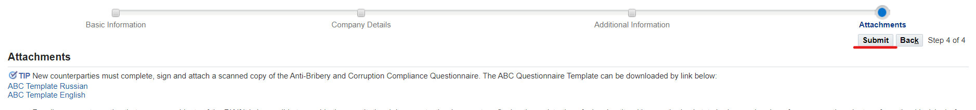

For your information.
After the registration, your questionnaire shall be sent to the KAZ Minerals Supplier Administrator for an audit of the data in the questionnaire.
If, in the course of checking your profile, the Administrator asks you for missing information, a notification will be sent to your email address. Click on the link in the notification.
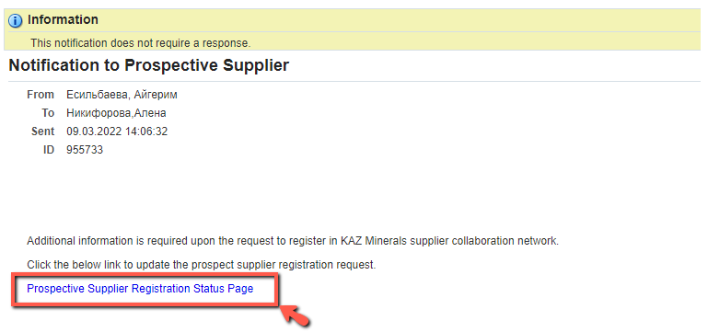

On the page that opens, click on (К) Respond.
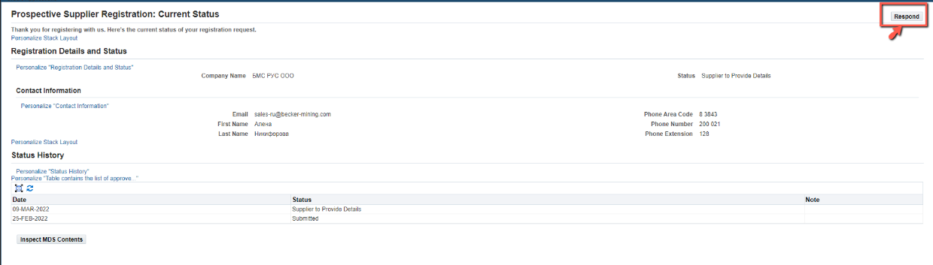

A registration form will open. Fill in the missing information and click on (K) Submit on the Annex page.

Upon successful registration, you will receive an email with your username and password.
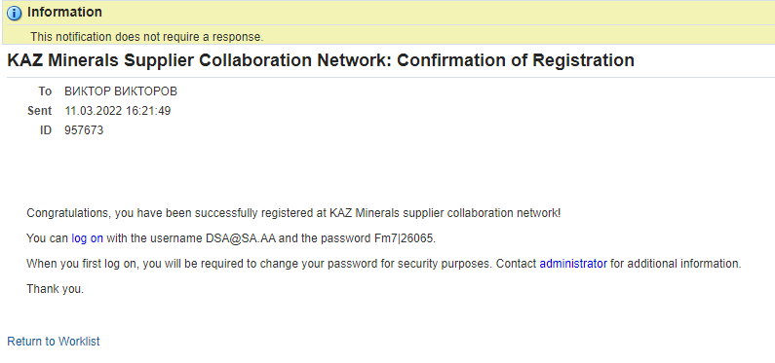
Also, after registering your account, you will receive the following notification

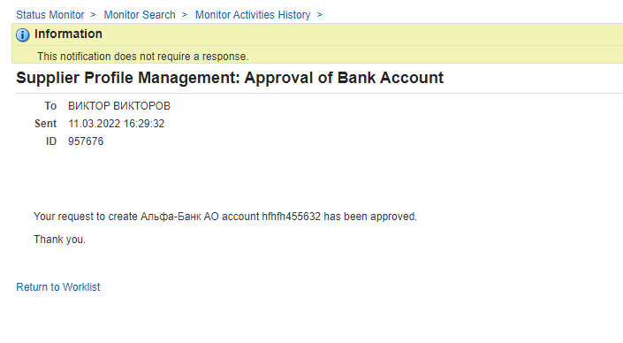

For this field, the controls are set to check: 1) the uniqueness of the number; 2) only a 12-digit number for the RoK residents.
If the “Country of Taxation” field shows the Russian Federation and the “KBE” field (at the third step of registration) shows a code equal to 27, then the KPP field shall be filled in.
For this field, the controls are set to check: 1) for the residents of the Republic of Kazakhstan, the value in this field is 20 characters; 2) for non-residents it is up to 30 characters; 3) this field can contain only numbers and Latin letters.
A mandatory field to fill in if the country is Russian Federation and the account currency is RUB. This field may contain 20 characters.
For the Residents of the RoK Individual entrepreneurs and legal entities that carry out operations listed below cannot be recognized as small businesses, including micro-businesses: 1) activities related to the turnover of narcotic drugs, psychotropic substances and precursors; 2) manufacturing and (or) wholesale of excisable products 3) grain storage operations at grain receiving units 4) lottery holding activities; 5) activities in the gambling business sector; 6) activities related to the circulation of radioactive materials; 7) banking business (or certain types of banking operations) and the insurance market business (except for insurance agent activities) 8) audit operations;
KBE is a 2-digit code. For the RoK residents, this field is from 11 to 19, and for the non-residents from 21 to 29. The first digit indicates residency status (1 – resident, 2 – non-resident). The second digit is the supplier's economic sector code: 1 - Central Government 2 - Regional and local authorities 3 - Central (national) banks 4 - Other depository institutions 5 - Other financial institutions 6 - State non-financial institutions 7 - Non-state non-financial institutions 8 - Non-profit organizations serving households 9 – Households.

